|  |  |
| --- | --- |
|  |  |

Q: How does data exchange between applications takes place?

|  |  |
| --- | --- |
|  | Here Application A wants to communicate with web service, so it sends one request to WS and based on the request it process those requests and send response back to the Application A. So the data exchange takes place using request and response. |

**Q: How we can we make web services platform independent?**

|  |  |
| --- | --- |
|  |  |

Three different application developed on different technologies should able to communicate with TodoSevice then TodoSevice will call platform independent. Since the communication between applications and web services is established by using request and response so these requests and responses should be in such a format so that every different platform can understand.

There are two specific formats of req and res which can be used and supported all kind of platform to make the web service platform independent. 1- XML 2- JSON

|  |  |
| --- | --- |
|  |  |

So to make the web service platform independent the request and response format should be platform independent

**Q: How does the application know the format of request and response?**

The solution to this is service definition. Every WS offers a service definition which specifies the following things.

|  |  |
| --- | --- |
|  | 1- Request and Response format  2- Request structure  3- Response Structure  4- End point i.e. how to call the service i.e. where the service is available |

**WS: Key Terminology:**

1. **Request and Response:** Request is the input for WS and Response is Output of WS
2. **Message exchange format (XML & JSON):** Format of request and response
3. **Service Provider or server:** Who host the WS
4. **Service Consumer or client:** Who consume the WS
5. **Service Definition :** Contract between Service Provider and Service consumer which as the things as shown
6. **Transport (1- HTTP 2- MQ):** IT defines how a service is called. Is the service is exposed over the internet then we will use URL or call it (HTTP)? Or a service is exposed over a Queue (MQ)?

|  |  |
| --- | --- |
|  | The Service Requester would place a message in the queue and the Service Provider will be listening on the Queue and take the request, process it, create the response and put it back to the Queue and Service requester would get the response from the queue and here the communication or transportation which is being used is MQ. |

Types of Web Service:

1. **SOAP:** Poses the restriction on the format XML which is being used between service provider and consumer i.e. it defines a specific format of request and response structure, so here we have to create one SAOP envelop which contain SOAP header and SOAP body. The header contains meta information like authentication, authorization, signature and SOAP header is optional in SOAP envelop.

|  |
| --- |
| **<soapenv:Envelope xmlns:soapenv="http://schemas.xmlsoap.org/soap/envelope/" xmlns:stud="http://in28minutes.com/students">**  **<soapenv:Header/>**  **<soapenv:Body>**  **<stud:GetStudentDetailsRequest>**  **<stud:id>2</stud:id>**  **</stud:GetStudentDetailsRequest>**  **</soapenv:Body>**  **</soapenv:Envelope>** |

SOAP body contains the real contents of request and response

So overall a SOAP defines the following things listed below.

* Format

SOAP XML Request

SOAP XML Response

* Transport

SOAP over MQ

SOAP over HTTP

* Service Definition

WSDL (Web Service Definition Language): It defines the following things

1- Endpoint

2- All operations

3- Request Structure

4- Response Structure

1. **REST:** (Representational State Transfer). This term was introduced by ROYE Fielding who also developed HTTP protocol. The key thing of REST is they want to have a best use of HTTP. As we know that HTTP is being used over the internet which defines request and response format (html format) over the internet. The http defines the header and body of the request and along with the response it contains the header and body. Along with the request header and request body http defines http methods (GET, PUT, POST) for different kind of action. Similarly along with the response header and body http contains Http response Status code (200, 201,404,500)

**The main key point in REST is– Resource**

The Resource is the anything that we want to expose outside the world through our application.

A resource has an URI (Uniform Resource Identifier)

* User/renga/todos/1
* User/Renga/todos
* User/Renga

A Resource can have different representation

* XML
* HTML
* JSON

As in case of SOAP we have restriction on data exchange but here in REST we don’t have restriction on data exchange we can use anything like XML or JSON

But we have restriction in case of transportation: Only HTTP.

As the rest is completely build on top of HTTP so there is no standard service definition like (WSDL) which can be attached with rest. But here have few things like WADL or swagger where we can define our REST request and response.

**Note**: These both are not really comparable (like apple to apple comparison)

|  |  |
| --- | --- |
| Restriction Vs Architectural Approach | SOAP has restriction and use only XML while Rest represents an architecture |
| Data Exchange Format | SOAP: XML while REST: XML/JSON/others format |
| Service Definition | SOAP uses WSDL and REST uses WADL / swagger now a days but it does not have any specific Service definition like SOAP |
| Transport | SOAP does not poses any restriction we can use HTTP or MQ while in REST transportation is done only on HTTP |
| Ease of implementation | REST is more easy in compare to SOAP. In SOAP we need to define WSDL and need to parse XML when required and other complicated things. |

**Implementation of Restful Web Services with spring boot**

<https://github.com/in28minutes/spring-microservices>

**Step 01 - Initializing a RESTful Services Project with Spring Boot**

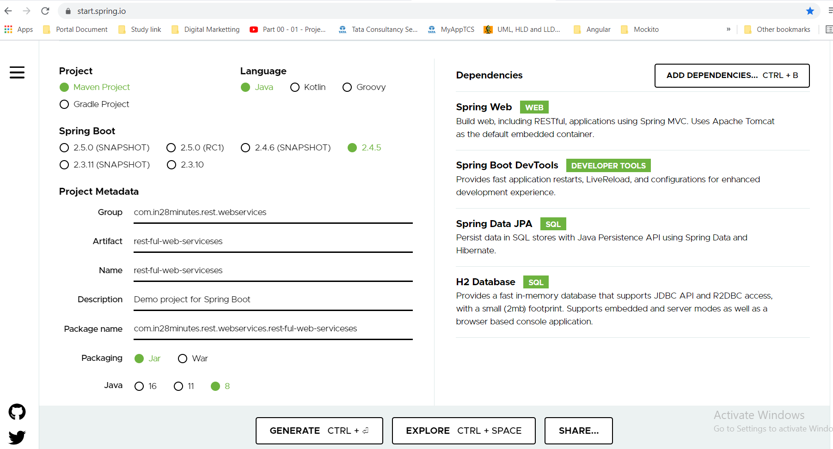

Fastest Approach to Solve All Your Exceptions

If you are using **Intellij** or you are using **Java 9+** or you are facing a **ClassNotFoundException**, we are here to help. This **50-page** troubleshooting guide and faq is our way of thanking you for choosing to learn from in28Minutes. It provides solutions for **200 FAQ** and Frequently faced Problems.

**Here's the Quick Start with Top 10 FAQ**

<https://github.com/in28minutes/in28minutes-initiatives/blob/master/The-in28Minutes-TroubleshootingGuide-And-FAQ/quick-start.md>

We love all our 150,000 learners. We want to help you in every way possible.We do not want you to get stuck because of a simple error.

**SNAPSHOT, M1, M2, M3, M4** releases are typically **WORK IN PROGRESS**. The Spring team is still working on them. We recommend **NOT** using them.

#### ****RECOMMENDED VERSION****: 2.3.1 +   (CHOOSE IN NEXT STEP)

**Step 02 - Understanding the Restful Services we would create in this course**

**#Restful Web Service guide line for ideal scenario for resources**

Here we are going to create Social Medial Application:

User will do post:

-To retrieve all Users 🡺 Get /users

-To create user 🡺 Post/ users

-To Retrieve one user 🡺 GET / users/{id} 🡺 ex: Get /users/1

-To Delete a user 🡺 DELETE /users/{id} 🡺 ex: DELETE /users/1

-Retrieve all the post for a user 🡺 GET/users/ {id}/posts

-Create a post for a user 🡺 POST / users/ {id}/posts

-Retrieve a detail of a post 🡺 GET/ users/ {id}/posts/ {post_id}

**Step 03 - Creating a Hello World Service**

|  |
| --- |
| **package** com.in28minutes.rest.webservices.restfulwebserviceses;  **import** org.springframework.web.bind.annotation.GetMapping;  **import** org.springframework.web.bind.annotation.RequestMapping;  **import** org.springframework.web.bind.annotation.RequestMethod;  **import** org.springframework.web.bind.annotation.RestController;  // Controller  @RestController  **public** **class** HelloWorldController {    // GET // URI // Method  //@RequestMapping(method=RequestMethod.GET, path="/helloworld")  @GetMapping("/helloworld")  **public** String helloWorld() {  **return** "Hello World";  }  }  <http://localhost:8080/hellowold>  output: |

**Step 04 - Enhancing the Hello World Service to return a Bean**

In the previous steps we have return hard coded String back, we have created the “/helloworld” URI which is calling to helloWorld () method and returns Hard coded string “Hello World”.

Now in this step we will create an object and return the same object.

|  |  |
| --- | --- |
| **package** com.in28minutes.rest.webservices.restfulwebserviceses;  **public** **class** HelloWorldBean {  **private** String message;  **public** HelloWorldBean(String message) {    **this**.setMessage(message);  }  **public** String getMessage() {  **return** message;  }  **public** **void** setMessage(String message) {  **this**.message = message;  }  @Override  **public** String toString() {  **return** String.*format*("HelloWorldBean [message=%s]", message);  }  }  Note: if we don’t create the getter of message then automatic conversion will not happen and we will get error. | @RestController  **public** **class** HelloWorldController {    // GET // URI // Method  //@RequestMapping(method=RequestMethod.GET, path="/helloworld")  @GetMapping("/helloworld")  **public** String helloWorld() {  **return** "Hello World";  }  // Create a class HelloWorldBean and returning the same object here using constructor  @GetMapping(path="/hello-world-bean")  **public** HelloWorldBean helloWorldBean() {  **return** **new** HelloWorldBean("Hello World");  }  }  Output: |

Once we create the getter of message then automatic conversion will happen and we will get Json message as shown above.

Here the message is the variable name defined in the HelloWorldBean class and “Hello World” the message being return from the helloWorldBean method which is being converted automatically into JSON.

**Step 05 - Quick Review of Spring Boot Auto Configuration and Dispatcher Servlet**

Here we would try to understand what happens in the background when the above two methods gets executed.

Put the below line in the application.properties to see all the debug level log:

logging.level.org.springframework: debug

When we run the eclipse in debugging mode then we will see “Auto Configuration report” Which consist of a lot of details like>

**DispatcherServletAutoConfiguration matched:** because it found in the classpath. And this comes from the [spring-boot-starter-web] which includes of Spring MVC DispatcherServlet in the class path.

**ErrorMvcAutoConfiguration matched:**

**ErrorMvcAutoConfiguration.WhitelabelErrorViewConfiguration matched:**

**How does the message convert automatically?**

**HttpMessageConvertersAutoConfiguration** **matched**:

**JacksonAutoConfiguration.Jackson2ObjectMapperBuilderCustomizerConfiguration** **matched**:

The automatic message converter happens because of above two matched in the classpath

So whatever it founds in the classpath it will mark those with matched and does the auto-configuration automatically.

**What happens when we hit-** [**http://localhost:8080/hello-world-bean**](http://localhost:8080/hello-world-bean) **?**

**First of the it will go to DispatcherServlet, now DS will search this request mapping in the available controller and where it finds the mapping then it invokes that method, Now the method will be executed and the returned object will be converted into JSON with the help of Jackson2Object and stored into ResponseBody object now again it will go the DispatcherServlet and finally it will render the message with the help of view resolver.**

**If go inside the @RestController then we will see the below code for @RestController:**

|  |
| --- |
| @Target(ElementType.***TYPE***)  @Retention(RetentionPolicy.***RUNTIME***)  @Documented  @Controller  @ResponseBody  **public** **@interface** RestController {  /**  * The value may indicate a suggestion for a logical component name,  * to be turned into a Spring bean in case of an autodetected component.  * **@return** the suggested component name, if any (or empty String otherwise)  * **@since** 4.0.1  */  @AliasFor(annotation = Controller.**class**)  String value() **default** "";  }  **So @RestController is nothing but an alias of controller only but it consist of @ResponseBody along with @Controller** |

**Step 06 - Enhancing the Hello World Service with a Path Variable**

Let’s create another helloworld method with a path parameter. The path parameter will be passed inside {name} and to map this passed {name} with the variable we will use **@PathVariable** annotation.

|  |
| --- |
| @GetMapping(path="/hello-world/path-variable/{name}")  **public** HelloWorldBean helloWorldPathVariable(@PathVariable String name) {  **return** **new** HelloWorldBean(String.*format*("Hello World, %s", name));  }  } |

Here when this method will be executed then the path variable name value will be replaced with %s so that it looks in proper format.

Output :

|  |  |
| --- | --- |
| <http://localhost:8080//hello-world/path-variable/Arun> | {  "message": "Hello World, Arun"  } |

**Note**: If we don’t put %s then the dynamic value will not be printed and will get only

{

"message": "Hello World,”

}

Steps to upload and commit the new project into Bit-bucket repository.

|  |
| --- |
| **Step-1:** Go to the particular file whose files needs to be added into repository and executed git init command  saraswati@DESKTOP-B1DPRDQ MINGW64 /e/In28MinutesMSWithCloud  $ git init  Initialized empty Git repository in E:/In28MinutesMSWithCloud/.git/  **Step-2: Now run the git space add space (dot.) command to add all the file**  saraswati@DESKTOP-B1DPRDQ MINGW64 /e/In28MinutesMSWithCloud  $ git add .  **Step-3: Run the below command to check the status of all added file**  saraswati@DESKTOP-B1DPRDQ MINGW64 /e/In28MinutesMSWithCloud (master)  $ git status  **Step-3: Run the below command to commit all the file local**  saraswati@DESKTOP-B1DPRDQ MINGW64 /e/In28MinutesMSWithCloud (master)  $ git commit -m "First Commit"  Step-4: Run the below command to move all the committed file into remote repository bit bucket  saraswati@DESKTOP-B1DPRDQ MINGW64 /e/In28MinutesMSWithCloud (master)  $ git remote add origin https://imarungupta@bitbucket.org/imarungupta/springcloudms.git  **Step-5:** Finally run the below command to push all the local committed files into remote repository  saraswati@DESKTOP-B1DPRDQ MINGW64 /e/In28MinutesMSWithCloud (master)  $ git push -f origin master |

**Step 07 - Creating User Bean and User Service**

Step1- Create one User class

Step2- Crete on UserDaoService component or repository class which will be managed by sprint itself and will talk to the database. Here will create static ArrayList of User class type and then inside the static block initialize the values using User parameterized constructor.

Now create

1. Method to return all the users
2. Method to add new use and increase the user count
3. Method to find particular user

|  |  |
| --- | --- |
| **package** com.in28minutes.rest.webservices.restfulwebserviceses.user;  **import** java.util.Date;  **public** **class** User {  **private** Integer id;  **private** String name;  **private** Date birthDate;  // Create the getters and setters  // Create ond parameteriezed constructer  // Override toString method  **public** User(**int** id, String name, Date birthDate) {  **super**();  **this**.id = id;  **this**.name = name;  **this**.birthDate = birthDate;  }  @Override  **public** String toString() {  **return** "User [id=" + id + ", name=" + name + ", birthDate=" + birthDate + "]";  }  **public** Integer getId() {  **return** id;  }  **public** **void** setId(Integer id) {  **this**.id = id;  }  **public** String getName() {  **return** name;  }  **public** **void** setName(String name) {  **this**.name = name;  }  **public** Date getBirthDate() {  **return** birthDate;  }  **public** **void** setBirthDate(Date birthDate) {  **this**.birthDate = birthDate;  } } | **package** com.in28minutes.rest.webservices.restfulwebserviceses.user;  **import** java.util.ArrayList;  **import** java.util.Date;  **import** java.util.List;  **public** **class** UserDaoService {  **private** **static** **int** *usersCount* =3;  **private** **static** List<User> *users* = **new** ArrayList<User>();  **static** {  *users*.add(**new** User(1, "John", **new** Date()));  *users*.add(**new** User(2, "Roney", **new** Date()));  *users*.add(**new** User(3, "Abhrahim", **new** Date()));  }  // Method to return all the users  **public** List<User>findAll(){  **return** *users*;  }  // Method to add new use and increase the user count  **public** User save(User user) {  **if**(user.getId() == **null**) {  user.setId(++*usersCount*);  }  *users*.add(user);  **return** user;  }  // Method to find particular user  **public** User findUser(**int** id) {  **for**(User user : *users*) {  **if**(user.getId()==id) {  **return** user;  }  }  **return** **null**;  }  } |

**Now in the next step we will create UserController class where we will Autowired UserDaoService class and will call each method to get response.**

Since we have not put @Component annotation at the UserDaoService class and Autowired this class inside UserResourceController class and that is why Tomcat server was not getting started and it gives following below error.

|  |
| --- |
| ***************************  **APPLICATION FAILED TO START**  **\*\*\*\*\*\*\*\*\*\*\*\*\*\*\*\*\*\*\*\*\*\*\*\*\*\*\***  **Description:**  **Field daoService in com.in28minutes.rest.webservices.restfulwebserviceses.user.UserResourceController required a bean of type 'com.in28minutes.rest.webservices.restfulwebserviceses.user.UserDaoService' that could not be found.**  **The injection point has the following annotations:**  **- @org.springframework.beans.factory.annotation.Autowired(required=true)** |

**Step 08 - Implementing GET Methods for User Resource or User Controller**

1-Here we will create one UserResourceController class and will call the UserDaoService class method.

2- First we have Autowired UserDaoService in the Controller class

|  |  |
| --- | --- |
| package com.in28minutes.rest.webservices.restfulwebserviceses.user;  import java.util.List;  **import** org.springframework.beans.factory.annotation.Autowired;  **import** org.springframework.web.bind.annotation.GetMapping;  **import** org.springframework.web.bind.annotation.PathVariable;  **import** org.springframework.web.bind.annotation.RestController;  **@RestController**  **public class UserResourceController {**  **@Autowired**  **private UserDaoService daoService;**  **//Retrieve all the list of users**  **@GetMapping(path="/users")**  **public List<User> retriveAllUsers(){**  **List<User> findAll = daoService.findAll();**  **return findAll;**  **}**  **//Retrieve one user**  **@GetMapping(path="/users/{id}")**  **public User retriveUser(@PathVariable int id) {**  **User findUser = daoService.findUser(id);**  **return findUser;**  **}**  } | **//Retrieve all the list of users**  [**http://localhost:8080/users/**](http://localhost:8080/users/) |
| **//Retrieve one user:** [**http://localhost:8080/users/2**](http://localhost:8080/users/2)  {  "id": 2,  "name": "Roney",  "birthDate": "2021-04-18T07:18:26.055+00:00"  } | |

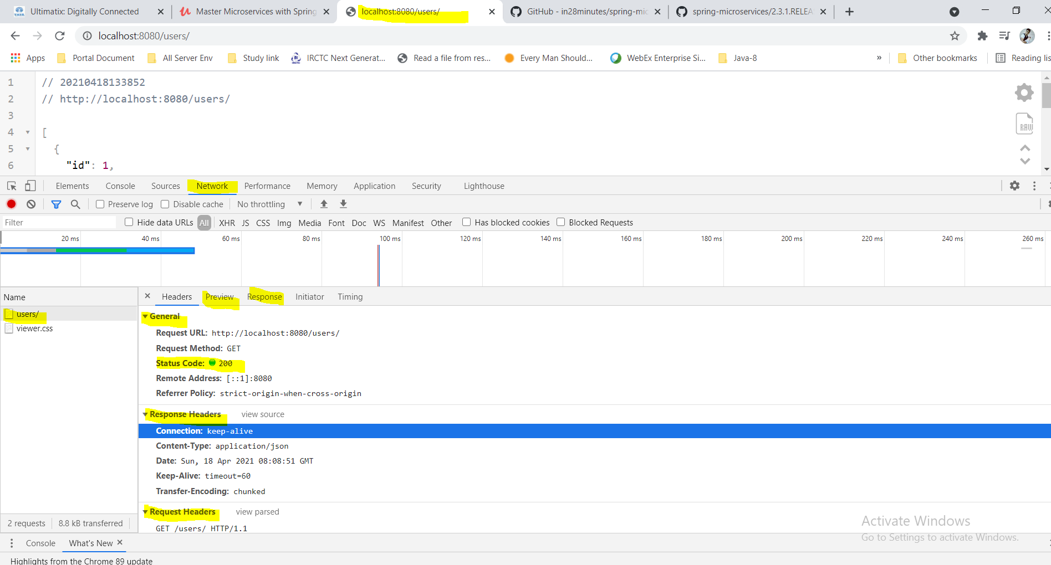

**Status code = 200 for successful**

**Step 09 - Implementing POST Method to create User Resource**

So far we have just retrieved the all the users and particular user based on id. Now here we will write method to save the new user in the list. To save the new user in the list we will use Http POST method. As per the above screen when we get successfully response then by default the status code-200 also returned.

Here in this case we have to create one new user so we have to follow the below action.

1. Provide details of the user (id, name, birthdate) as an input
2. In the output we will get response created with status code and created URI for new user
3. Here we are just creating new user and not returning anything so the return type would be void
4. Here the input parameter would be the body of the User class so to map the body of the request we will use @RequestBody

|  |  |
| --- | --- |
| **import org.springframework.web.bind.annotation.PostMapping;**  **import org.springframework.web.bind.annotation.RequestBody;**  **@RestController**  **public class UserResourceController {**  **@Autowired**  **private UserDaoService daoService;**  **@PostMapping(path = "/users")**  **public User addNewUser(@RequestBody User user) {**  **User newUser = daoService.save(user);**  **return newUser;**  **}** | For Post method default constructor is mandatory otherwise we will get error for POST request. But with the recent Jackson & Spring Boot Versions the default constructor is no longer needed and we will not see any error. So let’s create one default constructer inside User.java class  // Create Default constructor for post method in User.java  **protected** User() {  } |

1. For POST request we will use Rest client POSTMAN and from there we will send the RequestBody. Since in the service class we are setting the user id and increasing by adding +1 so in the request body we will keep only name and birthdate as given below

|  |
| --- |
| {  "name": "Rahman",  "birthDate": "2020-04-18T09:42:50.336+00:00"  } |

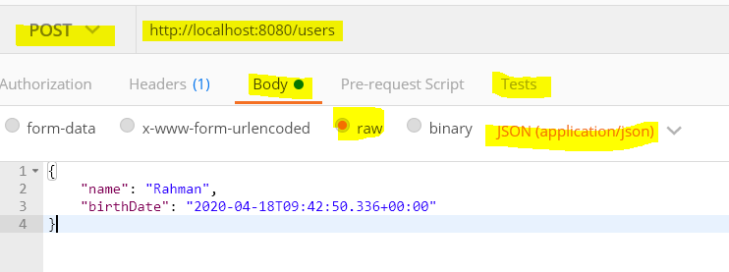

Here Http method: POST

In the body we have kept the request body in json form

Select raw and in the Tests section select JSON(application/json)

Now click on send button:

Explanation:

As soon as we send this request from POSTMAN the variable values mentioned in the Request body will be mapped to User.java variables (name and birthdate) and the same body request will be mapped to [(@RequestBody User user] user object and the same object(user) will be passed to save() method as shown in the above code.

|  |  |
| --- | --- |
| @PostMapping(path = "/users")  **public** **void** addNewUser(@RequestBody User user) {  User savedUser = daoService.save(user)  } | **public** User save(User user) {  **if**(user.getId() == **null**) {  user.setId(++*usersCount*);  }  *users*.add(user);  **return** user;  } |

Now here in the save () method the user id will be set by increasing userCount by 1. And the user request body will be added in the List and return the same user which needs to created.

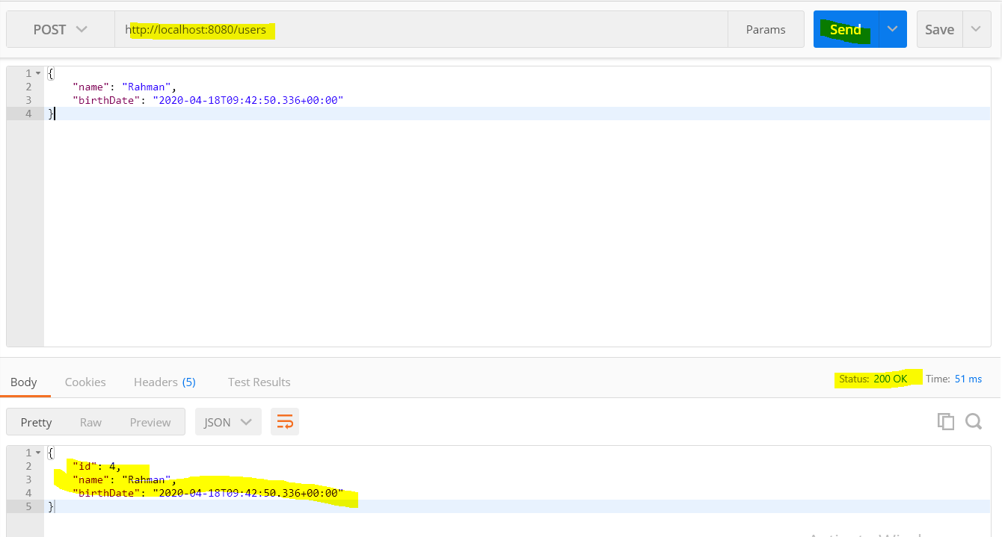 Now if we run the Get method then: We will get records with newly added user

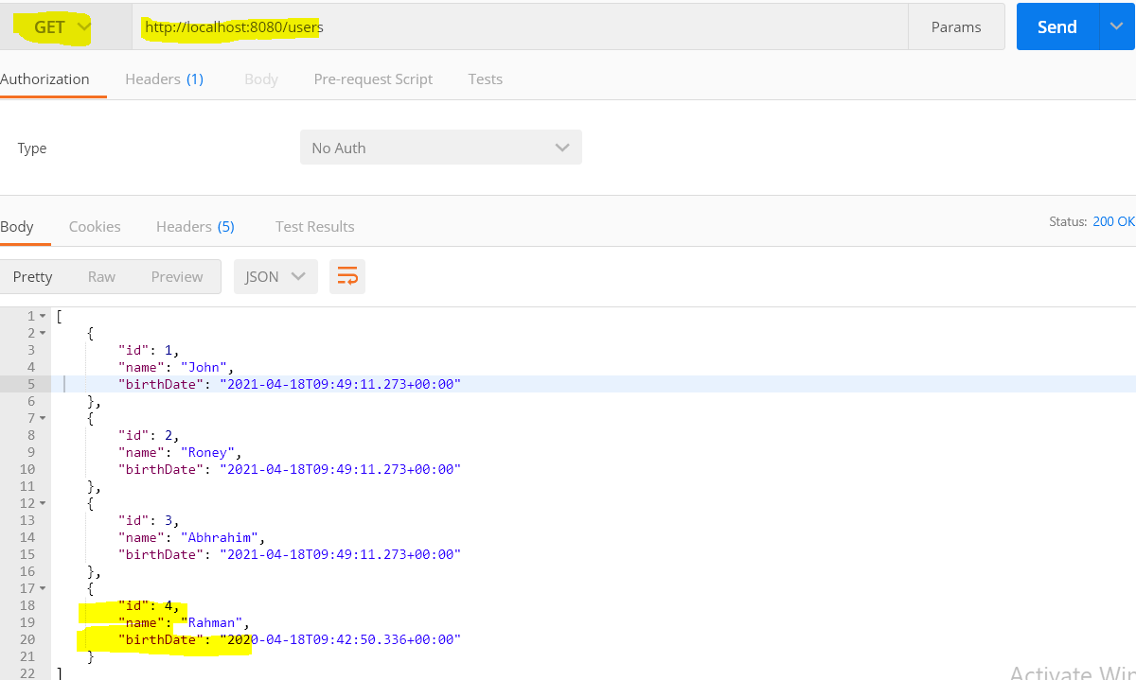

As in the above POST method once method executed successfully then we get the Http Status =200. Here in the above addNewUser method we are just returning the newly added user but if want to adhere the http standards then we need to actually respond back the status of created. As once the user is created then we want to get the detail of newly created user because we don’t know anything about newly created user like what would be the HTTP created status and what would be newly created user id. These two steps we will do in next step.

CODE BACKUP FILE : For Reference

Here's a complete code backup you can refer to if you have any problems with this section!

<https://github.com/in28minutes/spring-microservices/blob/master/02.restful-web-services/2.3.1.RELEASE-upgrade.md>

**RECOMMENDATION**: Do not forget to bookmark it.

**Step 10 - Enhancing POST Method to return correct HTTP Status Code and Location**

In the previous method we just created simple method addNewUser to save the new user in the list. We have mapped POST method to (“/users”) and use the @RequestBody to map the Request body to the User type reference parameter. Here we have not returned the status of created user and other thing the new URI that got created like (user/4) after method successfully execution. So here we will learn two things

1. How to return the status of created user
2. How to set the URI of the created resource into the response

To return the status of Created, we will use [**ResponseEntity.created (location)**]. ResponseEntity is the extenuation of HttpEntity which actually adds the status code in the response. Here in the created () method we are passing the location of new resource which was created.

So how do we create the URI for location?

For Location URI we will use [**ServeletURIComponentsBuilder. fromCurrentStatus ()**]. Here the current status is nothing but the URI of the newly created user like (“/users/4”) and the corresponding code for this URI would be [“users/ {id}”]

So now the above code for creating new use would be look as given below

|  |
| --- |
| @PostMapping(path = "/users")  **public** ResponseEntity<?> addNewUser(@RequestBody User user) {  User newUser = daoService.save(user);  // Created Status  // URI for created user /user/{id}  URI **uriLocation** = ServletUriComponentsBuilder.*fromCurrentRequestUri*().path("/{id}").buildAndExpand(newUser.getId()).toUri();  System.***out***.println("uriLocation-"+uriLocation);  ResponseEntity<?> **responseEntity**= ResponseEntity.*created*(uriLocation).build();  System.***out***.println("responseEntity-"+responseEntity);  **return** responseEntity;  //**uriLocation**-http://localhost:8080/users/4  //**responseEntity**-<201 CREATED Created,[Location:"http://localhost:8080/users/4"]>  } |

So first we have create uriLocation (Having the complete new URI for new user) and then pass this uriLocation to ResponseEntity.created(uriLocation). build().

This will return the complete information like status and newly created URI

**Note1-:**

**URI uriLocation = ServletUriComponentsBuilder.*fromCurrentRequestUri*().path("/{id}").buildAndExpand(newUser.getId()).toUri();**

**//uriLocation-http://localhost:8080/users/4**

Here the above line would create the URI (resource) for newly created user.

|  |  |
| --- | --- |
| **ServletUriComponentsBuilder.*fromCurrentRequestUri*().** | This line of code will create URI from the current resource URI i.e. it will give URI till <http://localhost:8080/users> |
| **path("/{id}").buildAndExpand(newUser.getId()).toUri()** | This line of code we are adding user id into above current resource URI using [**path("/{id**}")] and then the using [**buildAndExpand(newUser.getId**())] we are getting the newly created user id and put the result into path(“/4”). And finally converting into URI using toURI() |

Note2-

ResponseEntity<?> **responseEntity**= ResponseEntity.*created*(uriLocation).build();

//**responseEntity**-<201 CREATED Created,[Location:"http://localhost:8080/users/4"]>

The above line of code return created Http status and Resource URI for newly created user.

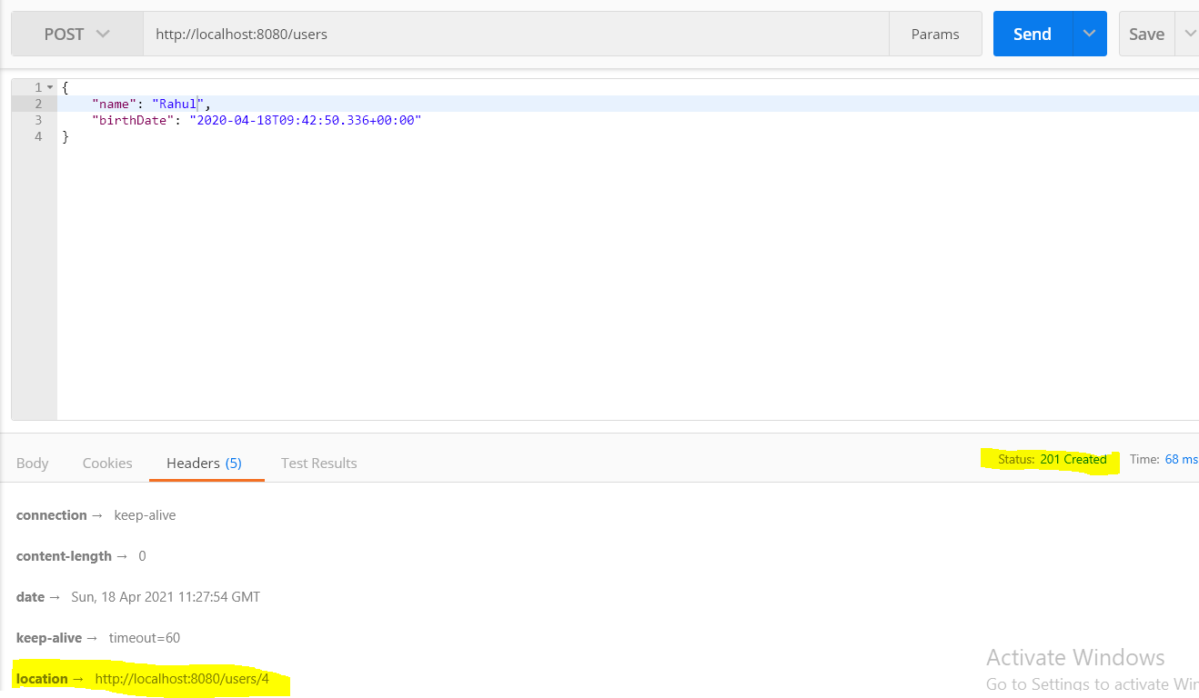

So when we create any resource then this status **201 created** are considered better http status code for POST. This **201 created** status says the request has been processed successfully and a new resource (URI) has been created. Now if we go to Headers🡺

And in the Headers section we have the newly created URILocation.

So in this way we can immediately get to know about the created status URILocation for newly created user resource. So we have got two things from the above code:

1. location →http://localhost:8080/users/4
2. status: 201 Created

**Step 11 - Implementing Exception Handling- 404 Resource Not Found**

One of key point of creating resources is that always return correct status back. In the previous step we have returned the correct status of created when we create new resource.

But what if something goes wrong like when a user not found then what should be response to return back.

For example let’s take an example in which we are providing available user and In the another example we are giving user id which is not yet created.

|  |
| --- |
|  |
|  |

So we can see that when the user id is available then we get the proper response in body while in case of user id is not available we don’t get any response body but in both the cases we have got same http status code- 200 Ok which shows successful status even though in the second request the user does not exist but we are getting successful http status code which is not really correct.

Let’s fix that first.

Let’s go inside

|  |  |
| --- | --- |
| @GetMapping(path = "/users/{id}")  **public** User retriveUser(@PathVariable **int** id) {  User findUser = daoService.findUser(id);  **return** findUser;  }  This is the earliest implementation where we are getting status 200 Ok even though user is not found.  To fix this when user is found then we will throw a new exception **throw** **new** UserNotFoundException("id-"+id);  When user is null | @GetMapping(path = "/users/{id}")  **public** User retriveUser(@PathVariable **int** id) {  User findUser = daoService.findUser(id);  **if**(findUser==**null**) {  **throw** **new** UserNotFoundException("id-"+id);  }  **return** findUser;  }  **Create class UserNotFoundException**  **package** com.in28minutes.rest.webservices.restfulwebserviceses.user;  **public** **class** UserNotFoundException **extends** RuntimeException {  //source>Generate Constructor from super class  **public** UserNotFoundException(String message) {  **super**(message);  }  } |

**Now if we hit the same get request in then we will get below error messages with passed id;**

|  |
| --- |
| {  "timestamp": "2021-04-18T14:42:15.659+00:00",  "status": 500,  "error": "**Internal Server Error",**  "path": **"/users/500"**  } |

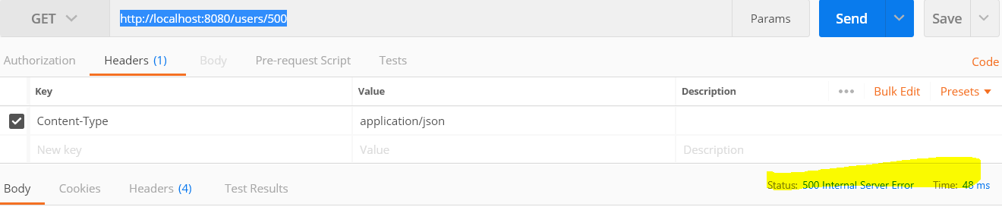

So now we are getting proper response when user is not found. And end user now can get generic information that request did not succeed which is better than earlier. But still this is not correct response because we are getting generic information Internal Server Error with generic status 500, while here message should be specific like user not found. So below is the modified code of UserNotFoundException for not found with proper status and message?

|  |
| --- |
| **package** com.in28minutes.rest.webservices.restfulwebserviceses.user;  **import** org.springframework.http.HttpStatus;  **import** org.springframework.web.bind.annotation.ResponseStatus;  **@ResponseStatus(HttpStatus.*NOT_FOUND*)**  **public** **class** UserNotFoundException **extends** RuntimeException {  //source>Generate Constructor from super class  **public** UserNotFoundException(String message) {  **super**(message);  }  }  Here we have used annotation with HttpStatus [**@ResponseStatus(HttpStatus.*NOT_FOUND*)]** |

Now if run the same Get request with not available user id then we will get proper response for not found

|  |
| --- |
| {  "timestamp": "2021-04-18T14:58:22.984+00:00",  **"status": 404,**  "**error": "Not Found",**  "message": "id-400",  "path": "/users/400"  } |

Now this is the correct error response when user id not found. This error handling is provided by default by (spring boot + Spring MVC) framework. So spring boot does auto configuration for handling default error handling like this.

Note: We should have consistent message from all the services for same type error or exception inside any organization application. So if not found occurs in any other services then every where the error or exception response should be same or consistent it should be different.

**Step 12 - Implementing Generic Exception Handling for all Resources**

In the previous step we have learnt how to get the default error response for user not found, provided by spring boot. But in any organization they create their own error or exception response instead of using default error response.

Here in this step we will create a standard structure for error or exception response.

|  |  |
| --- | --- |
| **package** com.in28minutes.rest.webservices.restfulwebserviceses.user;  **import** java.util.Date;  **public** **class** ExceptionResponse {  **private** Date timeStamp;  **private** String message;  **private** String details;  **public** ExceptionResponse(Date timeStamp, String message, String details) {  **super**();  **this**.timeStamp = timeStamp;  **this**.message = message;  **this**.details = details;  }  **public** Date getTimeStamp() {  **return** timeStamp;  }  **public** String getMessage() {  **return** message;  }  **public** String getDetails() {  **return** details;  }  } | Here we have created one class **ExceptionResponse** with three variables;  These will be used in creating standard structure for exception response.  Create parameterized constructer getters and setters.  Now this structure (class variable) will be used across all the services as a customized standard structure and most importantly this must be language independent and whenever any exception occurs then exception response should be displayed in this standard structure.  To do that we will use one of the classes present in the spring is [**ResponseEntityExceptionHandler**] class. This is an abstract class which will be extended to provide centralized |

|  |
| --- |
| **public** **abstract** **class** ResponseEntityExceptionHandler;  A convenient base class for {@link ControllerAdvice @ControllerAdvice} classes  * that provide centralized exception handling across all  * {@code @RequestMapping} methods through {@code @ExceptionHandler} methods.  *  * <p>This base class provides an {@code @ExceptionHandler} method for handling  * internal Spring MVC exceptions. |

**ResponseEntityExceptionHandler** class we can extend to provide our customized exception handling for all request.

The next thing is to apply this Exception Handler to all controllers and for this we will use to annotation **@RestController** and another is **@ControllerAdvice** (It is use to make the Exception Handler class to be applicable or to be shared across all the controller classes in the application.)

|  |
| --- |
| @ControllerAdvice  Specialization of {@link Component @Component} for classes that declare  * {@link ExceptionHandler @ExceptionHandler} for customized exception handling,  * {@link InitBinder @InitBinder} for date, or  * {@link ModelAttribute @ModelAttribute} methods to be shared across  * Multiple {@code @Controller} classes. |

So when we want share a particular class feature with across all the classes (like Controller classes) then we will **@ControllerAdvice** annotation.

**ResponseEntityExceptionHandler** class contains below method which we will override in our custom Exception Handler class

**public final ResponseEntity<Object> handleException(Exception ex, WebRequest request) throws Exception {}**

|  |
| --- |
| **package com.in28minutes.rest.webservices.restfulwebserviceses.exception;**  **import java.util.Date;**  **import org.springframework.http.HttpStatus;**  **import org.springframework.http.ResponseEntity;**  **import org.springframework.web.bind.annotation.ControllerAdvice;**  **import org.springframework.web.bind.annotation.ExceptionHandler;**  **import org.springframework.web.bind.annotation.RestController;**  **import org.springframework.web.context.request.WebRequest;**  **import org.springframework.web.servlet.mvc.method.annotation.ResponseEntityExceptionHandler;**  **@ControllerAdvice**  **@RestController**  **public class CustomizedResponseEntityExceptionHandler extends ResponseEntityExceptionHandler {**    **@ExceptionHandler(Exception.class)**  **public final ResponseEntity<Object> handleAllException(Exception ex, WebRequest request) throws Exception {**  **ExceptionResponse exceptionResponse = new ExceptionResponse(new Date(), ex.getMessage(), request.getDescription(false));**  **return new ResponseEntity<Object>(exceptionResponse,HttpStatus.*NOT_ACCEPTABLE*);**  **}**  **}**  **// Now we have define default exception for all the things and we are creating exception response(exceptionResponse) in our own structure** |

Step-1: Created **CustomizedResponseEntityExceptionHandler** and extends **ResponseEntityExceptionHandler** class

Step-2: override this method

Public final ResponseEntity<Object> handleAllException (Exception ex, WebRequest request) throws Exception {}

Step-3: Set our customized message in our own created structure class by using parameterized constructor

Step-4: pass the exceptionResponse and HttpStatus into ResponseEntity and return the same

**@ExceptionHandler(Exception.class) //**Annotation for handling exceptions in specific handler classes and/or handler methods.

Now if we try to execute the[**http://localhost:8080/users/500**](http://localhost:8080/users/500)then we will get our own customized exception response:

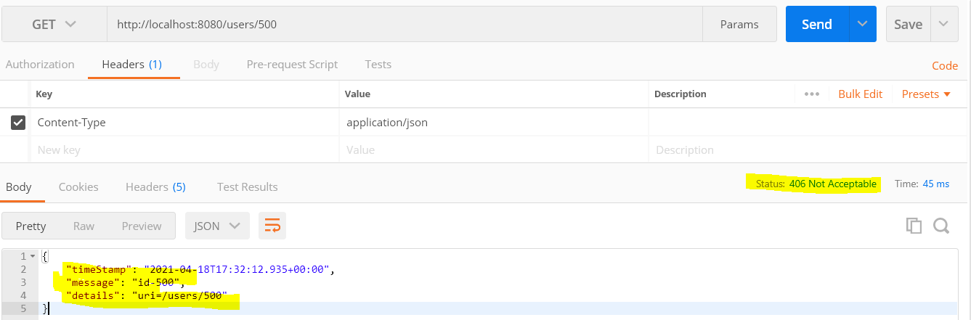

Now we have got our own customized exception response.

Let’s implement some other specific method:

|  |
| --- |
| **package com.in28minutes.rest.webservices.restfulwebserviceses.exception;**  **import java.util.Date;**  **import org.springframework.http.HttpStatus;**  **import org.springframework.http.ResponseEntity;**  **import org.springframework.web.bind.annotation.ControllerAdvice;**  **import org.springframework.web.bind.annotation.ExceptionHandler;**  **import org.springframework.web.bind.annotation.RestController;**  **import org.springframework.web.client.HttpClientErrorException.BadRequest;**  **import org.springframework.web.context.request.WebRequest;**  **import org.springframework.web.servlet.mvc.method.annotation.ResponseEntityExceptionHandler;**  **import com.in28minutes.rest.webservices.restfulwebserviceses.user.UserNotFoundException;**  **@ControllerAdvice**  **@RestController**  **public class CustomizedResponseEntityExceptionHandler extends ResponseEntityExceptionHandler {**  **// Generic exception for all type**  **@ExceptionHandler(Exception.class)**  **public final ResponseEntity<Object> handleAllException(Exception ex, WebRequest request) throws Exception {**  **ExceptionResponse exceptionResponse = new ExceptionResponse(new Date(), ex.getMessage(), request.getDescription(false));**  **return new ResponseEntity<Object>(exceptionResponse,HttpStatus.*INTERNAL_SERVER_ERROR*);**  **}**    **// Specific exception for user not found for UserNotFoundException class**  **@ExceptionHandler(UserNotFoundException.class)**  **public final ResponseEntity<Object> handleUserNotFoundException(UserNotFoundException ex, WebRequest request) throws Exception {**  **ExceptionResponse exceptionResponse = new ExceptionResponse(new Date(), ex.getMessage(), request.getDescription(false));**  **return new ResponseEntity<Object>(exceptionResponse,HttpStatus.*NOT_FOUND*);**  **}**  **// Specific exception for user not found**  **@ExceptionHandler(BadRequest.class)**  **public final ResponseEntity<Object> handleUnknowException(Exception ex, WebRequest request) throws Exception {**  **ExceptionResponse exceptionResponse = new ExceptionResponse(new Date(), ex.getMessage(), request.getDescription(false));**  **return new ResponseEntity<Object>(exceptionResponse,HttpStatus.*BAD_REQUEST*);**  **}**  **}// Now we have define default exception for all the things and we are creating exception response(exceptionResponse) in our own structure** |

In this way we can implement our own customized exception and display the exception response in our own format or structure.

**Step 13 - Exercise: User Post Resource and Exception Handling**

**Step 14 - Implementing DELETE Method to delete a User Resource**

In this step we will add the mapping for Delete resource.

Step1- Create Delete method in the UserDaoService component class.

|  |  |
| --- | --- |
| //Method to delete user  **public** User deleteById(**int** id) {  Iterator<User> itr = *users*.iterator();  **while** (itr.hasNext()) {  User user = itr.next();  **if** (user.getId() == id) {  itr.remove();  **return** user;  }  }  **return** **null**;  } | //Consuming the Delete method from UserDaoService class  // First approach  @DeleteMapping(path="/user/{id}")  **public** User deleteUser(@PathVariable **int** id) {  User deleteById = daoService.deleteById(id);  **return** deleteById;  } |

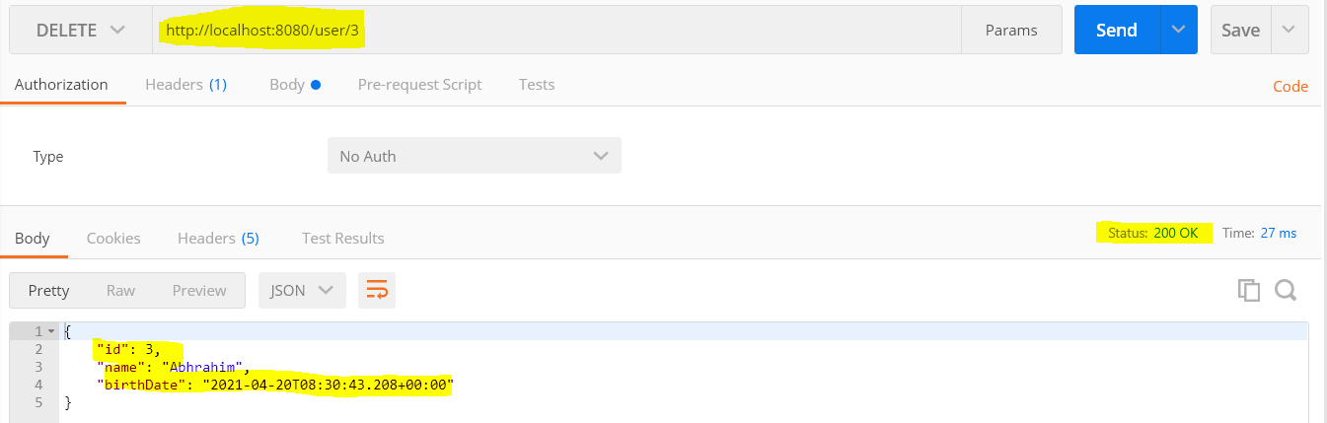

1. Execute this Delete mapping <http://localhost:8080/user/3>
2. It delete the User having id=3 and returned the same deleted user detail with Http status 200 OK

**Note** if we delete the same deleted user once again then it will not return the deleted user detail but we will get Http status 200 Ok which is not correct. So like in case find user earlier it was returning Http Status 200 Ok even though the user was not available. So here also if we try to delete the user which is not available then it should return 404 and user not found error response. So in the above code we will throw an exception.

|  |  |
| --- | --- |
| **//Method to delete user**  **// Second approach with new exception**  **@DeleteMapping(path="/user/{id}")**  **public User deleteUser(@PathVariable int id) {**  **User deleteById = daoService.deleteById(id);**  **if(deleteById==null) {**  **throw new UserNotFoundException("id-" + id);**  **}**  **return deleteById;**  **}**  **}** |  |

**Now when we try to delete already deleted user then now we are getting error/ exception response and now instead of getting default http status 200 OK now we are getting Http Status 404 Not Found.**

**Note: Apart from that we can create a Response Entity and return a status of No content.**

|  |
| --- |
| //Method to delete user  // Second approach with new exception  @DeleteMapping(path="/users/{id}")  **public** ResponseEntity<?> deleteExistUser(@PathVariable **int** id) {    User deleteById = daoService.deleteById(id);  **if**(deleteById==**null**) {  **throw** **new** NoContentException("id-" + id);  }  URI uriLocation = ServletUriComponentsBuilder.*fromCurrentRequestUri*().path("/{id}")  .buildAndExpand(deleteById.getId()).toUri();  System.***out***.println("uriLocation-" + uriLocation);  ResponseEntity<?> responseEntity = ResponseEntity.*noContent*().build();  System.***out***.println("responseEntity-" + responseEntity);  **return** responseEntity;  //uriLocation-http://localhost:8080/users/4/4  //responseEntity-<204 NO_CONTENT No Content,[]>  } |

**Now if we delete the deleted user then we will get Http status 204 No Content.**

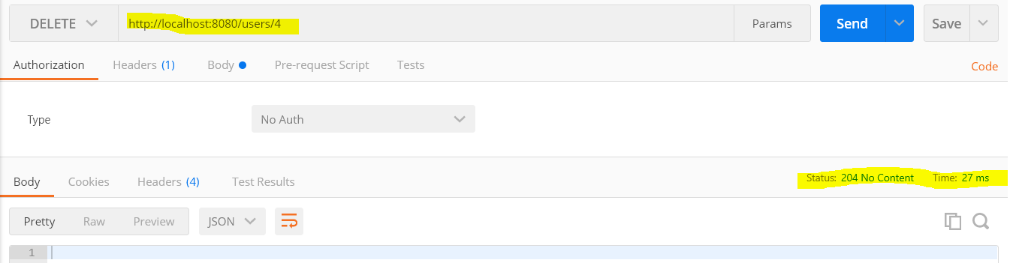

|  |
| --- |
| **@PostMapping(path = "/users"): ResponseEntity in case of PostMapping**  uriLocation-http://localhost:8080/users/4  responseEntity-<201 CREATED Created,[Location:"http://localhost:8080/users/4"]> |
| **@DeleteMapping(path="/users/{id}"): ResponseEntity in case of DeleteMapping**    uriLocation-http://localhost:8080/users/4/4  responseEntity-<204 NO_CONTENT No Content,[]> |

COURSE UPDATE : Add dependency spring-boot-starter-validation

If you are making use of Spring Boot Release (> 2.3.0) make sure to add the following dependency to your pom.xml (We are going to implement validations in next step):

<dependency>

<groupId>org.springframework.boot</groupId>

<artifactId>spring-boot-starter-validation</artifactId>

</dependency>

**RECOMMENDATION**

Stop and start your server again after adding the dependency.

**If you are of the curious kind:**

Here's the reason you need to add the dependency - <https://github.com/spring-projects/spring-boot/issues/19550>

**Step 15 - Implementing Validations for RESTful Services**

So far we have implemented the following services as shown above.

1. Receive User
2. Create User
3. Find User
4. Delete User

Now we will implement validation for these services.

Here we are going to do validation like web development where an error or warning message gets displayed when any field’s validation error occurs.

Here we in Rest services Validation are quite common requirement in all the services. Here we will Java validation API for validation of our beans (like User.java).

For example in Create user service we will validate the content (Request body) and in case of invalid content we will respond proper meaningful response.

|  |
| --- |
| **Step-1**  **Add the below dependency for validation**  <dependency>  <groupId>org.springframework.boot</groupId>  <artifactId>spring-boot-starter-validation</artifactId>  </dependency> |

|  |  |
| --- | --- |
| Step-2 include - @Valid before @RequestBody | Step-3 Include validation at bean variable level |
| **@PostMapping(path = "/users")**  **public ResponseEntity<?> addNewUser(@Valid @RequestBody User user) {** | **import javax.validation.constraints.Past;**  **import javax.validation.constraints.Size;**  **public class User {**  **private Integer id;**    **@Size(min=4)**  **private String name;**  **@Past**  **private Date birthDate;** |

Now if execute the Post request and provide the String name min=4 and past birth date then we will not get any problem and we will get http status 201 created and one new user will be created. But let’s say if we keep name length less than 4 we will get- Status: 400 Bad Request

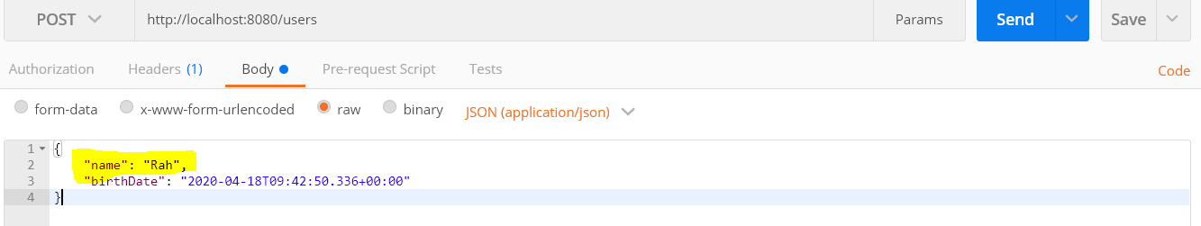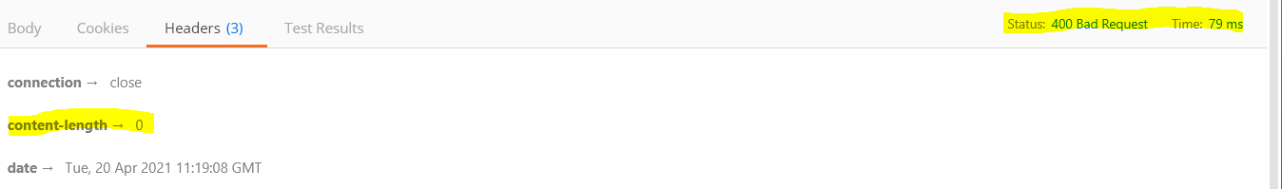

Here we have passed name less than 4 that is why we are getting 400 Bad Request. So the good thing we are validating it but the Http Status is not user friendly because here we are not able the get the why this Bad request is come because here the consumer not able to identify what value is being sent wrong.

So now we will add message so that consumer is able to get the proper information about wrong input.

How to add user friendly message for wrong input:

Answer: As we have already created **CustomizedResponseEntityExceptionHandler** class and in this class only we will include the code for message.

So for this we will override one method from the extended class ResponseEntityExceptionHandler which name is handleMethodArgumentNotValid

|  |
| --- |
| **/\*\***  **\* Customize the response for MethodArgumentNotValidException.**  **\* <p>This method delegates to {@link #handleExceptionInternal}.**  **\* @param ex the exception**  **\* @param headers the headers to be written to the response**  **\* @param status the selected response status**  **\* @param request the current request**  **\* @return a {@code ResponseEntity} instance**  **\*/**  **protected ResponseEntity<Object> handleMethodArgumentNotValid(**  **MethodArgumentNotValidException ex, HttpHeaders headers, HttpStatus status, WebRequest request) {**  **return handleExceptionInternal(ex, null, headers, status, request);**  } |

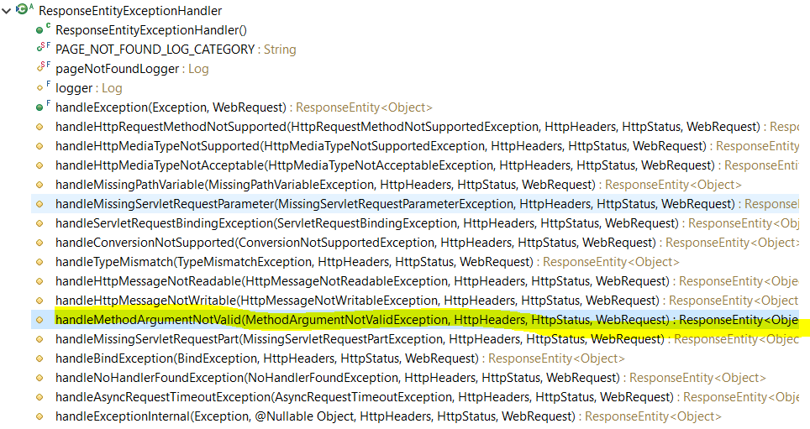

So we will override this method in our **CustomizedResponseEntityExceptionHandler class** and this method will be invoked when a binding to a specific method argument fails. So in the above example using **@Valid annotation** we are binding **User class** object variables (name and **birthdate)**

|  |
| --- |
| **@ControllerAdvice**  **@RestController**  **public class CustomizedResponseEntityExceptionHandler extends ResponseEntityExceptionHandler {**  **@Override**  **protected ResponseEntity<Object> handleMethodArgumentNotValid(**  **MethodArgumentNotValidException ex, HttpHeaders headers, HttpStatus status, WebRequest request) {**    **ExceptionResponse exceptionResponse = new ExceptionResponse(new Date(), ex.getMessage(),ex.getBindingResult().toString());**  **//request.getDescription(false)**  **//return handleExceptionInternal(ex, null, headers, status, request);**  **return new ResponseEntity<Object>(exceptionResponse,HttpStatus.*BAD_REQUEST*);**  **}**  **}** |

**We have added this [ex.getBindingResult().toString()] at the place of [request.getDescription(false)] this will contains all the binding results to be displayed. Now let’s execute PostMapping request in POSTMAN.**

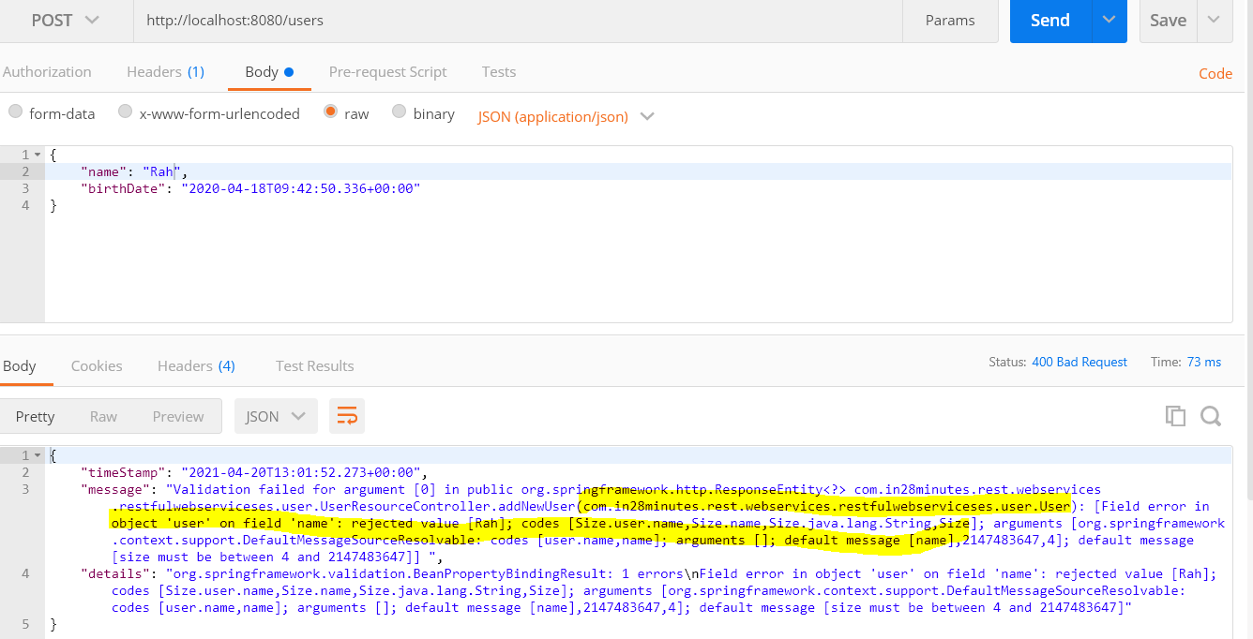

|  |
| --- |
| **{**  **"timeStamp": "2021-04-20T13:01:52.273+00:00",**  **"message": "Validation failed for argument [0] in public org.springframework.http.ResponseEntity<?> com.in28minutes.rest.webservices.restfulwebserviceses.user.UserResourceController.addNewUser(com.in28minutes.rest.webservices.restfulwebserviceses.user.User): [Field error in object 'user' on field 'name': rejected value [Rah]; codes [Size.user.name,Size.name,Size.java.lang.String,Size]; arguments [org.springframework.context.support.DefaultMessageSourceResolvable: codes [user.name,name]; arguments []; default message [name],2147483647,4]; default message [size must be between 4 and 2147483647]] ",**  **"details": "org.springframework.validation.BeanPropertyBindingResult: 1 errors\nField error in object 'user' on field 'name': rejected value [Rah]; codes [Size.user.name,Size.name,Size.java.lang.String,Size]; arguments [org.springframework.context.support.DefaultMessageSourceResolvable: codes [user.name,name]; arguments []; default message [name],2147483647,4]; default message [size must be between 4 and 2147483647]"**  **}** |

So now we have got message for that particular invalid input filed. But we are sending a lot of other detail to the consumer which is not correct. So send the specific message we will customize the message for that instead of including [**ex.getMessage()**] we will write specific message like [Validation failed]

|  |
| --- |
| **@Override**  **protected ResponseEntity<Object> handleMethodArgumentNotValid(**  **MethodArgumentNotValidException ex, HttpHeaders headers, HttpStatus status, WebRequest request) {**    **//ExceptionResponse exceptionResponse = new ExceptionResponse(new Date(), ex.getMessage(), request.getDescription(false));**  **ExceptionResponse exceptionResponse = new ExceptionResponse(new Date(), "Validation filed ",ex.getBindingResult().toString());**    **//return handleExceptionInternal(ex, null, headers, status, request);**  **return new ResponseEntity<Object>(exceptionResponse,HttpStatus.*BAD_REQUEST*);**  **}** |

Now if we execute PostMapping request then we will get only the message we have written in the exception Response constructor.

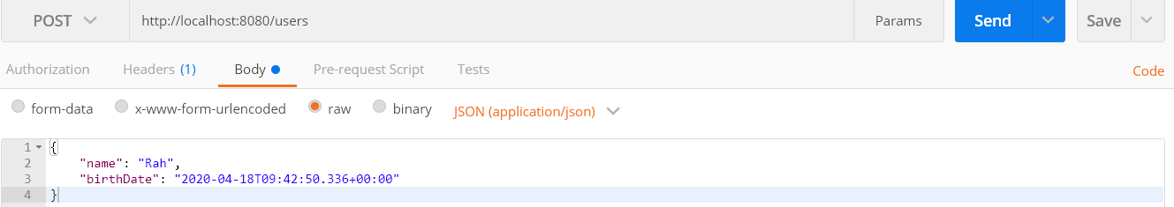

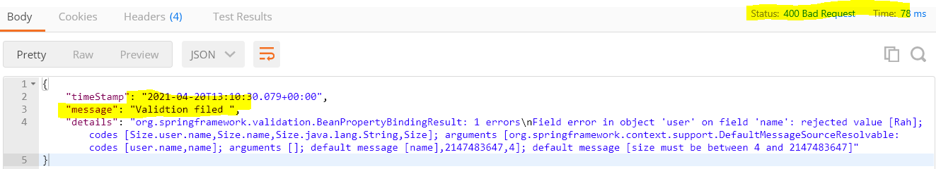

So as we can see that we are now getting only Validation filed and below that we are getting detail for the same.

|  |  |
| --- | --- |
| {  **"timeStamp": "2021-04-20T13:10:30.079+00:00",**  **"message": "Validtion filed ",**  **"details": "org.springframework.validation.BeanPropertyBindingResult: 1 errors\nField error in object 'user' on field 'name': rejected value [Rah]; codes [Size.user.name,Size.name,Size.java.lang.String,Size]; arguments [org.springframework.context.support.DefaultMessageSourceResolvable: codes [user.name,name]; arguments []; default message [name],2147483647,4]; default message [size must be between 4 and 2147483647]"**  } | |
| **public class User {**  **private Integer id;**    **@Size(min=4, message="name should have atlest 4 character")**  **private String name;**  **@Past(message="Birth Date should not be future date")**  **private Date birthDate;**  **}** | Now one more small change at the User class name variable so that we could get specific user defined error message |

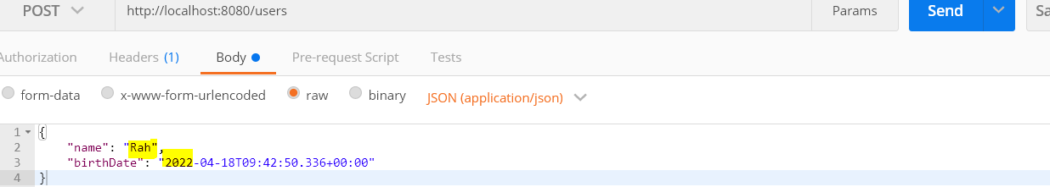

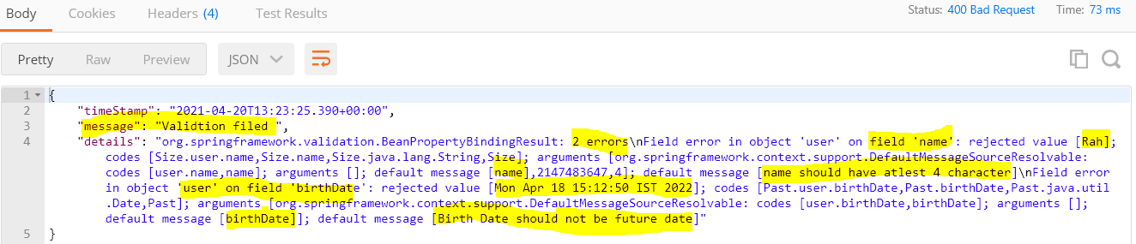

|  |
| --- |
| {  "timeStamp": "2021-04-20T13:23:25.390+00:00",  "message": "Validtion filed ",  "details": "org.springframework.validation.BeanPropertyBindingResult: 2 errors\nField error in object 'user' on field 'name': rejected value [Rah]; codes [Size.user.name,Size.name,Size.java.lang.String,Size]; arguments [org.springframework.context.support.DefaultMessageSourceResolvable: codes [user.name,name]; arguments []; default message [name],2147483647,4]; **default message** [name should have atlest 4 character]\nField error in object 'user' on field 'birthDate': rejected value [Mon Apr 18 15:12:50 IST 2022]; codes [Past.user.birthDate,Past.birthDate,Past.java.util.Date,Past]; arguments [org.springframework.context.support.DefaultMessageSourceResolvable: codes [user.birthDate,birthDate]; arguments []; default message [birthDate]]; **default message** [Birth Date should not be future date]"  } |

All the above validation is present in java Validation API it contains other validation classes

|  |  |
| --- | --- |
|  |  |

Apart from Size we have classes like Min, Max, Null, Email, Like Past we have Future class for future date, Pattern for defining specific pattern and etc.

So JAVA API validation defines most popular implementation of validation used in any application.

Apart from this Java API validation most popular validation API is Hibernate Validation API and it implements all the things what we have Java API validation.

|  |  |
| --- | --- |
|  |  |

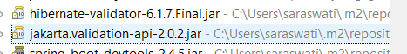

We are getting these two validation api as the part of Spring boot starter web and most interesting part is we don’t need to do any configuration for validation, we just need to use @Valid for the bean class which needs to be validated.

**COURSE UPDATE : HATEOAS Updates**

**VERSION UPDATES FOR NEXT LECTURE**

**There are a few modifications of HATEOAS in the latest release of Spring HATEOAS 1.0.0:**

#### Option 1 : Spring Boot Release >= 2.2.0

**Complete code:**[**https://github.com/in28minutes/spring-microservices/blob/master/02.restful-web-services/2.3.1.RELEASE-upgrade.md#srcmainjavacomin28minutesrestwebservicesrestfulwebservicesuseruserresourcejava**](https://github.com/in28minutes/spring-microservices/blob/master/02.restful-web-services/2.3.1.RELEASE-upgrade.md#srcmainjavacomin28minutesrestwebservicesrestfulwebservicesuseruserresourcejava)

|  |
| --- |
| **import static org.springframework.hateoas.server.mvc.WebMvcLinkBuilder.linkTo;**  **import static org.springframework.hateoas.server.mvc.WebMvcLinkBuilder.methodOn;**  **import org.springframework.hateoas.EntityModel;**  **import org.springframework.hateoas.server.mvc.WebMvcLinkBuilder;**    **@RestController**  **public class UserJPAResource {**    **@GetMapping("/users/{id}")**  **public EntityModel<User> retrieveUser(@PathVariable int id) {**  **User user = service.findOne(id);**  **if(user==null)**  **throw new UserNotFoundException("id-"+ id);**  **//"all-users", SERVER_PATH + "/users"**  **//retrieveAllUsers**  **EntityModel<User> resource = EntityModel.of(user);**  **WebMvcLinkBuilder linkTo =linkTo(methodOn(this.getClass()).retrieveAllUsers());**  **resource.add(linkTo.withRel("all-users"));**  **//HATEOAS**  **return resource;**  **}** |
| Option 2: Older versions  **import static org.springframework.hateoas.mvc.ControllerLinkBuilder.linkTo;**  **import static org.springframework.hateoas.mvc.ControllerLinkBuilder.methodOn;**  **import org.springframework.hateoas.Resource;**  **import org.springframework.hateoas.mvc.ControllerLinkBuilder;**    **Resource<User> resource = new Resource<User>(user);**  **ControllerLinkBuilder linkTo = linkTo(methodOn(this.getClass()).retrieveAllUsers());**  **resource.add(linkTo.withRel("all-users"));**  **return resource;** |

**Step 16 - Implementing HATEOAS (Hyper-Media-As-The-Engine-Of-Application-State) for RESTful Services**

Until new in the last few steps we have created new resources and perform different operations on the resources like (Get, Delete, and Post). Until now we have called URI on Get method and we have got data back if we have called the URI of particular user id on Get method then we have got the data for the specific user.

Now let’s us think in terms of web application, where we can have different kinds of link for different kind of action and details. The same concept we can user here in case of Restful services. For example when we ask for a particular user using URI (<http://localhost:8080/users/1> ) On Get method then along with particular user we can get the link which can provide all the users detail. This concept calls HATEOAS (**H**yper-**M**edia-**A**s-**T**he-**E**ngine-**O**f-**A**pplication-**S**tate).

So now we will implement HATEOS in one of the resources (ex. retriveUser ())

|  |  |
| --- | --- |
| **Without HATEOAS** |  |
| **@GetMapping(path = "/users/{id}")**  **public User retriveUser(@PathVariable int id) {**  **User findUser = daoService.findById(id);**  **if (findUser == null) {**  **throw new UserNotFoundException("id-" + id);**  **}**  **// Implement HATEOAS here**  **return findUser;**  **}** | So here we return the particular user detail then we would return link which will have all User’s detail. |

Step-1: Add HATEOAS dependency in the POM.xml to enable HATEOAS link in the Service

|  |
| --- |
| <!-- HATEOAS -->  <dependency>  <groupId>org.springframework.boot</groupId>  <artifactId>spring-boot-starter-**hateoas**</artifactId>  </dependency>  <!-- HATEOAS --> |

Step-2: Create a Resource from HATEOAS of User class and enable the link using ControllerLinkBuilder class using linkTo static method.

<https://www.javatpoint.com/restful-web-services-hateoas>

In Complete Need to complete later.

COURSE UPDATE : USE SWAGGER 3.0.0 for Spring Boot 2.2+

**If you are using Spring Boot Version >= 2.2, we recommend using SpringFox Swagger version 3.0.0.**

**NEW URL for SWAGGER UI - http://localhost:8080/swagger-ui/ or http://localhost:8080/swagger-ui/index.html**

**Example pom.xml with the changes here -**[**https://github.com/in28minutes/spring-microservices/blob/master/02.restful-web-services/2.3.1.RELEASE-upgrade.md#pomxml**](https://github.com/in28minutes/spring-microservices/blob/master/02.restful-web-services/2.3.1.RELEASE-upgrade.md#pomxml)

**Example SwaggerConfig with the changes here -**[**https://github.com/in28minutes/spring-microservices/blob/master/02.restful-web-services/2.3.1.RELEASE-upgrade.md#srcmainjavacomin28minutesrestwebservicesrestfulwebservicesswaggerconfigjava**](https://github.com/in28minutes/spring-microservices/blob/master/02.restful-web-services/2.3.1.RELEASE-upgrade.md#srcmainjavacomin28minutesrestwebservicesrestfulwebservicesswaggerconfigjava)

**Add these dependencies to pom.xml instead of the two swagger dependencies.**

**<dependency>**

**<groupId>io.springfox</groupId>**

**<artifactId>springfox-boot-starter</artifactId>**

**<version>3.0.0</version>**

**</dependency>**

**Step 20 - Configuring Auto Generation of Swagger Documentation**

So far we have created several services and let’s say we have to share a document of these services which contain all the information about contract, endpoint, operation detail and its parameter. In case of SAOP services we have WSDL which contains all the information about the service in detail, but in case of Rest services we don’t have any such kind of thing.

So here we will configure Swagger, which is one of popular documentation format for Restful Services. In this step we will look how to document our services using swagger.

Step-1: Add dependency as given below.

|  |
| --- |
| **Note: If you are using Spring Boot Version >= 2.2, we recommend using SpringFox Swagger version 3.0.0.**  **Add this dependencies to pom.xml instead of the old two swagger dependencies.**  <!-- Swagger -->  <dependency>  <groupId>io.springfox</groupId>  <artifactId>springfox-boot-starter</artifactId>  <version>3.0.0</version>  </dependency>  <!-- Swagger -->  **NEW URL for SWAGGER UI** - http://localhost:8080/swagger-ui/ or http://localhost:8080/swagger-ui/index.html |
| **Note: Deprecated Dependencies for Swagger:**  <!-- Swagger -->  <dependency>  <groupId>io.springfox</groupId>  <artifactId>springfox-swagger2</artifactId>  <version>2.4.0</version>  </dependency>  <dependency>  <groupId>io.springfox</groupId>  <artifactId>springfox-swagger2-ui</artifactId>  <version>2.4.0</version>  </dependency>  <!-- Swagger -->  **Note: URI To OPEN swagger UI in older deprecated dependency for swagger:**  <http://localhost:8080/swagger-ui.html> |

**Note:** @~~EnableSwagger2WebMvc is deprecated and now use~~ **@EnableSwagger2**

**Create a class for configuring Swagger doc and swagger ui.**

Step1- Created one class with the name **[**SwaggerConfig**]** and annotated with @Configuration, @EnableSwagger2

|  |
| --- |
| @Configuration // Used to tell the spring boot that it is bean class and configure automatically  @EnableSwagger2 // Enables this class as swagger configuration class  **public** **class** SwaggerConfig {  } |

Step2- Define a Bean Docket and in this bean we would configure application information, Documentation Type, Service Producer/Consumer data format.

|  |
| --- |
| **@Bean**  **public Docket api() {**    **return new Docket(DocumentationType.*SWAGGER_2*)**  **.apiInfo(*DEFAULT_API_INFO*)**  **.produces(*DEFAULT_PRODUCES_AND_CONSUMES*)**  **.consumes(*DEFAULT_PRODUCES_AND_CONSUMES*);**  **}** |

**Docket: A builder which is the primary interface into the Springfox framework. Provides sensible defaults methods for configuration.**

**Step3- Let’s Define DEFAULT_API_INFO using SpringFox ApiInfo constructor.**

|  |
| --- |
| **public static final Contact *DEFAULT_CONTACT* = new Contact(**  **"ArunKumarGupta", "http://www.in28minutes.com", "imarungupta@gmail.com");**  **public static final ApiInfo *DEFAULT_API_INFO* = new ApiInfo(**  **"Users API Title", "Users API Description", "1.0",**  **"urn:tos", *DEFAULT_CONTACT*,**  **"Apache 2.0", "http://www.apache.org/licenses/LICENSE-2.0", Arrays.*asList*());** |

Step4-:

Now let’s define the Service default consumer and producer type format whether it is in JSON or XML or both.

Full Code:

|  |
| --- |
| package com.in28minutes.rest.webservices.restfulwebserviceses.user;  import java.util.Arrays;  import java.util.HashSet;  import java.util.Set;  import org.springframework.context.annotation.Bean;  **import org.springframework.context.annotation.Configuration;**  import springfox.documentation.service.ApiInfo;  import springfox.documentation.service.Contact;  import springfox.documentation.spi.DocumentationType;  import springfox.documentation.spring.web.plugins.Docket;  **import springfox.documentation.swagger2.annotations.EnableSwagger2;**  import springfox.documentation.swagger2.annotations.EnableSwagger2WebMvc;  @Configuration  @EnableSwagger2  public class SwaggerConfig {  **public** **static** **final** Contact ***DEFAULT_CONTACT*** = **new** Contact(  "ArunKumarGupta", "http://www.in28minutes.com", "imarungupta@gmail.com");  **public** **static** **final** ApiInfo ***DEFAULT_API_INFO*** = **new** ApiInfo(  "Users API Title", "Users API Description", "1.0",  "urn:tos", ***DEFAULT_CONTACT***,  "Apache 2.0", "http://www.apache.org/licenses/LICENSE-2.0", Arrays.*asList*());  **private static final Set<String> *DEFAULT_PRODUCES_AND_CONSUMES* = new HashSet<String>();**  **// Or private static final Set<String> DEFAULT_PRODUCES_AND_CONSUMES1 = new HashSet<String>(Arrays.asList("application/json","application/xml"));**  **//**  **@Bean**  **public Docket api() {**  ***DEFAULT_PRODUCES_AND_CONSUMES*.add("application/json");**  ***DEFAULT_PRODUCES_AND_CONSUMES*.add("application/xml");**  ***DEFAULT_PRODUCES_AND_CONSUMES*.add("ABC");**  **return new Docket(DocumentationType.*SWAGGER_2*)**  **.apiInfo(*DEFAULT_API_INFO*)**  **.produces(*DEFAULT_PRODUCES_AND_CONSUMES*)**  **.consumes(*DEFAULT_PRODUCES_AND_CONSUMES*);**  **}**  **}** |

**Now to check the above configuration that we have configured above use below URL:**

[**http://localhost:8080/v2/api-docs**](http://localhost:8080/v2/api-docs)

|  |  |
| --- | --- |
| **{**  **"swagger": "2.0",**  **"info": {**  **"description": "Users API Description",**  **"version": "1.0",**  **"title": "Users API Title",**  **"termsOfService": "urn:tos",**  **"contact": {**  **"name": "ArunKumarGupta",**  **"url": "http://www.in28minutes.com",**  **"email": "imarungupta@gmail.com"**  **},**  **"license": {**  **"name": "Apache 2.0",**  **"url": "http://www.apache.org/licenses/LICENSE-2.0"**  **}**  **},** | **"host": "localhost:8080",**  **"basePath": "/",**  **"tags": [**  **{**  **"name": "basic-error-controller",**  **"description": "Basic Error Controller"**  **},**  **{**  **"name": "hello-world-controller",**  **"description": "Hello World Controller"**  **},**  **{**  **"name": "user-resource-controller",**  **"description": "User Resource Controller"**  **}**  **],**  **"consumes": [**  **"ABC",**  **"application/json",**  **"application/xml"**  **],**  **"produces": [**  **"ABC",**  **"application/json",**  **"application/xml"**  **],** |

**Now we can see all the information**

**Apart from this we can see all the information using swagger UI.**

[**http://localhost:8080/swagger-ui**](http://localhost:8080/swagger-ui)

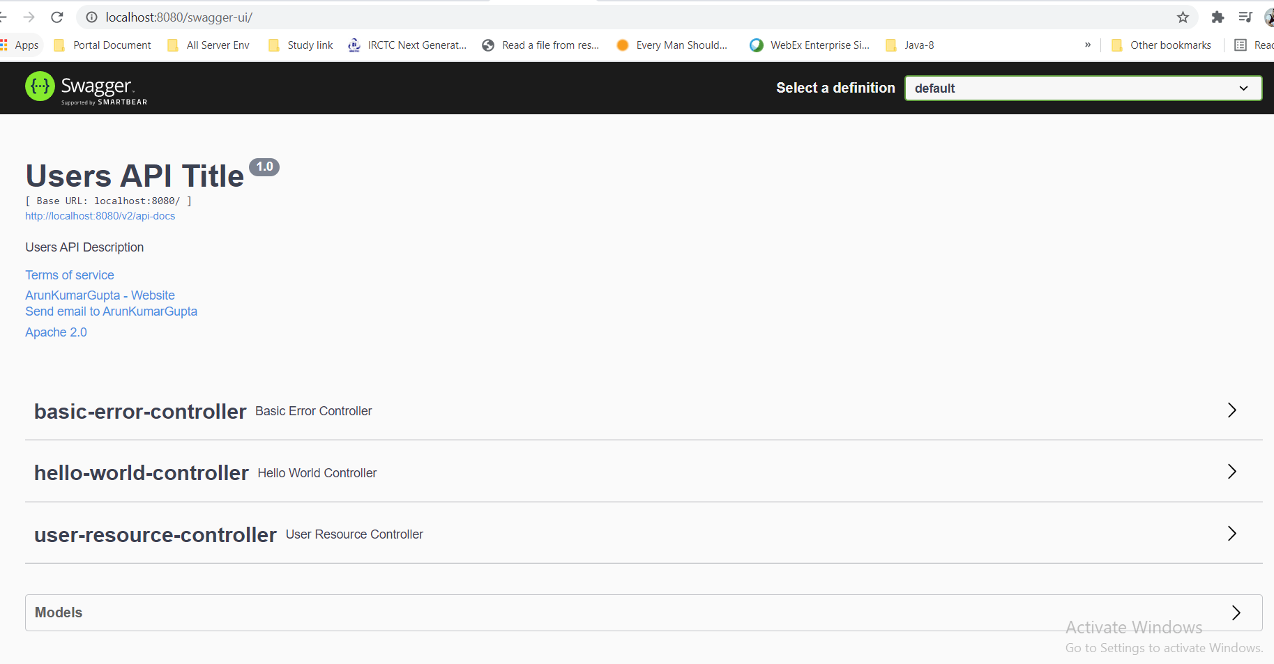

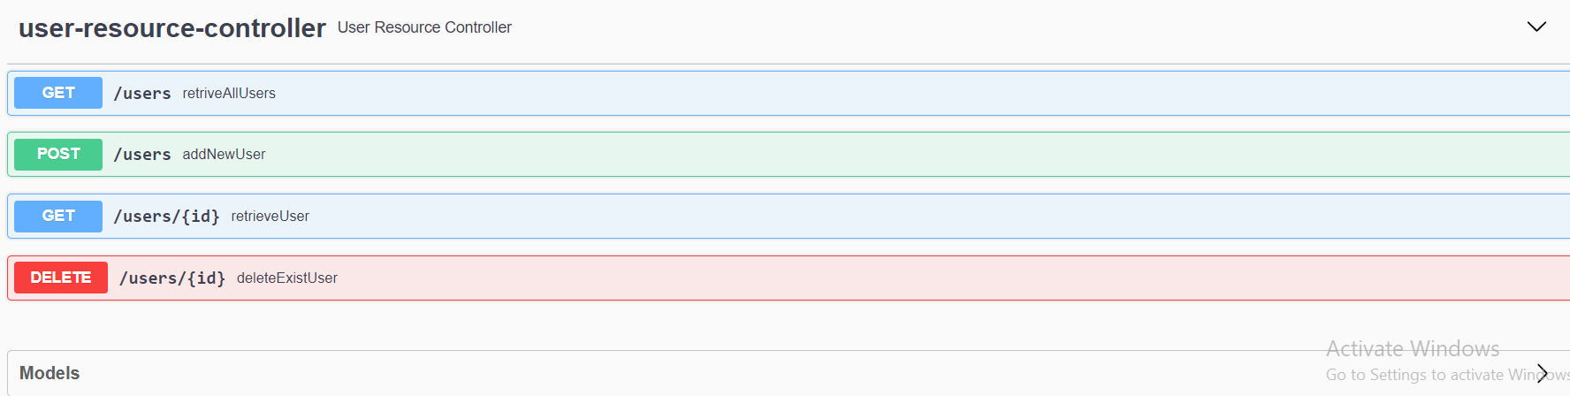

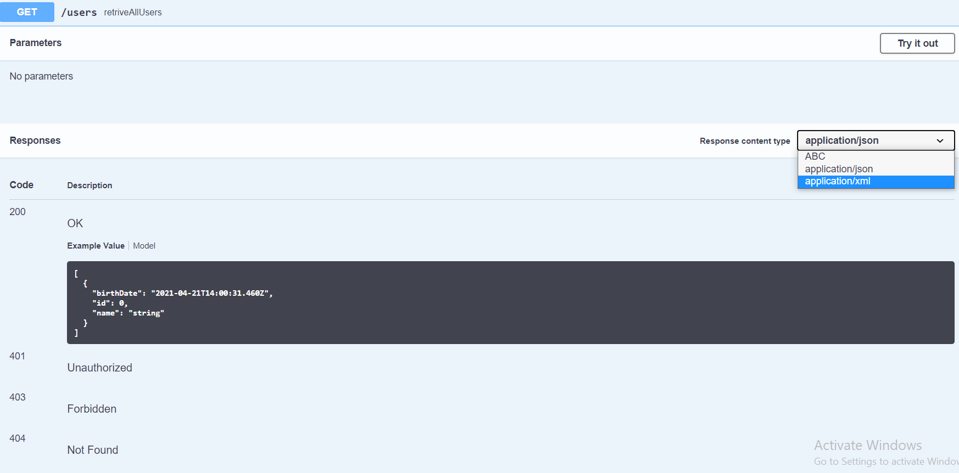

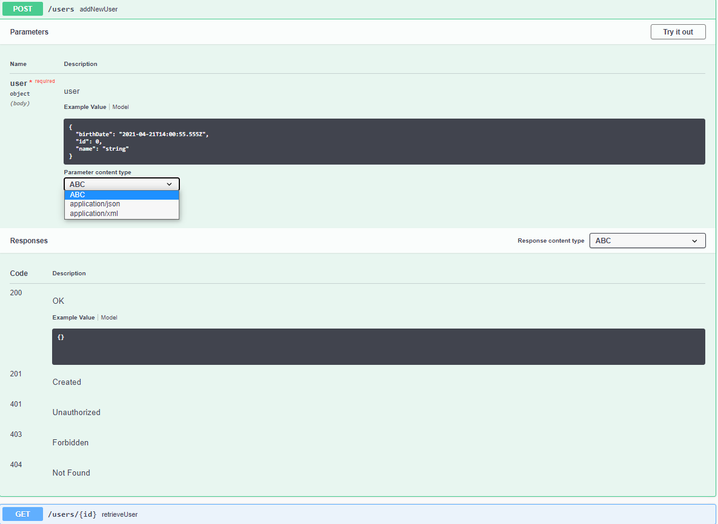

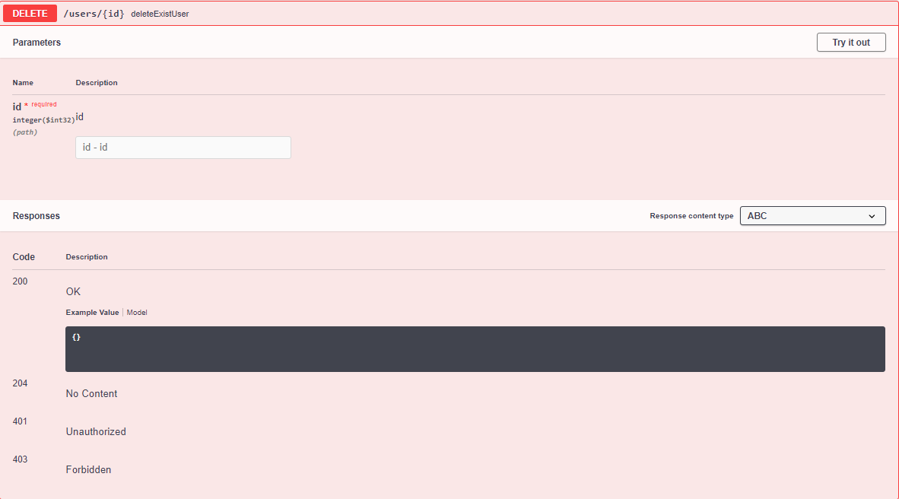

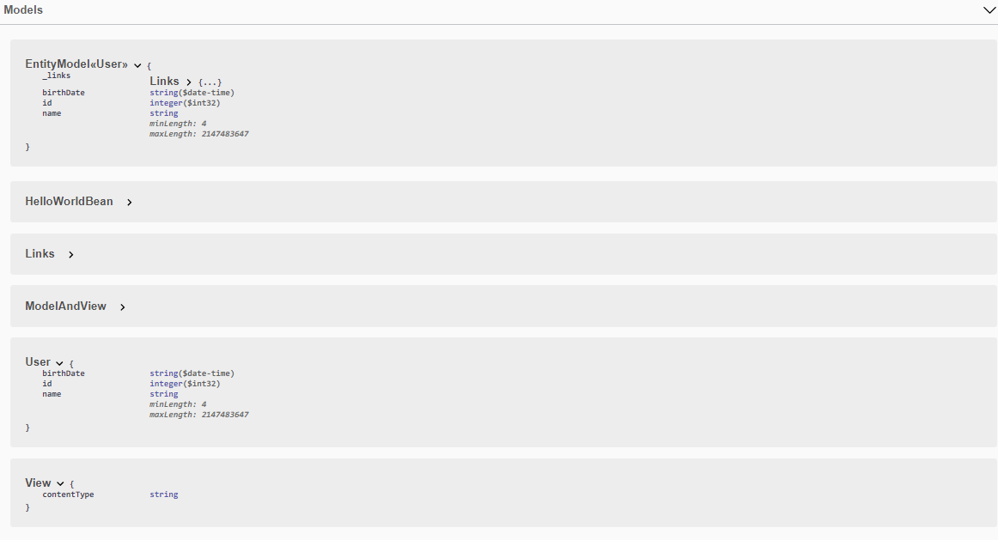

[**http://localhost:8080/v2/api-docs**](http://localhost:8080/v2/api-docs)

[**http://localhost:8080/swagger-ui**](http://localhost:8080/swagger-ui)

Now we can share these two links to consumer and they can get all the information from api-docs and same thing they can see visually using swagger-ui

**Step 21 - Introduction to Swagger Documentation Format**

At the high level we have

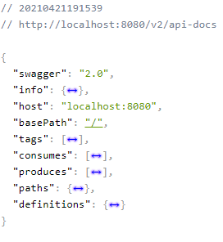

1. Here we are using Swagger version 2.0
2. Info level: Contains high level information about the API we have created or using.
3. Host: tells the destination where we are hosting our service.
4. Tags: is nothing the group of resources or controller (Controller class information)

|  |
| --- |
| **"tags": [**  **{**  **"name": "basic-error-controller",**  **"description": "Basic Error Controller"**  **},**  **{**  **"name": "hello-world-controller",**  **"description": "Hello World Controller"**  **},**  **{**  **"name": "user-resource-controller",**  **"description": "User Resource Controller"**  **}**  **],** |

1. Paths : Defines the number of resource URI;

|  |
| --- |
|  |

1. Definition: It tells the different types of element that we have used in the application.

|  |  |
| --- | --- |
| For example The User element contains the following information as shown in the RHS | **"User": {**  **"type": "object",**  **"properties": {**  **"birthDate": {**  **"type": "string",**  **"format": "date-time"**  **},**  **"id": {**  **"type": "integer",**  **"format": "int32"**  **},**  **"name": {**  **"type": "string",**  **"minLength": 4,**  **"maxLength": 2147483647**  **}**  **},**  **"title": "User"**  **},** |

1. **Consumers / Producers :**

|  |
| --- |
| **"consumes": [**  **"ABC",**  **"application/json",**  **"application/xml"**  **],**  **"produces": [**  **"ABC",**  **"application/json",**  **"application/xml"**  **],** |

**Step 22 - Enhancing Swagger Documentation with Custom Annotations**

**Section 5: Microservices with Spring Cloud- V1**

**59. Step 00 - 01 - Introduction to Microservices**

|  |  |
| --- | --- |
|  | In Short |

**In other word:**

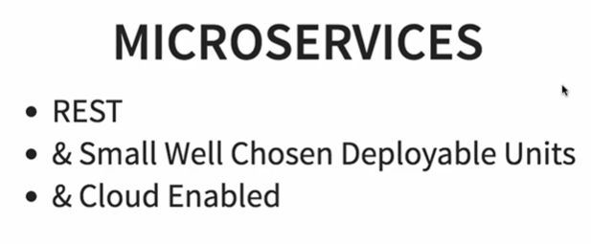

**Microservices are services which are exposed by REST, in addition to that we have small deployable units with very thought out boundaries and these should be cloud enable. In short Microservices are REST, having small deployable units which can be cloud enabled.**

**What do we mean be Cloud Enabled?**

**Here in Microservices development instead of building one big monolithic web service we will building a set of smaller Microservices with a well defined boundaries and which are interacting with each other and these are cloud enabled.**

**It means we should be enable to multiple instances each of these below microservices**

|  |  |
| --- | --- |
|  | **As per the image we have two instances of Microservice1, four instances of Microservice2 and one instance of Microservice3.**  **So By cloud enable means if there is more load on microservices3 then we should be easily bring up another instance of Microservice3 and they should not involve lot of configurations and if not required then take down back without having huge problem.** |

**60. Step 00 - 02 - Challenges with Microservices**

1. **Bounded Context:** As here instead of building a big monolithic service, we develop a number of small microservices then initially in the beginning of new project development when we have very little knowledge about the business then it is very difficult to indentify that what we need to do in these services, it is very difficult to identify that what we should do and what we should not do.
2. **Configuration Management:** - As here we would have a number of microservices and each of them could have multiple instances in different-2 environment and there could be multiple environments also. For example let’s say we have 10 microservices in 5 different environments and so we would have 50 instances so in this case we would have to do lot of configuration to the operation team to maintain.
3. **Dynamic Scale Up and Scale Down:**- As the load in the microservices could be different in the different environment some time we need only two instances and some time we need more than two instances so we should be able to manage scale up and scale down with dynamic load balancing.
4. **Visibility:** - If I say the functionality is distributed among 10 microservices and there is a bug then how do we indentify where the bug is? We need to have a centralized log from where we can find out what happens for a specific request and which Microservice cause the problem and apart from that we also need monitoring these services we could be able to identify dynamically that which service is up and running fine and which service is down.
5. **Fault Tolerance:**- It means let’s say we have built a number of services which are communicating to each other and let’s say among these services one the service is the main service upon which other services has been built and if this main service goes down then other dependent service will also down. So we should have fault tolerance in our microservices.

**61. Step 00 - 03 - Introduction to Spring Cloud**

Spring Cloud

Spring Cloud provides tools for developers to quickly build some of the common patterns in distributed systems (e.g. configuration management, service discovery, circuit breakers, intelligent routing, micro-proxy, control bus, one-time tokens, global locks, leadership election, distributed sessions, cluster state). Coordination of distributed systems leads to boiler plate patterns, and using Spring Cloud developers can quickly stand up services and applications that implement those patterns. They will work well in any distributed environment, including the developer’s own laptop, bare metal data centres, and managed platforms such as Cloud Foundry.

## Features

Spring Cloud focuses on providing good out of box experience for typical use cases and extensibility mechanism to cover others.

* Distributed/versioned configuration
* Service registration and discovery
* Routing
* Service-to-service calls
* Load balancing
* Circuit Breakers
* Global locks
* Leadership election and cluster state
* Distributed messaging

**Spring Cloud Projects: -** There are several spring cloud project for different purposes. Few of the important project on which we will have a discussions are**.**

[Spring Cloud Config](https://spring.io/projects/spring-cloud-config)

[Spring Cloud Netflix](https://spring.io/projects/spring-cloud-netflix)

[Spring Cloud Stream](https://spring.io/projects/spring-cloud-stream)

[Spring Cloud Stream Applications](https://spring.io/projects/spring-cloud-stream-applications)

[Spring Cloud Gateway](https://spring.io/projects/spring-cloud-gateway)

[**Spring Cloud Config**](https://spring.io/projects/spring-cloud-config)**:**

As we have already discussed about the **challenges of spring cloud and configuration of the microservices in could is one of the biggest challenges to maintain.** As an application moves through the deployment pipeline from dev to test and into production you can manage the configuration between those environments and be certain that applications have everything they need to run when they migrate. It provides an approach where we can store the entire configuration for all the different environment of all the microservices in a Git repository. In other words With the Config Server you have a central place-(GIT) to manage external properties for applications across all environments.

|  |  |
| --- | --- |
|  | Hence this central place Git helps us to keep all the configuration in one place and that makes very easy to maintain in the configuration in all the microservices. |

The next challenge that we talked about is **Dynamic Scale Up And Down**:

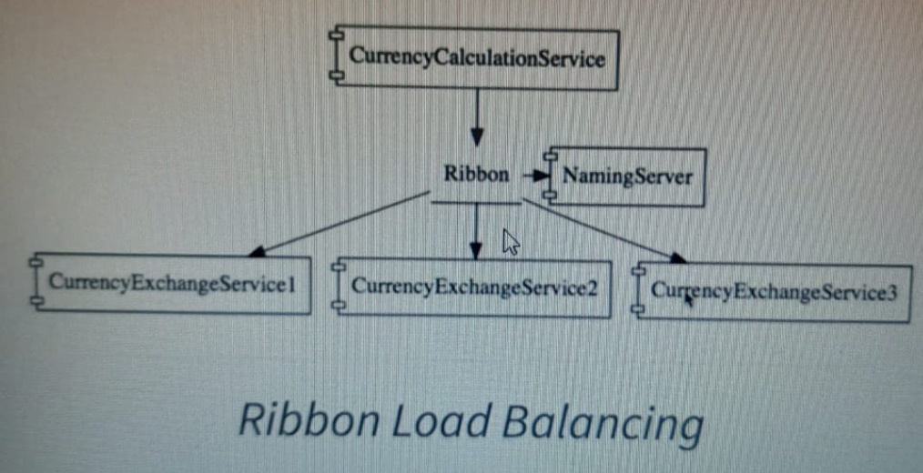

As in the above diagram one Microservice [CurrencyCalculationService] and there are multiple instances of CurrencyExchangeService still at any point of time we can add or remove instances according to requirement and load balancing. And here we want CurrencyCalculationService to be able to distribute the load among all the instances of the CurrencyExchangeService. We would be able to check dynamically what all the available instances of services what the entire load distributed among them.

The solution that we would be discussing here is the listed below.

1. **Naming server (Eureka):** All the instances of all the microservices would be registered with the naming server. The naming server has two important features: (1) Service Registration (2) Service Discovery

**In the above example the** CurrencyCalculationService can ask the Eureka Naming server “Hey Naming Server Give me the current instances of CurrencyExchangeService” and the naming service would provide those URLs to the CurrencyCalculationService. This helps to establish dynamic relationship between the CurrencyCalculationService and the instances of CurrencyExchangeService.

1. **Here would be using Ribbon for client side load balancing i.e. the** CurrencyExchangeService will host Ribbon and it would make sure that the load is evenly distributed among the existing instances that it get from the Naming Server.
2. **Feign (Easiest Rest Clients):**

The next challenge is **Visibility and Monitoring**

The solution for visibility and Monitoring are listed below:

1. **Zipkin Distributed Tracing Server:** use to trace a request across all multiple components.
2. **Netflix API Gateway:** The common feature that all the microservices contain like logging, security, Analytics etc. We don’t need to implement in all the services, API gateway provides the best solution for this kind of challenges. Here we will use Netflix zool API Gateway
3. **Finally we will implement Fault Tolerance:** Using Hystrix, if service is down then Hystrix helps us to configure a default response

**Note: Please go through this link for more information: VVVVImporatant:** [**https://spring.io/projects/spring-cloud**](https://spring.io/projects/spring-cloud)

**62. Step 00 - 04 - Advantages of Microservices Architectures**

1. **New Technology and Process Adaption**: As in case of Monolithic architecture all the services is developed in one languages and takes lot of configuration to interact with services developed in other language. But in case of Microservices Architecture we can develop services in any of the language like (**java**, **C#**, **nodejs** etc) and they all can communicate with each other with a minimum configuration.
2. **Dynamic Scaling:** If our microservices are cloud enable then we can easily scale up and scale down based on load. For example the e-commerce websites like Amazon they have business load especially on festival season so they can increase the number of instances of services to balance the load and latter at a point again they can scale down the instances to balance the load.
3. **Faster Release Cycle:** Since here we are developing microservices as a smallest unit to in compare to monolithic we can develop and release microservices very faster. Hence we can bring new feature faster to the market and this is the big advantage in this competitive world.

**63. Step 00 - 05 - Microservice Components -Standardizing Ports and URL**

**One of the important things about this microservices section that we would be developing a lot of component. Here would be installing at least seven different project and therefore it is very important to standardized the port on which we would run these applications.** [**https://github.com/in28minutes/spring-microservices/tree/master/03.microservices**](https://github.com/in28minutes/spring-microservices/tree/master/03.microservices)

## Ports

| **Application** | **Port** |
| --- | --- |
| **Limits Service** | **8080, 8081, ...** |
| **Spring Cloud Config Server** | **8888** |
|  |  |
| **Currency Exchange Service** | **8000, 8001, 8002,** |
| **Currency Conversion Service** | **8100, 8101, 8102, ...** |
| **Netflix Eureka Naming Server** | **8761** |
| **Netflix Zuul API Gateway Server** | **8765** |
| **Zipkin Distributed Tracing Server** | **9411** |

## URLs---------------------------------------------------------------------------------

| **Application** | **URL** |
| --- | --- |
| **Limits Service** | [**http://localhost:8080/limits**](http://localhost:8080/limits)[**http://localhost:8080/actuator/refresh**](http://localhost:8080/actuator/refresh)**(POST)** |
| **Spring Cloud Config Server** | [**http://localhost:8888/limits-service/default**](http://localhost:8888/limits-service/default)[**http://localhost:8888/limits-service/dev**](http://localhost:8888/limits-service/dev) |
| **Currency Converter Service - Direct Call** | [**http://localhost:8100/currency-converter/from/USD/to/INR/quantity/10**](http://localhost:8100/currency-converter/from/USD/to/INR/quantity/10) |
| **Currency Converter Service - Feign** | [**http://localhost:8100/currency-converter-feign/from/EUR/to/INR/quantity/10000**](http://localhost:8100/currency-converter-feign/from/EUR/to/INR/quantity/10000) |
| **Currency Exchange Service** | [**http://localhost:8000/currency-exchange/from/EUR/to/INR**](http://localhost:8000/currency-exchange/from/EUR/to/INR)[**http://localhost:8001/currency-exchange/from/USD/to/INR**](http://localhost:8001/currency-exchange/from/USD/to/INR) |
| **Eureka** | [**http://localhost:8761/**](http://localhost:8761/) |
| **Zuul - Currency Exchange & Exchange Services** | [**http://localhost:8765/currency-exchange-service/currency-exchange/from/EUR/to/INR**](http://localhost:8765/currency-exchange-service/currency-exchange/from/EUR/to/INR)[**http://localhost:8765/currency-conversion-service/currency-converter-feign/from/USD/to/INR/quantity/10**](http://localhost:8765/currency-conversion-service/currency-converter-feign/from/USD/to/INR/quantity/10) |
| **Zipkin** | [**http://localhost:9411/zipkin/**](http://localhost:9411/zipkin/) |
| **Spring Cloud Bus Refresh** | [**http://localhost:8080/actuator/bus-refresh**](http://localhost:8080/actuator/bus-refresh)**(POST)** |

**We will use above ports and URLs for upcoming microservices projects:**

**Section 5: Microservices with Spring Cloud- V1**

**64. Next Section uses Latest Version of Spring Boot**

**This section is useful if we are working on Microservice less that version 2.x.x.**

65. Step 01 - Part 1 - Intro to Limits Microservice and Spring Cloud Config Server

66. IMPORTANT : SPRING BOOT AND SPRING CLOUD VERSIONS

67. Step 01 - Part 2 - Setting up Limits Microservice

68. Step 02 - Creating a hard coded limits service

69. Step 03 -Enhance limits service to get configuration from application properties

70. Step 04 - Setting up Spring Cloud Config Server

71. Step 05 - Installing Git

72. Step 06 - Creating Local Git Repository

73. Step 07 - Connect Spring Cloud Config  
Server to Local Git Repository

74. Step 08 - Configuration for Multiple Environments in Git Repository

75. COURSE UPDATE : Limits service with >=2.4.0 of SPRING BOOT

76. Step 09 - Connect Limits Service to Spring Cloud Config Server

77. Debugging problems with Spring Cloud Config Server

78. Step 10 - Configuring Profiles for Limits Service

79. Step 11 - A review of Spring Cloud Config Server

80. Step 12 - Introduction to Currency Conversion and Currency Exchange Microservice

81. IMPORTANT : SPRING BOOT AND SPRING CLOUD VERSIONS

82. Step 13 - Setting up Currency Exchange Microservice

83. Step 14 - Create a simple hard coded currency exchange service

84. Step 15 - Setting up Dynamic Port in the the Response

85. Step 16 - Configure JPA and Initialized Data

86. Step 17 - Create a JPA Repository

87. Step 18 - Setting up Currency Conversion Microservice

88. Step 19 - Creating a service for currency conversion

89. Step 20 - Invoking Currency Exchange Microservice from Currency Conversion Micro

90. Step 21 - Using Feign REST Client for Service Invocation

91. Step 22 - Setting up client side load balancing with Ribbon

92. COURSE UPDATE : Ribbon DOES NOT work with Spring Boot 2.4

93. Step 23 - Running client side load balancing with Ribbon

94. Debugging problems with Feign and Ribbon

95. Step 24 - Understand the need for a Naming Server

96. Step 25 - Setting up Eureka Naming Server

97. Step 26 - Connecting Currency Conversion Microservice to Eureka

98. Step 27 - Connecting Currency Exchange Microservice to Eureka

99. COURSE UPDATE : Exclude dependency on jackson-dataformat-xml

100. Step 28 - Distributing calls using Eureka and Ribbon

101. Debugging Problems with Naming Server (Eureka ) and Ribbon

102. Step 29 - A review of implementing Eureka,Ribbon and Feign

103. Step 30 - Introduction to API Gateways

104. Step 31 - Setting up Zuul API Gateway

105. Step 32 - Implementing Zuul Logging Filter

106. Step 33 - Executing a request through Zuul API Gateway

107. Step 34 - Setting up Zuul API Gateway between microservice invocations

108. Debugging Problems with Zuul API Gateway

109. Step 35 - Introduction to Distributed Tracing

110. Step 36 - Implementing Spring Cloud Sleuth

111. Step 37 - Introduction to Distributed Tracing with Zipkin

112. Step 38 - Installing Rabbit MQ

113. Updates to Step 39 - Running Zipkin on Windows

114. Step 39 - Setting up Distributed Tracing with Zipkin

115. Step 40 - Connecting microservices to Zipkin

116. Updates to Step 40 : Usespring-cloud-starter-zipkin and spring-rabbit

117. Step 41 - Using Zipkin UI Dashboard to trace requests

118. Debugging Problems with Zipkin

119. Step 42 - Understanding the need forSpring Cloud Bus

120. Step 43 - Implementing Spring Cloud Bus

121. Step 44 - Fault Tolerance with Hystrix

**Section 6: Microservices with Spring Cloud - V2**

**22. What's NEW in V2?**

**Here we are going to use the latest update version of spring boot and spring cloud given the Microservices in last 2 to 3 years.**

**Important updates:**

* **Latest Versions of Spring Boot and Spring Cloud:**

1. **Spring Cloud Load Balancer instead of Ribbon: In the earlier version before 2.3 we have been using Ribbon as a load balancer**
2. **Spring cloud Gateway instead of zuul**
3. **Resilience4j instead of Hystrix**

* **Docker Containerize Microservices : Run Microservices using Docker and Docker Compose**
* **Kubernetes: Orchestrate all your microservices with Kubernetes**

**125. Step 01 - Setting up Limits Microservice - V2**

|  |  |
| --- | --- |
|  |  |

Both the images describing the same thing i.e. centralized configuration and for that we will create spring cloud config Server and connect this with GIT to store the entire configuration so that these configuration can be used in the cloud when requires.

Here first we will create the Limit Microservice and then we setup Spring Cloud Config Server which would be connected to Git Repo as per the diagram.

**Required Dependencies for limit-service**

Spring Web: Build web, including Restful, applications using Spring MVC. Uses Apache Tomcat as the default embedded container.

Spring Boot DevTools: Provides fast application restarts, Live Reload, and configurations for enhanced development experience.

Spring Boot Actuator Supports built in (or custom) endpoints that let you monitor and manage your application - such as application health, metrics, sessions, etc.

Config Client Client that connects to a Spring Cloud Config Server to fetch the application's configuration.

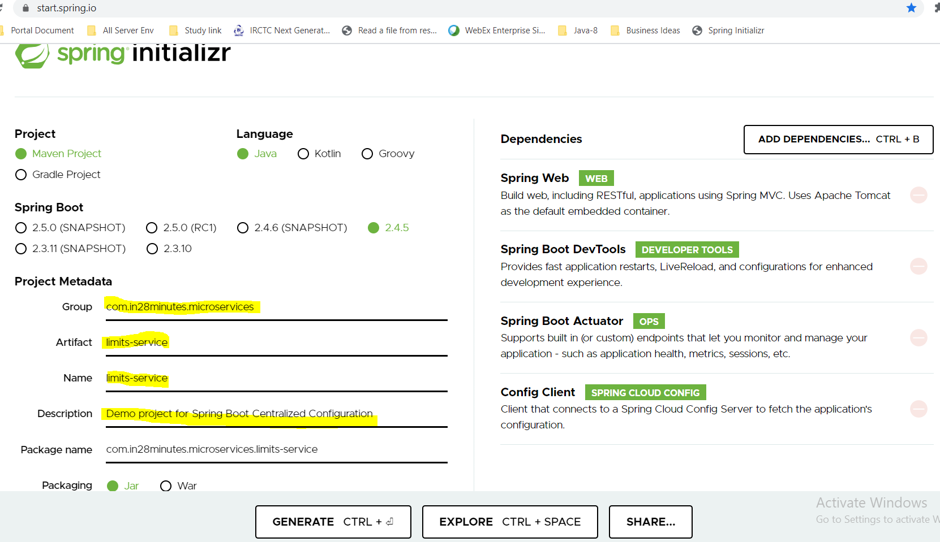 Now Generate the Project which will be downloaded into zip. Unzip and import into eclipse as existing maven project.

Pom.xml:

|  |
| --- |
| <?xml version=*"1.0"* encoding=*"UTF-8"*?>  <project xmlns=*"http://maven.apache.org/POM/4.0.0"* xmlns:xsi=*"http://www.w3.org/2001/XMLSchema-instance"*  xsi:schemaLocation=*"http://maven.apache.org/POM/4.0.0 https://maven.apache.org/xsd/maven-4.0.0.xsd"*>  <modelVersion>4.0.0</modelVersion>  <parent>  <groupId>org.springframework.boot</groupId>  <artifactId>spring-boot-starter-parent</artifactId>  <version>2.4.5</version>  <relativePath/> <!-- lookup parent from repository -->  </parent>  <groupId>com.in28minutes.microservices</groupId>  <artifactId>limits-service</artifactId>  <version>0.0.1-SNAPSHOT</version>  <name>limits-service</name>  <description>Demo project for Spring Boot Centralized Configuration</description>  <properties>  <java.version>1.8</java.version>  <spring-cloud.version>2020.0.2</spring-cloud.version>  </properties>  <dependencies>  <dependency>  <groupId>org.springframework.boot</groupId>  <artifactId>spring-boot-starter-actuator</artifactId>  </dependency>  <dependency>  <groupId>org.springframework.boot</groupId>  <artifactId>spring-boot-starter-web</artifactId>  </dependency>  <dependency>  <groupId>org.springframework.cloud</groupId>  <artifactId>spring-cloud-starter-config</artifactId>  </dependency>  <dependency>  <groupId>org.springframework.boot</groupId>  <artifactId>spring-boot-devtools</artifactId>  <scope>runtime</scope>  <optional>true</optional>  </dependency>  <dependency>  <groupId>org.springframework.boot</groupId>  <artifactId>spring-boot-starter-test</artifactId>  <scope>test</scope>  </dependency>  </dependencies>  <dependencyManagement>  <dependencies>  <dependency>  <groupId>org.springframework.cloud</groupId>  <artifactId>spring-cloud-dependencies</artifactId>  <version>${spring-cloud.version}</version>  <type>pom</type>  <scope>import</scope>  </dependency>  </dependencies>  </dependencyManagement>  <build>  <plugins>  <plugin>  <groupId>org.springframework.boot</groupId>  <artifactId>spring-boot-maven-plugin</artifactId>  </plugin>  </plugins>  </build>  </project> |
| package com.in28minutes.microservices.limitsservice;  import org.springframework.boot.SpringApplication;  import org.springframework.boot.autoconfigure.SpringBootApplication;  @SpringBootApplication  public class LimitsServiceApplication {  public static void main(String[] args) {  SpringApplication.run(LimitsServiceApplication.class, args);  }  } |

Server was not getting started so we have configured below any of two lines and then server is getting started now.

spring.cloud.config.enabled=false – OR

spring.cloud.config.import-check.enabled=false

**126. Step 02 - Creating a hard coded limits service - V2**

1. **No any change in POm.xml**
2. **Created LimitsController.java**
3. **Created one bean class Limits.java**

|  |  |
| --- | --- |
| **package com.in28minutes.microservices.limitsservice.bean;**  **public class Limits {**  **private int minimum;**  **private int maximum;**  **public Limits() {**  **super();**  **}**  **public Limits(int minimum, int maximum) {**  **super();**  **this.minimum = minimum;**  **this.maximum = maximum;**  **}**  **public int getMinimum() {**  **return minimum;**  **}**  **public void setMinimum(int minimum) {**  **this.minimum = minimum;**  **}**  **public int getMaximum() {**  **return maximum;**  **}**  **public void setMaximum(int maximum) {**  **this.maximum = maximum;**  **}**  **}** | **package com.in28minutes.microservices.limitsservice.controller;**  **import org.springframework.web.bind.annotation.GetMapping;**  **import org.springframework.web.bind.annotation.RestController;**  **import com.in28minutes.microservices.limitsservice.bean.Limits;**  **@RestController**  **public class LimitsController {**  **@GetMapping(path="/limits")**  **public Limits retrieveLimits() {**    **return new Limits(1,1000);**  **}**  **}**  **Here we are sending hard value of min and max limit.**  **Output:**  [**http://localhost:8080/limits**](http://localhost:8080/limits)  **{"minimum":1,"maximum":1000}** |

**127. Step 03 - Enhance limits service – Get configuration from application props - V2**

**Here in this step we will try to get min and max value of limit from configuration from application.properties.**

**Step-1 : Created min and max values in the application.properties as given below**

|  |
| --- |
| **# Setting limits min and max values**  **limits-service.minimum=22**  **limits-service.maximum=999** |

Step-2: Let’s create on Class Configuration which matches the structure for min and max defined in the application.properties.

|  |  |
| --- | --- |
| **package com.in28minutes.microservices.limitsservice.configuration;**  **import org.springframework.boot.context.properties.ConfigurationProperties;**  **import org.springframework.stereotype.Component;**  **@Component**  **@ConfigurationProperties("limits-service")**  **public class Configuration {**  **private int minimum;**  **private int maximum;**  **public int getMinimum() {**  **return minimum;**  **}**  **public void setMinimum(int minimum) {**  **this.minimum = minimum;**  **}**  **public int getMaximum() {**  **return maximum;**  **}**  **public void setMaximum(int maximum) {**  **this.maximum = maximum;**  **}**  **}**  **1-Created on class Configuration and annotated with @ConfigurationProperties with the same initial name (limits-service) defined in the application.properties file.**  **2-Created the exact variable name [minimum, maximum] matching with the application.properties.**  **So that it could be matched like[limits-service dot minimum & limits-service dot maximum**  **3- Don’t forgot to mention this class to annotate with @Component because this class be Autowired in the LimitController.java class, otherwise server will not be started.** | **package com.in28minutes.microservices.limitsservice.controller;**  **import org.springframework.beans.factory.annotation.Autowired;**  **import org.springframework.web.bind.annotation.GetMapping;**  **import org.springframework.web.bind.annotation.RestController;**  **import com.in28minutes.microservices.limitsservice.bean.Limits;**  **import com.in28minutes.microservices.limitsservice.configuration.Configuration;**  **@RestController**  **public class LimitsController {**    **@Autowired**  **private Configuration config;**  **@GetMapping(path="/limits")**  **public Limits retrieveLimits() {**  **//return new Limits(1,1000);**  **return new Limits(config.getMinimum(),config.getMaximum());**  **}**  **}**   1. **Here now first of all Autowired Configuration class and get the values from the properties file instead of setting hard values in the constructor.**   **Output:**  [**http://localhost:8080/limits**](http://localhost:8080/limits)  **{**  **"minimum": 22,**  **"maximum": 999**  **}** |

**128. Step 04 - Setting up Spring Cloud Config Server - V2**

|  |  |
| --- | --- |
|  | In the previous step we have setup limits-service.  Now in this step we will setup spring cloud config server and connect it to the git repository, from where the entire configuration will be getting  Create a project from spring initializer, import it into eclipse. |

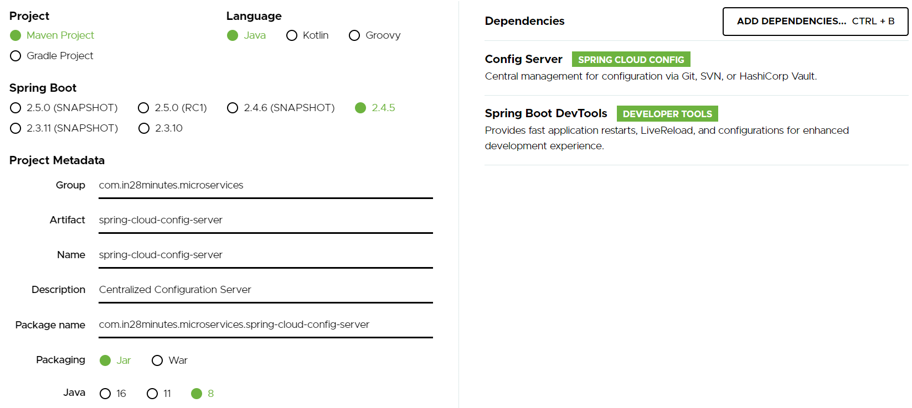

**Here we have added only two dependencies.**

**Step-1**

* **Config Server:** SPRING CLOUD CONFIG Central management for configuration via Git, SVN, or HashiCorp Vault.
* **Spring Boot DevTools DEVELOPER TOOLS:** Provides fast application restarts, LiveReload, and configurations for enhanced development experience.

Pom.xml:

|  |
| --- |
| <dependency>  <groupId>org.springframework.cloud</groupId>  <artifactId>spring-cloud-config-server</artifactId>  </dependency>  <dependency>  <groupId>org.springframework.boot</groupId>  <artifactId>spring-boot-devtools</artifactId>  <scope>runtime</scope>  <optional>true</optional>  </dependency> |

**Step-2:** We cannot run all the application on the default port 8080. So let’s run this application spring-cloud-config-server on different port and for that we will have to mention the particular port number in the application.properties file. One more thing is that we will mention the each spring application name in the application.properties file; this is the best practice that we have to follow for every services. So the changes that we have mentioned in the property file are.

**Application.properties:**

|  |
| --- |
| spring.application.name=spring-cloud-config-server  server.port=8888 |

Now let’s try to start the tomcat server and check: Tomcat started on port(s): 8888 (http) with context path ''

**129. Step 05 - Installing Git and Creating Local Git Repository - V2**

Open the GIT Bash command prompt:

|  |
| --- |
| saraswati@DESKTOP-B1DPRDQ MINGW64 /d/SpringCloudMicroserviceWS/git-localconfig-repo  $ |
| $ git init  Initialized empty Git repository in D:/SpringCloudMicroserviceWS/git-localconfig-repo/.git/  Now will store all the configuration here! |
|  |

Now let’s create limits-service.properites inside git-localconfig-repo and keep the same name what we have already kept in the limits-services application.properties because we want to get the limits-service configuration data from this central location- git-localconfig-repo.

Now let’s commit the file in the same central location.

|  |
| --- |
| saraswati@DESKTOP-B1DPRDQ MINGW64 /d/SpringCloudMicroserviceWS/git-localconfig-repo (master)  $ ls  limits-service.properties  saraswati@DESKTOP-B1DPRDQ MINGW64 /d/SpringCloudMicroserviceWS/git-localconfig-repo (master)  $ git add limits-service.properties  OR $ git add *  saraswati@DESKTOP-B1DPRDQ MINGW64 /d/SpringCloudMicroserviceWS/git-localconfig-repo (master)  $ git commit -m "Adding limits-service.properties"  [master (root-commit) 6716847] Adding limits-service.properties  1 file changed, 3 insertions(+)  create mode 100644 limits-service.properties  saraswati@DESKTOP-B1DPRDQ MINGW64 /d/SpringCloudMicroserviceWS/git-localconfig-repo (master)  $ |

Now it committed into our local repository.

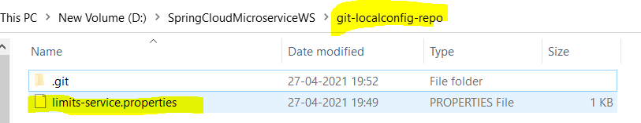

So we have so far now:

1. Limits-service
2. spring-cloud-config-server
3. local git repository

Now we will see how to connect all the above three.

Debugging problems with Spring Cloud Config Server - V2

**Debugging** microservices problems can be **difficult** as there are multiple components involved.

**Step by Step instructions** is provided in the **troubleshooting guide** to help you troubleshoot frequently occurring problems.

Using the **Chrome Browser** is recommended.

<https://github.com/in28minutes/spring-microservices-v2/blob/main/03.microservices/01-step-by-step-changes/microservices-v2-1.md#spring-cloud-config-server---steps-01-to-08>

**131. Step 06 - Connect Spring Cloud Config Server to Local Git Repository - V2**

**Let’s now connect the centralized server to git repository.**

**Step1- Open the application.properties of Spring Cloud Config Server and mention the below configuration.**

|  |
| --- |
| saraswati@DESKTOP-B1DPRDQ MINGW64 /d/SpringCloudMicroserviceWS/git-localconfig-repo (master)  $ pwd  /d/SpringCloudMicroserviceWS/git-localconfig-repo |
| **application.properties:** Now here will configure folder🡺 /d/SpringCloudMicroserviceWS/git-localconfig-repo  **spring.cloud.config.server.git.uri=** **file:\\\D:\\SpringCloudMicroserviceWS\\git-localconfig-repo** |

**In case of Linux; give like below:**

**spring.cloud.config.server.git.uri=file:///**d/SpringCloudMicroserviceWS/git-localconfig-repo

Now start the server and check the configuration using below Uri:

<http://localhost:8888/limits-service/default>

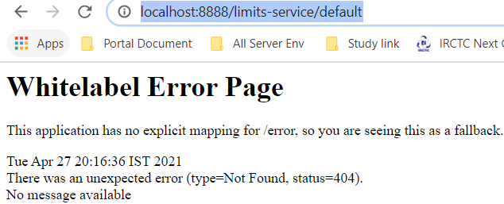

**So we have got the above error because have one annotation left to be mentioned in the spring boot launcher file:**

|  |
| --- |
| **package com.in28minutes.microservices.springcloudconfigserver;**  **import org.springframework.boot.SpringApplication;**  **import org.springframework.boot.autoconfigure.SpringBootApplication;**  **import org.springframework.cloud.config.server.EnableConfigServer;**  **@EnableConfigServer**  **@SpringBootApplication**  **public class SpringCloudConfigServerApplication {**  **public static void main(String[] args) {**  **SpringApplication.run(SpringCloudConfigServerApplication.class, args);**  **}**  **}**  **Note: @EnableConfigServer once we use this annotation it immediately connect the git to centralized server. Now lets run again the above url: //** [**http://localhost:8888/limits-service/default**](http://localhost:8888/limits-service/default) **[http://localhost:8888/filename/default]** |
| **{**  **"name": "limits-service",**  **"profiles": [**  **"default"**  **],**  **"label": null,**  **"version": "6716847170224a84ba725481673d4767e01d0e83",**  **"state": null,**  **"propertySources": [**  **{**  **"name": "file:\\D:\\SpringCloudMicroserviceWS\\git-localconfig-repo/file:D:\\SpringCloudMicroserviceWS\\git-localconfig-repo\\limits-service.properties",**  **"source": {**  **"limits-service.minimum": "4",**  **"limits-service.maximum": "996"**  **}**  **}**  **]**  **}** |

**So now we have got our JSON having all the information from the Centralized server from the git. We have got name, propertySources and the value present in the property file.**

**So now we have connected Centralized server to Git repo:**

**132. Step 07 - Connect Limits Service to Spring Cloud Config Server - V2**

|  |  |
| --- | --- |
|  | So we have so far now:   1. Limits-service 2. spring-cloud-config-server 3. local git repository 4. Connected spring-cloud-config-server with local git repository 5. Now next thing is to connect limits-service to spring-cloud-config-server |

Step-1

To connect limits-services to spring-cloud-config-server we need on dependency in limits-service pom.xml which we have already included during limits-service project creation.

|  |
| --- |
| <dependency>  <groupId>org.springframework.cloud</groupId>  <artifactId>spring-cloud-starter-config</artifactId>  </dependency> |

This will help limits-service to talk to centralized config server.

**Step2- Next thing that we have to do is config the URL[** [**http://localhost:8888**](http://localhost:8888/) **] of cloud config server in the application.properties file of limits-service. This would provide the entire configuration to the limits-service from the cloud config server.**

|  |
| --- |
| spring.config.import=optional:configserver: <http://localhost:8888>  Here we are making this optional that is why we have mentioned optional, if we want to make it mandatory then remove optional.  spring.config.import=configserver: <http://localhost:8888> |

**Note**: In the early version of spring-boot we needed to create a separate file (bootstrap.properties) but it is not needed anymore and we can directly connect to the spring cloud config server and import the configuration from its application.properties.

|  |
| --- |
| **limits-service – application.properties:**  spring.application.name=limits-service  #spring.cloud.config.enabled=true  #spring.cloud.config.import-check.enabled=false  spring.config.import=optional:configserver:http://localhost:8888  # Setting limits min and max values  limits-service.minimum=22  limits-service.maximum=999 |
| **spring-cloud-config-server[application.properties]**  spring.application.name=spring-cloud-config-server  server.port=8888  spring.cloud.config.server.git.uri= file:\\\D:\\SpringCloudMicroserviceWS\\git-localconfig-repo |
| **limits-service.properties file in the git:**  # Setting limits min and max values in the git repo  limits-service.minimum=44  limits-service.maximum=996 |

**Now when we execute limits-service URL then instead of getting from its own properties file, it will get the values from the git through could config server.**

|  |  |
| --- | --- |
|  | <http://localhost:8080/limits>  {  "minimum": 44,  "maximum": 996  } |

Limits-service logs:

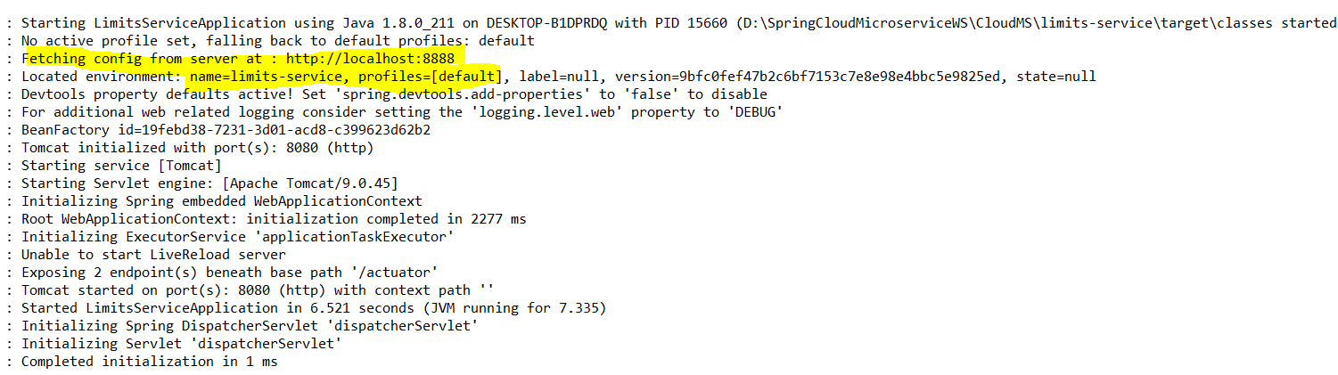

Fetching config from server at: <http://localhost:8888>

Located environment: name=limits-service, profiles= [default]: here limits-service is the application name

So as per the above log first it goes to cloud config server <http://localhost:8888> then it goes to the location where the config file is saved and then it uses default profile and finally it will make the below

The above marked like will look like as: <http://localhost:8888/limits-service/default> as we have seen earlier.

|  |
| --- |
| {  "name": "limits-service",  "profiles": [  "default"  ],  "label": null,  "version": "6716847170224a84ba725481673d4767e01d0e83",  "state": null,  "**propertySources**": [  {  **"name": "file:\\D:\\SpringCloudMicroserviceWS\\git-localconfig-repo/file:D:\\SpringCloudMicroserviceWS\\git-localconfig-repo\\limits-service.properties",**  "source": {  "limits-service.minimum": "44",  "limits-service.maximum": "996"  }  }  ]  } |

So when <http://localhost:8888/limits-service/default> execute then it takes the configuration from the propertySources.

Note: The values in the application.properties in the limits-service application has less priority compare the values which available in the git repository.

So finally we have connected the entire chain.

So we have so far now:

1. Limits-service
2. spring-cloud-config-server
3. local git repository
4. Connected spring-cloud-config-server with local git repository
5. Connected limits-service to spring-cloud-config-server

**In short:**

**Limits-service application🡺spring-cloud-config-server 🡺 local git repository**

**135. Step 08 - Configuring Profiles for Limits Service - V2**

In the earlier step we have connected limits-service to cloud config server and store the entire configuration into git repository.

**Now let’s say there are multiple environment for limits-service like (dev, test, stage, prod) then how do we store a separate configurations for limits-service for these four environments, and how do we make use of it from the spring cloud config server?**

Let’s look at that in this step:

**Step-1:** The first thing that we need to indentify that how we store the configuration related multiple environments in git repository.

In the previous step we have created limits-service.properties in git-localconfig-repo, in the same way we have to create multiple copies for different environments.

|  |  |  |
| --- | --- | --- |
| dev | **limits-service-dev.properties** |  |
| Test(QA) | **limits-service-qa.properties** |
| stage | **limits-service-stage.properties** |

Now we will configure different values:

|  |  |
| --- | --- |
| Default: limits-service.properties:  **# Setting limits min and max values in the git repo**  limits-service.minimum=44  limits-service.maximum=996 | Dev: limits-service-dev.properties  **# Setting limits min and max values in the git repo for dev**  limits-service.minimum=11  limits-service.maximum=99 |
| Test: limits-service-qa.properties  **# Setting limits min and max values in the git repo for QA**  limits-service.minimum=22  limits-service.maximum=999 | Stage: limits-service-stage.properties  **# Setting limits min and max values in the git repo for stage**  limits-service.minimum=33  limits-service.maximum=9999 |

Now let’s start cloud config server and hit the URL based on the defined profile then we will get the configured value for that particular environment as well as default profile configured value.

|  |  |
| --- | --- |
| <http://localhost:8888/limits-service/default>  {  "name": "limits-service",  "profiles": [  "default"  ],  "label": null,  "version": "9bfc0fef47b2c6bf7153c7e8e98e4bbc5e9825ed",  "state": null,  "propertySources": [  {  "name": "file:\\D:\\SpringCloudMicroserviceWS\\git-localconfig-repo/file:D:\\SpringCloudMicroserviceWS\\git-localconfig-repo\\limits-service.properties",  "source": {  "limits-service.minimum": "44",  "limits-service.maximum": "996"  }  }  ]  } | <http://localhost:8888/limits-service/dev>  {  "name": "limits-service",  "profiles": [  "dev"  ],  "label": null,  "version": "9bfc0fef47b2c6bf7153c7e8e98e4bbc5e9825ed",  "state": null,  "propertySources": [  {  "name": "file:\\D:\\SpringCloudMicroserviceWS\\git-localconfig-repo/file:D:\\SpringCloudMicroserviceWS\\git-localconfig-repo\\**limits-service-dev.properties**",  "source": {  "limits-service.minimum": "11",  "limits-service.maximum": "99"  }  },  {  "name": "file:\\D:\\SpringCloudMicroserviceWS\\git-localconfig-repo/file:D:\\SpringCloudMicroserviceWS\\git-localconfig-repo\\**limits-service.properties**",  "source": {  "limits-service.minimum": "44",  "limits-service.maximum": "996"  }  }  ]  } |

|  |  |
| --- | --- |
| [**http://localhost:8888/limits-service/qa**](http://localhost:8888/limits-service/qa)  **{**  **"name": "limits-service",**  **"profiles": [**  **"qa"**  **],**  **"label": null,**  **"version": "9bfc0fef47b2c6bf7153c7e8e98e4bbc5e9825ed",**  **"state": null,**  **"propertySources": [**  **{**  **"name": "file:\\D:\\SpringCloudMicroserviceWS\\git-localconfig-repo/file:D:\\SpringCloudMicroserviceWS\\git-localconfig-repo\\limits-service-qa.properties",**  **"source": {**  **"limits-service.minimum": "22",**  **"limits-service.maximum": "999"**  **}**  **},**  **{**  **"name": "file:\\D:\\SpringCloudMicroserviceWS\\git-localconfig-repo/file:D:\\SpringCloudMicroserviceWS\\git-localconfig-repo\\limits-service.properties",**  **"source": {**  **"limits-service.minimum": "44",**  **"limits-service.maximum": "996"**  **}**  **}**  **]}** | [**http://localhost:8888/limits-service/stage**](http://localhost:8888/limits-service/stage)  **{**  **"name": "limits-service",**  **"profiles": [**  **"stage"**  **],**  **"label": null,**  **"version": "9bfc0fef47b2c6bf7153c7e8e98e4bbc5e9825ed",**  **"state": null,**  **"propertySources": [**  **{**  **"name": "file:\\D:\\SpringCloudMicroserviceWS\\git-localconfig-repo/file:D:\\SpringCloudMicroserviceWS\\git-localconfig-repo\\limits-service-stage.properties",**  **"source": {**  **"limits-service.minimum": "33",**  **"limits-service.maximum": "9999"**  **}**  **},**  **{**  **"name": "file:\\D:\\SpringCloudMicroserviceWS\\git-localconfig-repo/file:D:\\SpringCloudMicroserviceWS\\git-localconfig-repo\\limits-service.properties",**  **"source": {**  **"limits-service.minimum": "44",**  **"limits-service.maximum": "996"**  **}**  **}**  **]}** |

**So now we have created the limits-service configuration file for different environments and we have values for multiple environments which being picked up from git repo. One thing is to note here that in every profile the default profile configured values are also coming so if the particular environment value is not defined then it will be picked up from default profile configured value, but first priority will be for property values for defined environment profile.**

**If we don’t see the latest changes then please commit the new changes In the git and then check again.**

**Step2- Now in this step we will identify that how the limits-service application would get the values from the cloud config server?**

**So we will configure the below properties in the limits-service application.properties file. Typically when we want to support multiple environments in a spring application then we would go for concept called profile and the same way we are going to do here in the limits-service application.properties file.**

|  |  |
| --- | --- |
| #Configuring multiple profiles for different environments  spring.profiles.active = dev  spring.profiles.active = qa  spring.profiles.active = stage | But we will make active only one profile based on the environments like let’s say we need profile active for dev env.  #Configuring multiple profiles for different environments  spring.profiles.active = dev  #spring.profiles.active = qa  #spring.profiles.active = stage |

**Now when we see in the limits-server console log then we will found that dev profile is active**

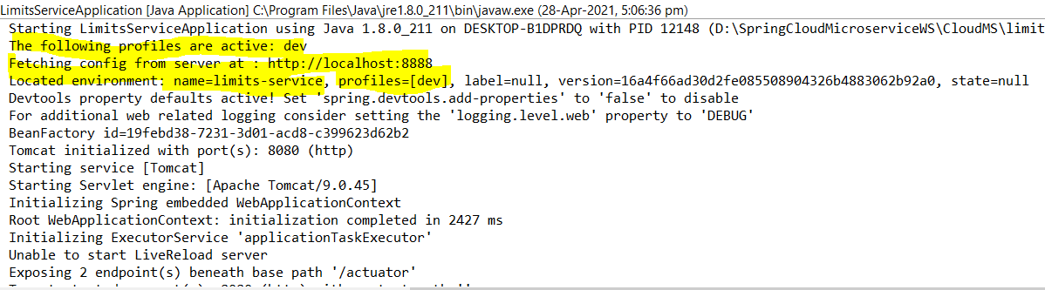

Note , this is good that here the it is picking profile from dev, as here we can see profiles=[dev] in the previous version of the springs profiles still shows default even making only dev profile active in limits-service, in this condition we have to put one more property in the limits-service application.properties file as given below.

spring.cloud.config.prifile=dev

But as we are using latest version of spring boot so this issue is not coming and it is picking the configuration based on the active profile in the limits-service as we can see below.

|  |  |
| --- | --- |
| #Configuring multiple profiles for different environments  #spring.profiles.active = dev  spring.profiles.active = qa  #spring.profiles.active = stage |  |
| #Configuring multiple profiles for different environments  #spring.profiles.active = dev  #spring.profiles.active = qa  spring.profiles.active = stage  #spring.cloud.config.prifiles=stage |  |

Now let’s hit limits-service URL and check whether the values are coming or not based on the active profile in limits-service application.properties file.

|  |  |
| --- | --- |
| We have made active profile for stage env  #spring.profiles.active = dev  #spring.profiles.active = qa  spring.profiles.active = stage  #spring.cloud.config.prifiles=stage | **Stage profile configured value:** |
| Now let’s hit limits-service and check  <http://localhost:8080/limits> | So as we can see that when we hit limits-service url then we are getting configured values from Git via spring cloud config server. |
|  | So we have so far now:   1. Limits-service 2. spring-cloud-config-server 3. local git repository 4. Connected spring-cloud-config-server with local git repository 5. Connected limits-service to spring-cloud-config-server   After that for different environment |

1. Created one profile for dev, qa and stage environment
2. Configured the different limit values in all three environments
3. Now configured on property in the limits-service application.properties file [spring.profiles.active = stage]
4. And based on the above active profile it is picking the values in the limits-service from the centralized git via cloud config server
5. Now like limits-service, if we what to get the configuration for other services (X,Y) from centralized git via could config server then we have to follow the below steps.

**Step-1:** Configured the property in the X & Y application.properties file [spring.config.import=optional:configserver:http://localhost:8888]

**Step-2:** Create the profile for dev and QA for X & Y application in the Git repo just like we have done in case of limits-service application [limits-service-dev.properties] for limits Dev profile. [microservice-x-dev.properties] for X application etc.

**Step-3:** Finally make the profile active in the X application.properties file like [spring.profiles.active = dev]

**In this way we can configure the configuration for multiple environments for any microservices application and whenever we want to make any change then just change the value commit in the git and we are ready with new values.**

**136. Step 09 - Introduction to Currency Conversion & Exchange Microservices - V2**

So far we have learnt how to connect spring-cloud-config-server with centralized storage like git and how a Microservice can be configured into different environment using spring-cloud-config-server and git repo.

Now to let’s explore more service and get the configuration from centralized git repo.

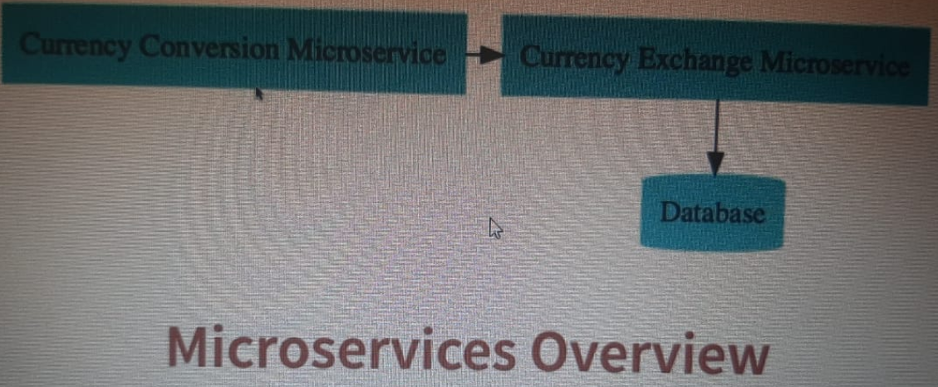

As per the image we will have two microservices (1) Currency Conversion Microservice & (2) Currency Exchange Microservice.

**Currency Exchange Microservice:**  This service exposes, what is the exchange rate of one currency in another.

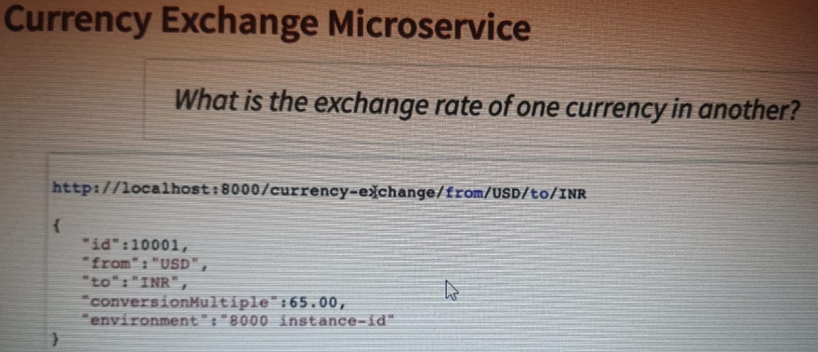

**As here we can see that from this service it is exposing a simple URL- /currency-exchange/from/USD/to/INR.**

**So here it is converting USD to INR and this service would return back the conversion rate of one USD to INR and we have the format of response shown above in the image. So this is one service that we would setup.**

**For this service we will use following port: 8000, 8001, 8002**

**Currency Conversion Microservice: This service is responsible for conversion the number of quantity of USD into INR.**

|  |  |
| --- | --- |
|  | **As per the image it is exposing service URL**  **Currency-conversion/from/USD/to/INR/quantity/10**  **Here it is sending the response in the given format and it is exposing all the things like Currency From – to currency. Conversion Rate, Quantity of USD and total INR currency after conversion and port from where this is happened.** |

**This service would call the currency exchange Microservice and ask what the value of USD in INR is today and then it would take the rate and it would then multiply with the quantity and will return the total calculated amount of INR.**

**For this service we will use following port: 8100, 8101, 8102**

**So first let’s start setup with currency exchange Microservice in the next step:**

**137. Step 10 - Setting up Currency Exchange Microservice - V2**

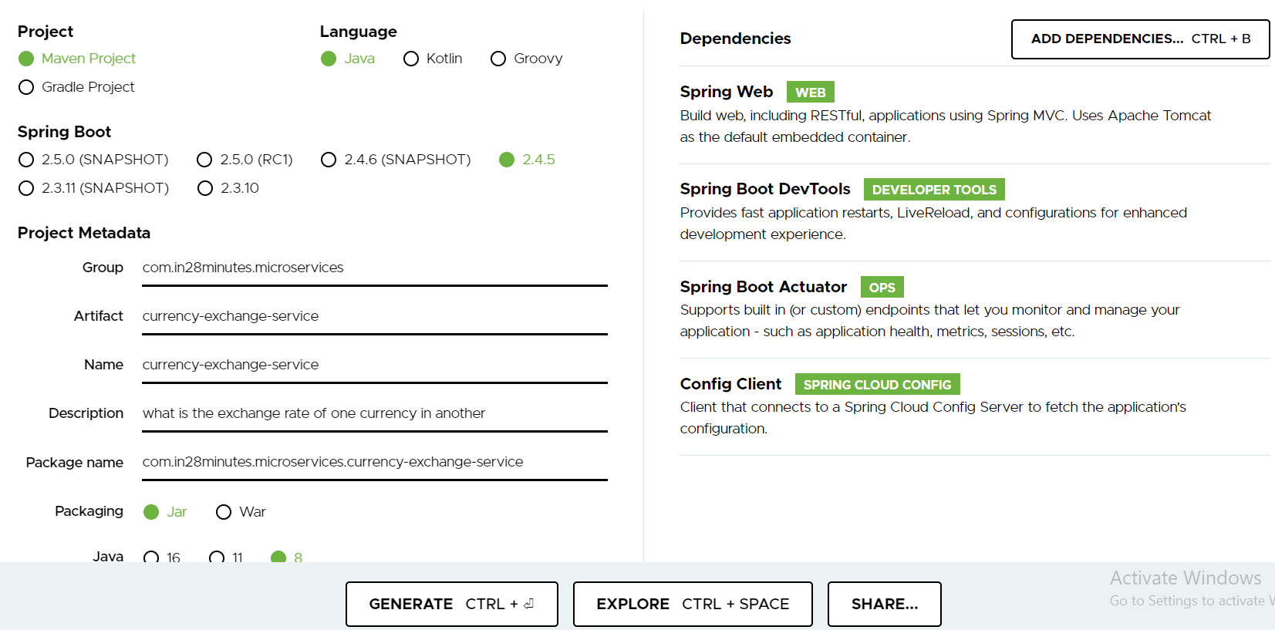

**Dependencies:**

* **Spring Web :** Build web, including Restful, applications using Spring MVC. Uses Apache Tomcat as the default embedded container.
* **Spring Boot DevTools DEVELOPER TOOLS:** Provides fast application restarts, LiveReload, and configurations for enhanced development experience.
* **Spring Boot Actuator OPS:** Supports built in (or custom) endpoints that let you monitor and manage your application - such as application health, metrics, sessions, etc.
* **Config Client SPRING CLOUD CONFIG: Client** that connects to a Spring Cloud Config Server to fetch the application's configuration.

**Step1-** Downloaded, extracted and imported the project into eclipse workspace.

**Step2-** Since same port cannot be used for all the services so we have changed the port number and mention the service name in the application.properties.

|  |
| --- |
| spring.application.name=currency-exchange  server.port=8000 |

Now let’s try to start the server: the server will fail to start and we will get the below exception:

|  |
| --- |
| APPLICATION FAILED TO START  ***************************  Description:No **spring.config.import** property has been defined  Action:  Add a spring.config.import=configserver: property to your configuration.  If configuration is not required add spring.config.import=optional:configserver: instead.  To disable this check, set spring.cloud.config.enabled=false or  spring.cloud.config.import-check.enabled=false. |

**So to start the server either set the property and mention false because here we are using Config-Client dependency and it is expecting the source or centralized server from where the entire configuration would be configured in this service.**

**So we will mention the spring.config.import and the set the URL of cloud config server and then the server will be started without any exception.**

|  |
| --- |
| spring.application.name=currency-exchange  server.port=8000  **spring.config.import**=optional:configserver:http://localhost:8888 |

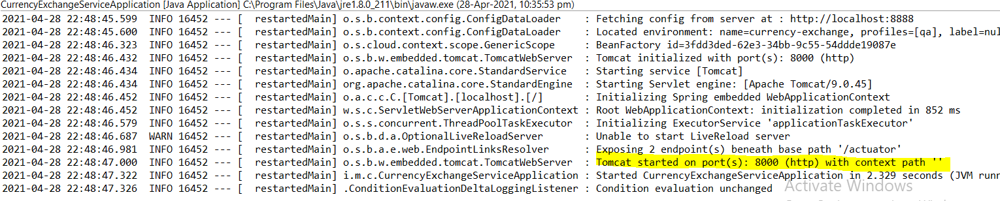

**139. Step 11 - Create a simple hard coded currency exchange service - V2**

Here we will create the below url and response structure.

**URL and Response Structure for Currency Exchange Service**

We will make use of these in the next lecture!

URL : http://localhost:8000/currency-exchange/from/USD/to/INR

**Response Structure**

**{**

**"id":10001,**

**"from":"USD",**

**"to":"INR",**

**"conversionMultiple":65.00,**

**"environment":"8000 instance-id"**

**}**

**Step1- Let’s creates one controller class and one method with resource exposing the above URL and which would return the above response structure. I.e. id, from which currency to which currency and what is multiple rate and environment detail.**

|  |  |
| --- | --- |
| **package com.in28minutes.microservices.currencyexchangeservice.bean;**  **import java.math.BigDecimal;**  **public class CurrencyExchange {**  **private long id;**  **private String from;**  **private String to;**  **private BigDecimal conversionRate;**  **public CurrencyExchange() {**  **super();**  **}**  **public CurrencyExchange(long id, String from, String to, BigDecimal conversionRate) {**  **super();**  **this.id = id;**  **this.from = from;**  **this.to = to;**  **this.conversionRate = conversionRate;**  **}**  **}** | **package com.in28minutes.microservices.currencyexchangeservice.controller;**  **import java.math.BigDecimal;**  **import org.springframework.web.bind.annotation.GetMapping;**  **import org.springframework.web.bind.annotation.PathVariable;**  **import org.springframework.web.bind.annotation.RestController;**  **import com.in28minutes.microservices.currencyexchangeservice.bean.CurrencyExchange;**  **@RestController**  **public class CurrencyExcnageController {**    **//resource= /currency-exchange/from/USD/to/INR**  **@GetMapping(path="/currency-exchange/from/{from}/to/{to}")**  **public CurrencyExchange retriveExchangeRate(**  **@PathVariable String from, @PathVariable String to) {**    **return new CurrencyExchange(1000L, "USD", "INR", BigDecimal.*valueOf*(70));**  **}**  **}**  **Output:** |
| [**http://localhost:8000/currency-exchange/from/USD/to/INR**](http://localhost:8000/currency-exchange/from/USD/to/INR)  **{**  **"id": 1000,**  **"from": "USD",**  **"to": "INR",**  **"conversionRate": 70**  **}** | **So we have got the output :** |

Now here we have not set the port number: So in the next we will set port number of the server from where it is coming.

**142. Step 12 - Setting up Dynamic Port in the Response - V2**

|  |  |
| --- | --- |
| **Added port :**  **package com.in28minutes.microservices.currencyexchangeservice.bean;**  **import java.math.BigDecimal;**  **public class CurrencyExchange {**  **private long id;**  **private String from;**  **private String to;**  **private BigDecimal conversionRate;**  **private String port;**  **public CurrencyExchange() {**  **super();**  **}**  **public CurrencyExchange(long id, String from, String to, BigDecimal conversionRate) {**  **super();**  **this.id = id;**  **this.from = from;**  **this.to = to;**  **this.conversionRate = conversionRate;**  **}**  **// We have added string port and its getters and setters:**  **// In the controller class we have created Environment from Spring [import org.springframework.core.env.Environment;] and then from the application property we are getting port using below key**  **String port = environment.getProperty("local.server.port");**  **And then we are setting this port to CurrencyExchange object.**  **Now this object got the newly added filed port.**  **Let’s test and check.** | **package com.in28minutes.microservices.currencyexchangeservice.controller;**  **import java.math.BigDecimal;**  **import org.springframework.beans.factory.annotation.Autowired;**  **import org.springframework.core.env.Environment;**  **import org.springframework.web.bind.annotation.GetMapping;**  **import org.springframework.web.bind.annotation.PathVariable;**  **import org.springframework.web.bind.annotation.RestController;**  **import com.in28minutes.microservices.currencyexchangeservice.bean.CurrencyExchange;**  **@RestController**  **public class CurrencyExcnageController {**    **@Autowired**  **private Environment environment;**    **//resource= /currency-exchange/from/USD/to/INR**  **@GetMapping(path="/currency-exchange/from/{from}/to/{to}")**  **public CurrencyExchange retriveExchangeRate(**  **@PathVariable String from, @PathVariable String to) {**      **//return new CurrencyExchange(1000L, "USD", "INR", BigDecimal.valueOf(70));**    **// Extract this to local variable : Select the above line of code from new key word> Right click > Refactor >create local variable**  **CurrencyExchange currencyExchange = new CurrencyExchange(1000L, "USD",**  **"INR", BigDecimal.*valueOf*(70));**    **String port = environment.getProperty("local.server.port");**  **currencyExchange.setPort(port);**    **return currencyExchange;**  **}**  **}** |
| <http://localhost:8000/currency-exchange/from/USD/to/INR>  **{**  **"id": 1000,**  **"from": "USD",**  **"to": "INR",**  **"conversionRate": 70,**  **"port": "8000"**  **}** |  |

**Now let’s start another instance of currency-exchange-service on another port 8001 using following steps:**

**Right click on the application 🡺 Goto Run Configurations 🡺**

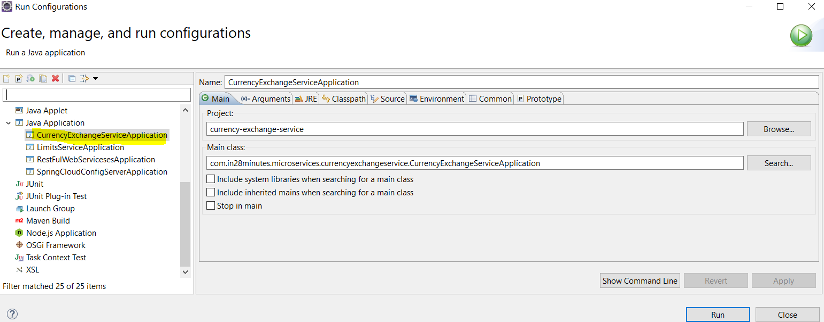

|  |  |
| --- | --- |
|  | **Create a duplicate of existing one and create another instance with different port:**  **Go to Argument tab and provide the below comment in the VM-Argument**  **-Dserver.port=8001** |

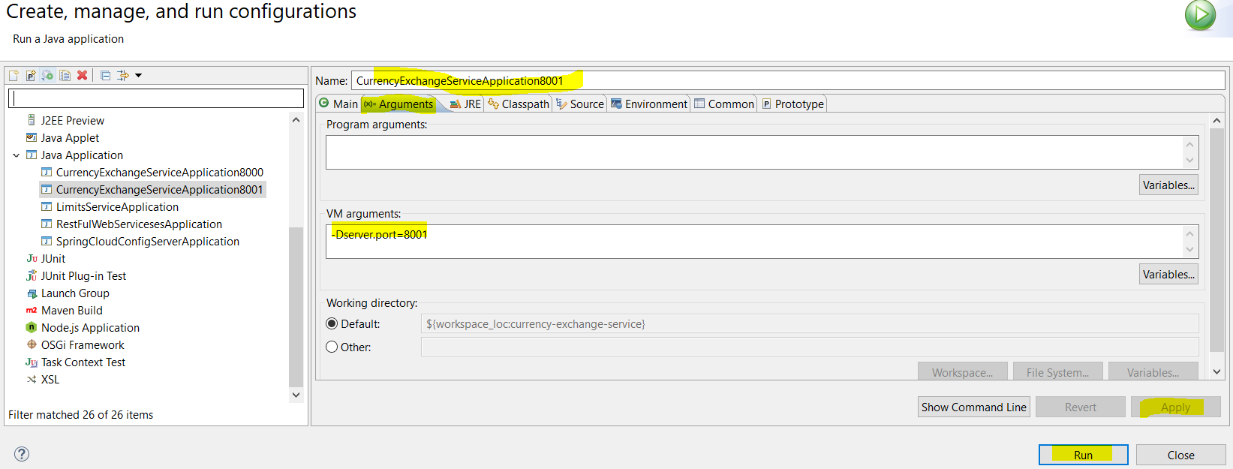

**Now as soon as we click on Run then another instart will start running at port 8001 as shown below in the console log:**

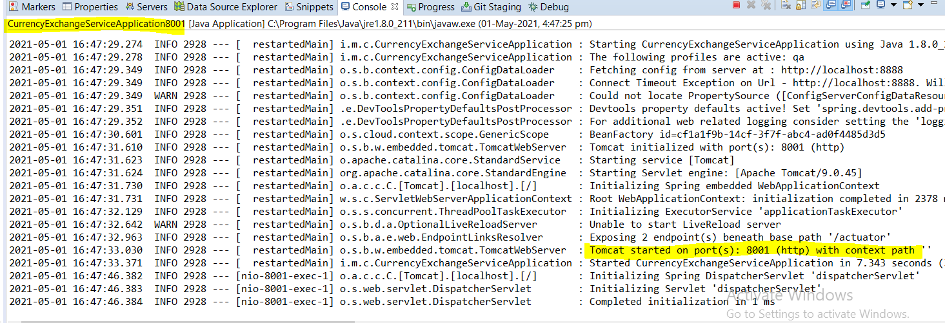

**Now let’s check the server on the port 8000 and 8001**

|  |  |
| --- | --- |
|  |  |
| [**http://localhost:8000/currency-exchange/from/USD/to/INR**](http://localhost:8000/currency-exchange/from/USD/to/INR)  **{**  **"id": 1000,**  **"from": "USD",**  **"to": "INR",**  **"conversionRate": 70,**  **"port": "8000"**  **}** | [**http://localhost:8001/currency-exchange/from/USD/to/INR**](http://localhost:8001/currency-exchange/from/USD/to/INR)  **{**  **"id": 1000,**  **"from": "USD",**  **"to": "INR",**  **"conversionRate": 70,**  **"port": "8001"**  **}** |

**Hence two instance of one application is running on two different port and we are getting same response with their environment port information. In this way we can get to know that from which environment the response is coming.**

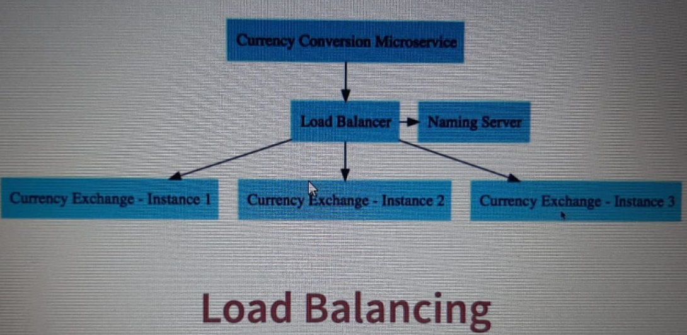

**As in this step we have created multiple instances of Currency Exchange on different port [8000 & 8001] and we have got successful response on the both the instance. In the later steps we will create Currency Conversion Microservices and will create multiple instances and when we will call Currency Conversion Microservice then we would need to know which instance of currency exchange services is proving the response this will be managed by Load Balancer and Naming server.**

**143. Updates for data.sql - Spring Boot 2.5.0 or Greater**

Updates for data.sql - Spring Boot 2.5.0 or Greater

**Summary**

**If you are using Spring Boot 2.5.0 or Greater, you have two options**

**1) Use schema.sql instead of data.sql  OR**

**2) Continue using data.sql. Add the following property to application.properties**

**spring.jpa.defer-datasource-initialization=true**

**Why do you need to make the change?**

[**https://github.com/spring-projects/spring-boot/wiki/Spring-Boot-2.5.0-M3-Release-Notes#hibernate-and-datasql**](https://github.com/spring-projects/spring-boot/wiki/Spring-Boot-2.5.0-M3-Release-Notes#hibernate-and-datasql)

**By default, data.sql scripts are now run before Hibernate is initialized. This aligns the behaviour of basic script-based initialization with that of Flyway and Liquibase. If you want to use data.sql to populate a schema created by Hibernate, set spring.jpa.defer-datasource-initialization to true. While mixing database initialization technologies is not recommended, this will also allow you to use a schema.sql script to build upon a Hibernate-created schema before it’s populated via data.sql.**

Fullscreen

**144. Step 13 - Configure JPA and Initialized Data - V2**

In the previous project we have hard coded the data. Now in this step let’s fetch the data from the DB. Here we would use in memory database H2 and we will be using JPA to talk to the memory database and for this we need to add few dependencies.

|  |
| --- |
| <!-- JPA -->  <dependency>  <groupId>org.springframework.boot</groupId>  <artifactId>spring-boot-starter-data-jpa</artifactId>  </dependency>  <!-- H2 In-Memory Database -->  <dependency>  <groupId>com.h2database</groupId>  <artifactId>h2</artifactId>  </dependency> |

**Stop and start the server explicitly**

**Once the server start up and running then in the console we can see that now the H2 database and JPA is available for application.**

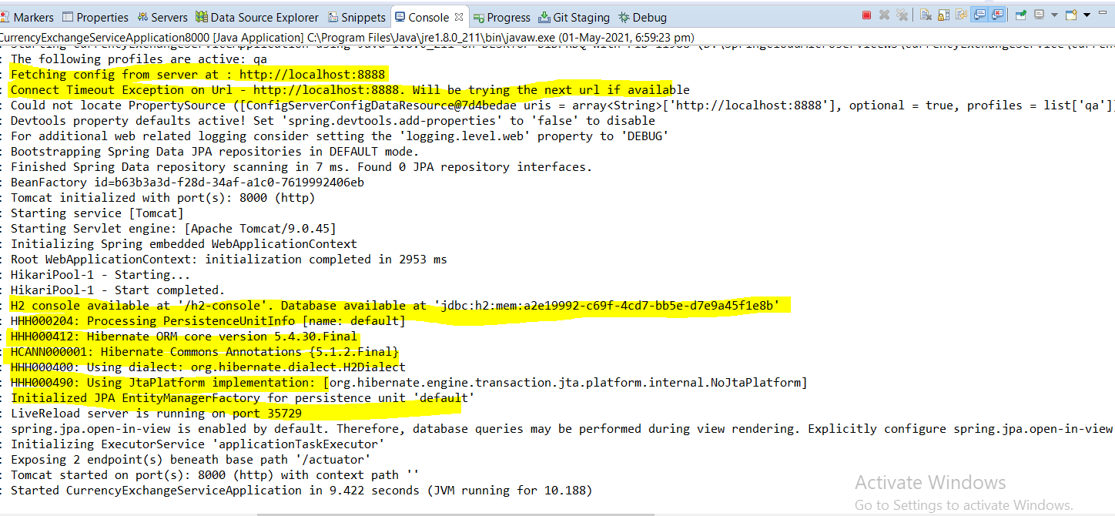

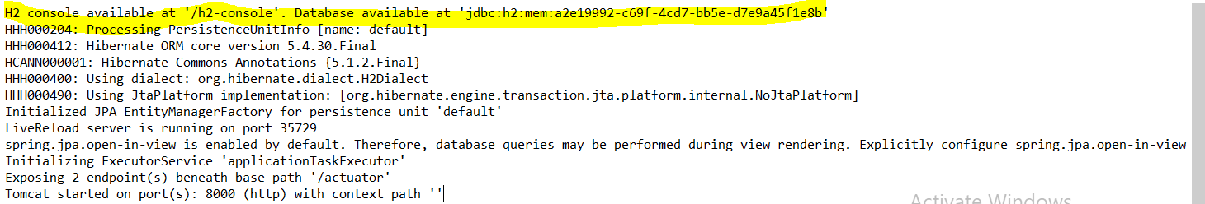

In memory data has been created in this specific location:

H2 console available at '/h2-console'. Database available at 'jdbc:h2:mem:a2e19992-c69f-4cd7-bb5e-d7e9a45f1e8b'

Now we cannot use this random location in URL so let’s configure our own URL in application.properties.

1. The first property will make sure that all the sql statement are being generated
2. The next one is data source URL
3. And finally enable H2 Console to check the detail present in database.

Go to application.properties file of currency-exchange-service application

|  |
| --- |
| # SPRING DATA JPA CONFIGURATIONS:  #1- The first property will make sure that all the sql statement are being generated  spring.jpa.show-sql=true  #2- The next one is data source URL  spring.datasource.url=jdbc:h2:mem:testdb  #3- And finally enable H2 Console to check the detail present in database.  spring.h2.console.enabled=true |

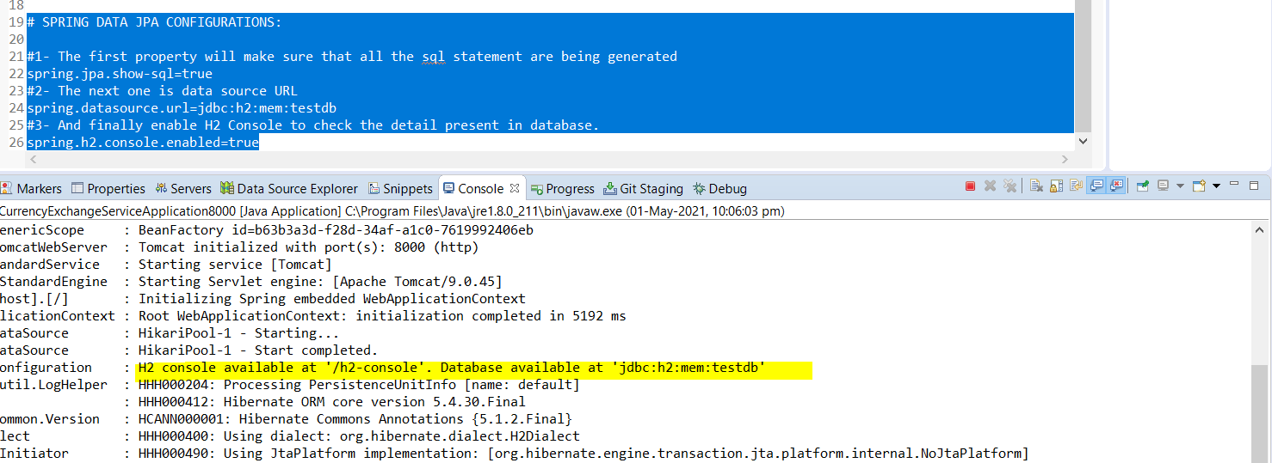

o.s.b.a.h2.H2ConsoleAutoConfiguration : H2 console available at '/h2-console'. Database available at 'jdbc:h2:mem:testdb'

Now hit this URL to get H2 In memory database console: <http://localhost:8000/h2-console/>

|  |  |
| --- | --- |
|  |  |

**Now after configuring the above property we will see the console log and we will get that now the H2 database is located at defined URL instead of random generated URL by spring.**

**Now take the JDBC URL from the property file what we have configured and paste it in JDBC URL and click on connect instead of jdbc:h2~/test.**

spring.datasource.url=jdbc:h2:mem:testdb

Click Connect now:

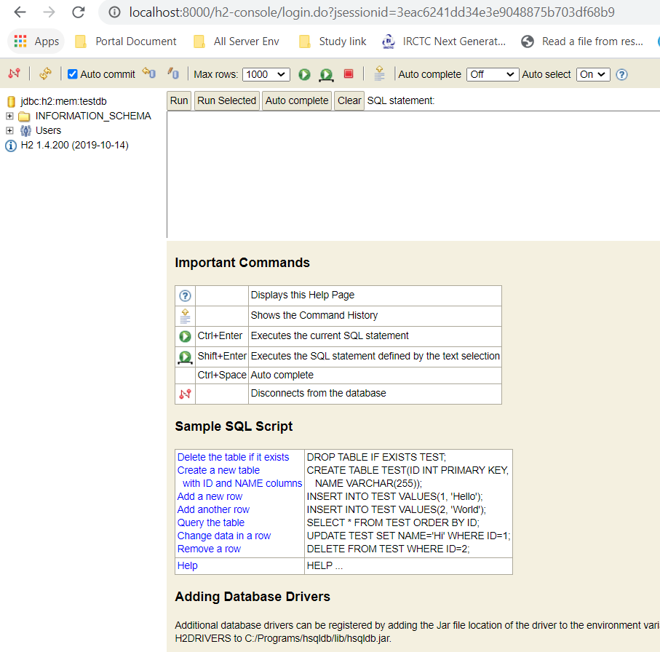

**So finally we have got console and now we will create table and data inside the table.**

**To be able to create table, let’s first define JPA Entity inside the CurrencExchange model class and it automatically create a table for us.**

|  |  |
| --- | --- |
| **import javax.persistence.Entity;**  **import javax.persistence.Id;**  **@Entity**  **public class CurrencyExchange {**  **@Id**  **private long id;**  **private String from;**  **private String to;**  **private BigDecimal conversionRate;**  **private String port;** | **Here @Entity will create a Table with the same name what class name has and**  **@id will create primary key with the same name id.**  **Now once we re-start the server it would create the table and primary of the table.** |

Caused by: org.h2.jdbc.JdbcSQLSyntaxErrorException: Syntax error in SQL statement "CREATE TABLE CURRENCY_EXCHANGE (ID BIGINT NOT NULL, CONVERSION_RATE DECIMAL(19,2), FROM[*] VARCHAR(255), PORT VARCHAR(255), TO VARCHAR(255), PRIMARY KEY (ID))";

**expected "identifier"; SQL statement:**

create table currency_exchange (id bigint not null, conversion_rate decimal(19,2), from varchar(255), port varchar(255), to varchar(255), primary key (id)) [42001-200]

So after restart we have got the above exception expecting identifier and when we get this kind of exception then it means we are using some sql keyword in the java class. So yes we are using ‘from’ which is a keyword in the sql statement and because of this we are getting this exception.So the solution is either change this java variable name or another solution change the column name using @Column(name=”currency_from”)

|  |  |
| --- | --- |
| **@Column(name="currency_from")**  **private String from;**  **@Column(name="currency_to")**  **private String to;** | **So now in the java it would be from only but in the table it now the column name would be with the name of ‘currency_from’ instead of ‘from’**  **And now the column name would be ‘currency _to’ instead of only ‘to’** |

Now re-start the server and now we will not get any problem, now check the log in the console and we would get the sql statement for create table.

|  |
| --- |
| **Hibernate: drop table if exists currency_exchange CASCADE**  **Hibernate: create table currency_exchange (id bigint not null, conversion_rate decimal(19,2), currency_from varchar(255), port varchar(255), currency_to varchar(255), primary key (id))** |

And same table we will see in H2 Console:

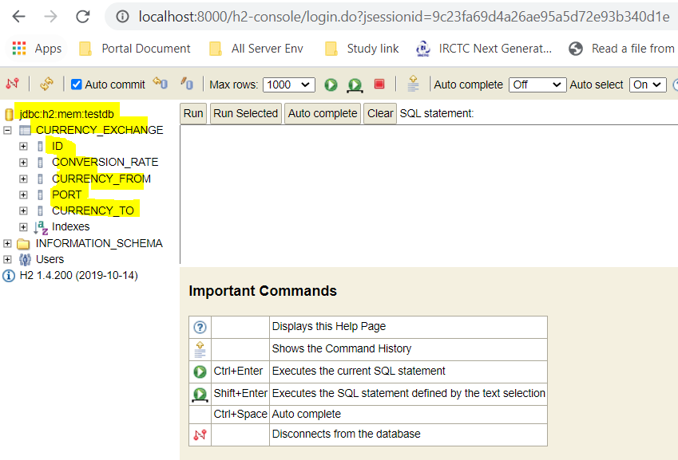

Now to check more let’s run select query statement.

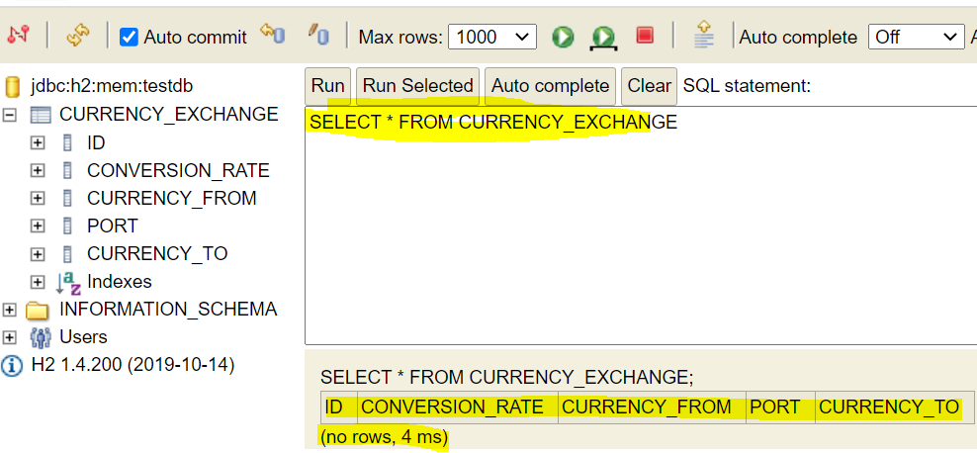

And there is no data but we can see the name of table and all the columns in java all the names was in camel case but here in case of sql two words are separated by underscore.

Now insert some data: To insert record into H2 database let’s create on data.sql file inside the resource folder of the application and place the below sql insert command and once we start the server all the data method in the file will be inserted into table.

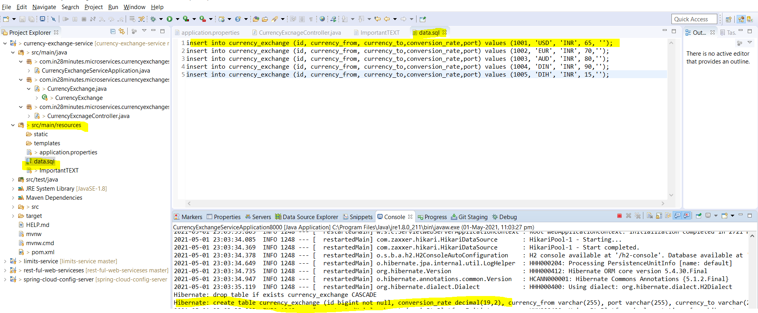

Now let’s check the H2 console: [select * from currency_exchange]

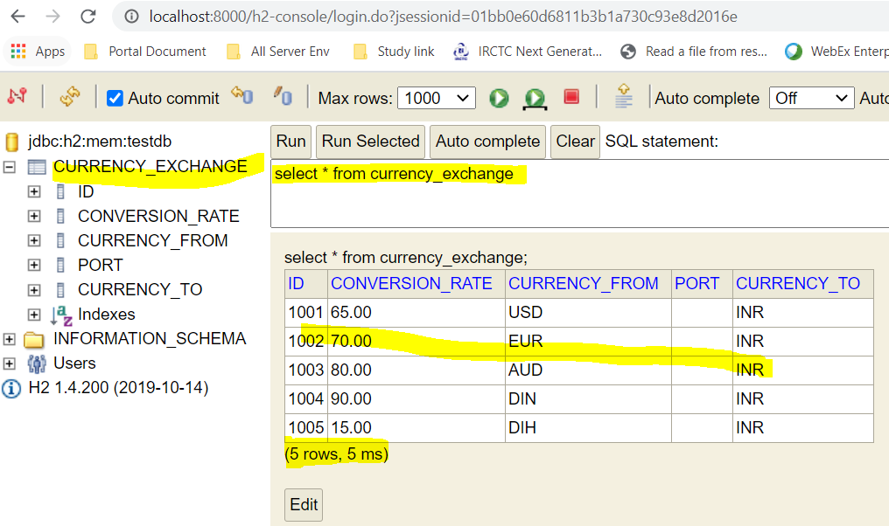

So yes now record has been inserted into table.

Now in the next step let’s connect this H2 DB to our service.

**145. CODE BACKUP FILES and STEP BY STEP CHANGES : For Reference**

#### ****Help for Debugging Problems:****

* Here's the code backup at the end of Step 13: <https://github.com/in28minutes/spring-microservices-v2/blob/main/03.microservices/step13.md>
* Step by Step changes are detailed here: <https://github.com/in28minutes/spring-microservices-v2/blob/main/03.microservices/01-step-by-step-changes/microservices-v2-1.md#step-13>

#### ****Two Recommended Activities:****

**Activity - 1** : Explore other backups for this section (Steps 08,10,13,15,21,25,29, final) - <https://github.com/in28minutes/spring-microservices-v2/tree/main/03.microservices>

**Activity - 2** : Get Familiar with the structure of Step by Step changes file - <https://github.com/in28minutes/spring-microservices-v2/blob/main/03.microservices/01-step-by-step-changes/microservices-v2-1.md#step-13>

**146. Step 14 - Create a JPA Repository - V2**

In this step let’s now update our REST API to connect to the Data base. And for that we need to create spring interface called Repository.

So let’s create one interface Repository with name [CurrencyExchangeRepository] to manage CurrencyExchange class variables.

This interface will extends **extends** JpaRepository<CurrencyExchange, Long> and here will pass the entity which has to managed by repository and primary key which type is long.

|  |
| --- |
| **package com.in28minutes.microservices.currencyexchangeservice.repository;**  **import org.springframework.data.jpa.repository.JpaRepository;**  **import com.in28minutes.microservices.currencyexchangeservice.bean.CurrencyExchange;**  **public interface CurrencyExchangeRepository extends JpaRepository<CurrencyExchange, Long> {**  **CurrencyExchange findByFromAndTo(String from, String to);**  **// When the above method will be executed then this would be converted into select query and this two from and to**  **// will be used to find**  **}** |

**Note: Here findByFromAndTo name should be in camel case and From / To initials should be in capital otherwise JPA would not be able to understand and cannot convert this into sql query statement.**

**This interface CurrencyExchangeRepository helps us to talk to database.**

|  |  |
| --- | --- |
| **package** com.in28minutes.microservices.currencyexchangeservice.controller;  **import** java.math.BigDecimal;  **import** org.springframework.beans.factory.annotation.Autowired;  **import** org.springframework.core.env.Environment;  **import** org.springframework.web.bind.annotation.GetMapping;  **import** org.springframework.web.bind.annotation.PathVariable;  **import** org.springframework.web.bind.annotation.RestController;  **import** com.in28minutes.microservices.currencyexchangeservice.bean.CurrencyExchange;  **import** com.in28minutes.microservices.currencyexchangeservice.repository.CurrencyExchangeRepository;  **@RestController**  **public class CurrencyExcnageController {**    **@Autowired**  **private CurrencyExchangeRepository repository;**  **@Autowired**  **private Environment environment;**    **//resource= /currency-exchange/from/USD/to/INR**  **@GetMapping(path="/currency-exchange/from/{from}/to/{to}")**  **public CurrencyExchange retriveExchangeRate(@PathVariable String from, @PathVariable String to) {**      **//return new CurrencyExchange(1000L, "USD", "INR", BigDecimal.valueOf(70));**    **// Extract this to local variable : Select the above line of code from new key word> Right click > Refactor >create local variable**    **//CurrencyExchange currencyExchange = new CurrencyExchange(1000L, "USD", "INR", BigDecimal.valueOf(70));**    **CurrencyExchange currencyExchange =repository.findByFromAndTo(from, to);**    **String port = environment.getProperty("local.server.port");**  **currencyExchange.setPort(port);**    **return currencyExchange;**  **}**  **}** | |
| [**http://localhost:8000/currency-exchange/from/USD/to/INR**](http://localhost:8000/currency-exchange/from/USD/to/INR)  **{**  **"id": 1001,**  **"from": "USD",**  **"to": "INR",**  **"conversionRate": 65.00,**  **"port": "8000"**  **}** | [**http://localhost:8000/currency-exchange/from/EUR/to/INR**](http://localhost:8000/currency-exchange/from/EUR/to/INR)  **{**  **"id": 1002,**  **"from": "EUR",**  **"to": "INR",**  **"conversionRate": 70.00,**  **"port": "8000"**  **}** |
| [**http://localhost:8000/currency-exchange/from/AUD/to/INR**](http://localhost:8000/currency-exchange/from/AUD/to/INR)  **{**  **"id": 1003,**  **"from": "AUD",**  **"to": "INR",**  **"conversionRate": 80.00,**  **"port": "8000"**  **}** | [**http://localhost:8000/currency-exchange/from/DIN/to/INR**](http://localhost:8000/currency-exchange/from/DIN/to/INR)  **{**  **"id": 1004,**  **"from": "DIN",**  **"to": "INR",**  **"conversionRate": 90.00,**  **"port": "8000"**  **}** |
| [**http://localhost:8000/currency-exchange/from/DIH/to/INR**](http://localhost:8000/currency-exchange/from/DIH/to/INR)  **{**  **"id": 1005,**  **"from": "DIH",**  **"to": "INR",**  **"conversionRate": 15.00,**  **"port": "8000"**  **}** | **So now we can see the response based on the request parameter from and to.**  **Now we are fetching this value from database.** |

insert into currency_exchange (id, currency_from, currency_to,conversion_rate,port) values (1001, 'USD', 'INR', 65, '');

insert into currency_exchange (id, currency_from, currency_to,conversion_rate,port) values (1002, 'EUR', 'INR', 70,'');

insert into currency_exchange (id, currency_from, currency_to,conversion_rate,port) values (1003, 'AUD', 'INR', 80,'');

insert into currency_exchange (id, currency_from, currency_to,conversion_rate,port) values (1004, 'DIN', 'INR', 90,'');

insert into currency_exchange (id, currency_from, currency_to,conversion_rate,port) values (1005, 'DIH', 'INR', 15,'');

We have completed Currency-Exchange-Service and now next we will setup Currency-Conversion-service in the next step;

**147. Step 15 - Setting up Currency Conversion Microservice - V2**

|  |  |
| --- | --- |
|  | [**http://localhost:8000/currency-exchange/from/USD/to/INR**](http://localhost:8000/currency-exchange/from/USD/to/INR)  **{**  **"id": 1001,**  **"from": "USD",**  **"to": "INR",**  **"conversionRate": 65.00,**  **"port": "8000"**  **}** |

As per image so far we have created Currency Exchange services which talks to data base and it give response as mentioned in the next column.

Now let’s talk about Currency Conversion Microservices and its responses. Here we will implement the Currency Conversion

Let’s create the project using spring initializer. Click generate

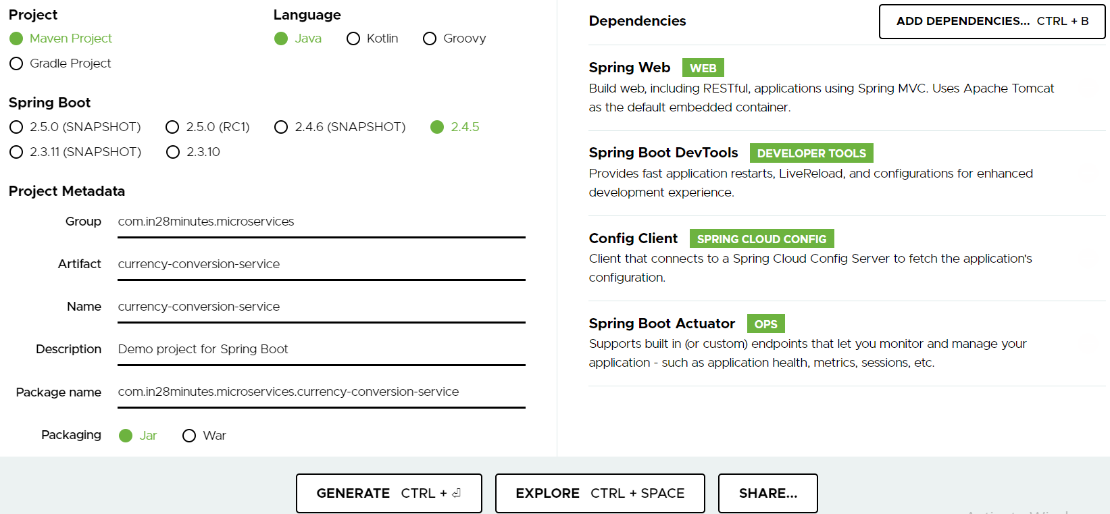

Select the following dependencies:

* **Spring Web WEB**Build web, including RESTful, applications using Spring MVC. Uses Apache Tomcat as the default embedded container.
* **Spring Boot DevTools DEVELOPER TOOLS**Provides fast application restarts, LiveReload, and configurations for enhanced development experience.
* **Config Client SPRING CLOUD CONFIG**Client that connects to a Spring Cloud Config Server to fetch the application's configuration.
* **Spring Boot Actuator O**Supports built in (or custom) endpoints that let you monitor and manage your application - such as application health, metrics, sessions, etc.

Step2- Import the project into eclipse and in the application.properties file configures the following properties.

|  |
| --- |
| spring.application.name=currency-conversion  server.port=8100  #Enable the below property when spring.config.import property is not configured  #spring.cloud.config.import-check.enabled=false  #CENTRALZED CONFIG SERVER TO IMPORT CONFIGURATION FROM GIT  spring.config.import=optional:configserver:http://localhost:8888  #CONFIGURATIONS OF MULTIPLE PROFILE FOR DIFFERENT ENVIRONMENTS  #spring.profiles.active = dev  spring.profiles.active = qa  #spring.profiles.active = stage  #spring.cloud.config.prifiles=stage |

Now let’s launch the server :

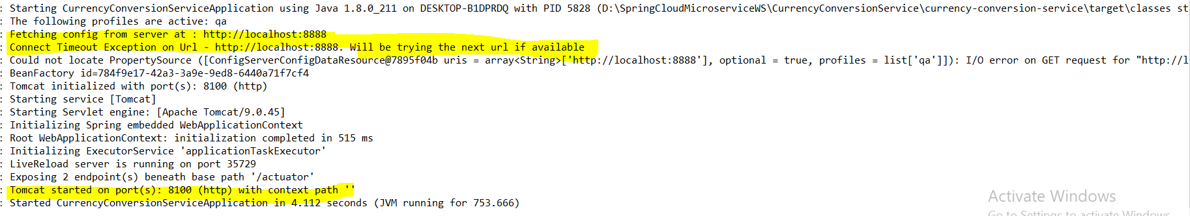

And now server is running at port: 8100

**149. Step 16 - Creating a service for currency conversion - V2**

In this step let’s create simple Rest Api. Here we would Consume the Currency Exchange services and then calculate the conversion. We will create the resource url and response as per the given structure.

Microservices which will give the response as mentioned below.

|  |
| --- |
| URL and Response Structure for Currency Conversion Service  URL  <http://localhost:8100/currency-conversion/from/USD/to/INR/quantity/10>  Response Structure  {  "id": 10001,  "from": "USD",  "to": "INR",  "conversionMultiple": 65.00,  "quantity": 10,  "totalCalculatedAmount": 650.00,  "environment": "8000 instance-id"  } |

<http://localhost:8100/currency-conversion/from/USD/to/INR/quantity/10>

Here currency-conversion/from/USD/to/INR/quantity/10 =🡺 currency-conversion/from/{from}/to/{To}/quantity/{quantity}

So here have to provide the three inputs from this service and we will get the above response.

First of all let’s provide the hard coded values and later we will consume currency-Exchange service and will get dynamic value based on the passed parameters.

|  |
| --- |
| **package com.in28minutes.microservices.currencyconversionservice.bean;**  **import java.math.BigDecimal;**  **public class CurrencyConversion {**  **private Long id;**  **private String from;**  **private String to;**  **private BigDecimal conversionMultiple;**  **private BigDecimal quantity;**  **private BigDecimal totalCalculatedAmount;**  **private String port;**    **public CurrencyConversion() {**  **super();**  **}**  **public CurrencyConversion(Long id, String from, String to, BigDecimal quantity,BigDecimal conversionMultiple,**  **BigDecimal totalCalculatedAmount, String port) {**  **super();**  **this.id = id;**  **this.from = from;**  **this.to = to;**  **this.conversionMultiple = conversionMultiple;**  **this.quantity = quantity;**  **this.totalCalculatedAmount = totalCalculatedAmount;**  **this.port = port;**  **}**  **// Getters and setters** |
| **package** com.in28minutes.microservices.currencyconversionservice.controller;  **import java.math.BigDecimal;**  **import org.springframework.web.bind.annotation.GetMapping;**  **import org.springframework.web.bind.annotation.PathVariable;**  **import org.springframework.web.bind.annotation.RestController;**  **import com.in28minutes.microservices.currencyconversionservice.bean.CurrencyConversion;**  **@RestController**  **public class CurrencyConversionController {**  **//Here currency-conversion/from/USD/to/INR/quantity/10 =➔ currency-conversion/from/{from}/to/{To}/quantity/{quantity}**  **@GetMapping(path="currency-conversion/from/{from}/to/{to}/quantity/{quantity}")**  **public CurrencyConversion calculateCurrencyConversion(**  **@PathVariable String from,**  **@PathVariable String to,**  **@PathVariable BigDecimal quantity**  **) {**  **return new CurrencyConversion(1000L, from, to, quantity, BigDecimal.*ONE*, BigDecimal.*ONE*, "8100");**  **}**  **}** |
| [**http://localhost:8100/currency-conversion/from/USD/to/INR/quantity/10**](http://localhost:8100/currency-conversion/from/USD/to/INR/quantity/10)  **{**  **"id": 1000,**  **"from": "USD",**  **"to": "INR",**  **"conversionMultiple": 1,**  **"quantity": 10,**  **"totalCalculatedAmount": 1,**  **"port": "8100"**  **}**  **So we have to the response as per the hard values passed in the constructor.** |

In the next step we will talk to currency-exchange service and the will calculate the totalCalculatedAmount

**150. Step 17 - Invoking Currency Exchange from Currency Conversion Microservice using RestTemplate client- V2**

How to call currency exchange service in currency conversion service

We will use RestTemplate () to consume currency-exchange rest service.

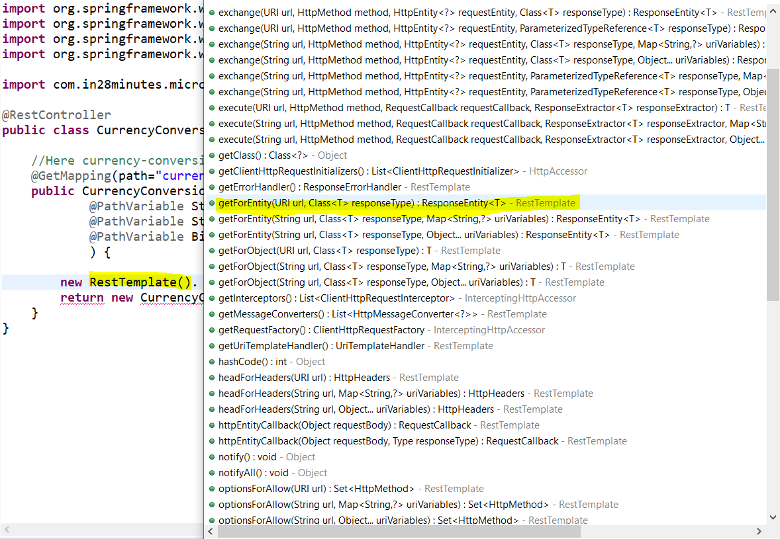

Here we will use below syntax

**ResponseEntity<CurrencyConversion> response = new RestTemplate ().getForEntity (String url, Class<T> responseType, MAP<String?>uriVariables)**

So here we are using getForEntity () method of RestTemplate class. It takes three parameters

1. **URL** : Rest Service URL to be consumed
2. **Class responseType**: The class in which format response needs to be mapped
3. **uriVariables**: It is the request parameter which will be send in the form of Map

|  |  |
| --- | --- |
| **package** com.in28minutes.microservices.currencyconversionservice.controller;  **import** java.math.BigDecimal;  **import** java.util.HashMap;  **import** java.util.Map;  **import** org.springframework.http.ResponseEntity;  **import** org.springframework.web.bind.annotation.GetMapping;  **import** org.springframework.web.bind.annotation.PathVariable;  **import** org.springframework.web.bind.annotation.RestController;  **import** org.springframework.web.client.RestTemplate;  **import** com.in28minutes.microservices.currencyconversionservice.bean.CurrencyConversion;  **@RestController**  **public class CurrencyConversionController {**    **@GetMapping(path = "/currency-conversion/from/{from}/to/{to}/quantity/{quantity}")**  **public CurrencyConversion calculateCurrencyConversion(@PathVariable String from, @PathVariable String to,**  **@PathVariable BigDecimal quantity) {**    **// Use RestTemplate syntax to consume currency-exchange service**  **// new RestTemplate().getForEntity(String url, Class<T> responseType, MAp<String,?>uriVariables)**  **// URL: http://localhost:8000/currency-exchange/from/AUD/to/INR**  **// ReponseType: CurrencyConversion**  **// uriVariables put in HashMap**    **Map<String, String> uriVariables = new HashMap<String, String>();**    **uriVariables.put("from", from);**  **uriVariables.put("to", to);**      **ResponseEntity<CurrencyConversion> response = new RestTemplate()**  **.getForEntity("http://localhost:8000/currency-exchange/from/{from}/to/{to}", CurrencyConversion.class, uriVariables);**  **CurrencyConversion currencyConversionBody = response.getBody();**    **System.*out*.println("currencyConversionBody.getId()-"+currencyConversionBody.getId());**  **System.*out*.println("currencyConversionBody.getConversionMultiple()-"+currencyConversionBody.getConversionMultiple());**  **System.*out*.println("Total-"+quantity.multiply(currencyConversionBody.getConversionMultiple()));**  **System.*out*.println("currencyConversionBody.getPort()-"+currencyConversionBody.getPort());**    **return new CurrencyConversion(currencyConversionBody.getId(), from, to,**  **quantity,currencyConversionBody.getConversionMultiple(),**  **quantity.multiply(currencyConversionBody.getConversionMultiple()),**  **currencyConversionBody.getPort());**    **//return new CurrencyConversion(1000L, from, to, quantity,BigDecimal.ONE,BigDecimal.ONE, "8100");**  **}**  **}** | |
| [**http://localhost:8000/currency-exchange/from/USD/to/INR/**](http://localhost:8000/currency-exchange/from/USD/to/INR/)  **{**  **"id": 1001,**  **"from": "USD",**  **"to": "INR",**  **"conversionRate": 65.00,**  **"port": "8000"**  **}** | [**http://localhost:8100/currency-conversion/from/USD/to/INR/quantity/1000**](http://localhost:8100/currency-conversion/from/USD/to/INR/quantity/1000)  **{**  **"id": 1001,**  **"from": "USD",**  **"to": "INR",**  **"conversionMultiple": 65.00,**  **"quantity": 1000,**  **"totalCalculatedAmount": 65000.00,**  **"port": "8000"**  **}** |

Log:

currencyConversionBody.getId ()-1001

currencyConversionBody.getConversionMultiple ()-65.00

Total-65000.00

currencyConversionBody.getPort ()-8000

So here we are consuming currency-exchange services and store the body in the currencyConversionBody object

and now using this object we are extracting each data from the currency-exchange service.

And now we are getting the response as expected.

|  |  |
| --- | --- |
| <http://localhost:8000/currency-exchange/from/AUD/to/INR/>  {  "id": 1003,  "from": "AUD",  "to": "INR",  "conversionRate": 80.00,  "port": "8000"  }  This service is being consumed in currency conversion service. | <http://localhost:8100/currency-conversion/from/AUD/to/INR/quantity/1000>  {  "id": 1003,  "from": "AUD",  "to": "INR",  "conversionMultiple": 80.00,  "quantity": 1000,  "totalCalculatedAmount": 80000.00,  "port": "8000"  } |

So finally now we are ready with currency-exchange-service and currency-conversion-service and now we are ready to explore more towards spring cloud side.

**151. Step 18 - Using Feign REST Client for Service Invocation - V2**

**In the last step we have written several lines of tedious codes around RestTemplate to get Currency-Conversion-Service to talk to currency-exchange-Microservice, So just to consume one service or to talk to other service we have to write about more than 20 lines of codes. So if we have 100 of microservices to talk to each other then we will have to repeat this line of code everywhere.**

**To solve this reparative work, spring cloud provides us a frame work called Feign Rest Client. It makes very easy to consume other microservices. To make use of Feign we have to follow some steps mentioned below.**

**Step-1: Add the below dependency in currency-conversion-service pom.xml file**

|  |
| --- |
| <dependency>  <groupId>org.springframework.cloud</groupId>  <artifactId>spring-cloud-starter-openfeign</artifactId>  </dependency> |

**Step-2:** Put @EnableFeignClients in the spring launcher class as given below.

|  |
| --- |
| **package com.in28minutes.microservices.currencyconversionservice;**  **import org.springframework.boot.SpringApplication;**  **import org.springframework.boot.autoconfigure.SpringBootApplication;**  **import org.springframework.cloud.openfeign.EnableFeignClients;**  **@SpringBootApplication**  **@EnableFeignClients**  **public class CurrencyConversionServiceApplication {**  **public static void main(String[] args) {**  **SpringApplication.run(CurrencyConversionServiceApplication.class, args);**  **}**  **}** |

**Step-3: Now to be able to talk with currency-exchange-service, and for that we need to create proxy in a new interface inside currency-conversion-service. And put @FeignClient annotation on this interface as given below. And inside this provide the service application name (which we have declared in its properties file) and its URL which we want to consume or want to talk.**

spring.application.name=currency-exchange

URL : http://localhost:8000/currency-exchange/from/USD/to/INR

|  |
| --- |
| **package** com.in28minutes.microservices.currencyconversionservice.proxy;  **import** org.springframework.cloud.openfeign.FeignClient;  **@FeignClient(name ="currency-exchange", url = "localhost:8000")**  **public** **interface** CurrencyConversionProxy {  **@GetMapping(path="/currency-exchange/from/{from}/to/{to}")**  **public CurrencyConversion retriveExchangeRate(@PathVariable String from, @PathVariable String to);**  }  **Note**: We don’t need to put whole URL, just need to put localhost: 8000 and the remaining part of url (/currency-exchange/from/USD/to/INR) should be the part of method declare inside the proxy interface.  So copy the same method which we have defined in the currency-exchange controller class and match it with the currency-conversion service model class so that it could match with the response we are expecting. |

**Step-4:** Now finally we will call this proxy method inside the Currency-conversion controller class as given below.

Autowired the above CurrencyConversionProxy interface inside the controller class and class use this proxy method to talk to currency exchange service.

|  |
| --- |
| @Autowired  **private** CurrencyConversionProxy proxy;    @GetMapping(path = "/currency-conversion-feign/from/{from}/to/{to}/quantity/{quantity}")  **public** CurrencyConversion calculateCurrencyConversionFeign(  @PathVariable String from,  @PathVariable String to,  @PathVariable BigDecimal quantity) {    **CurrencyConversion currencyConversionBody = proxy.retriveExchangeRate(from, to);**    **System.*out*.println("currencyConversionBody.getId()-"+currencyConversionBody.getId());**  **System.*out*.println("currencyConversionBody.getConversionMultiple()-"+currencyConversionBody.getConversionMultiple());**  **System.*out*.println("Total-"+quantity.multiply(currencyConversionBody.getConversionMultiple()));**  **System.*out*.println("currencyConversionBody.getPort()-"+currencyConversionBody.getPort());**    **return new CurrencyConversion(currencyConversionBody.getId(), from, to, quantity, currencyConversionBody.getConversionMultiple(),**  **quantity.multiply(currencyConversionBody.getConversionMultiple()),**  **currencyConversionBody.getPort());**    **//return new CurrencyConversion(1000L, from, to, quantity,BigDecimal.ONE,BigDecimal.ONE, "8100");**  } |

So if we compare with RestTemplate, here only one line of code need to write this will get the response body of currency-exchange service.

Recommended to compare it with RestTemplate that we have used in the last step.

Output:

|  |
| --- |
| **Using Feign Client:**  <http://localhost:8100/currency-conversion-feign/from/USD/to/INR/quantity/10>  {  "id": 1001,  "from": "USD",  "to": "INR",  "conversionMultiple": 65.00,  "quantity": 10,  "totalCalculatedAmount": 650.00,  "port": "8000-From FeignClient"  } |
| **Using RestTemplate:**  <http://localhost:8100/currency-conversion/from/USD/to/INR/quantity/10>  {  "id": 1001,  "from": "USD",  "to": "INR",  "conversionMultiple": 65.00,  "quantity": 10,  "totalCalculatedAmount": 650.00,  "port": "8000-From RestTemplate"  } |
|  |

So we are getting same response.

Complete code:

|  |
| --- |
| **package** com.in28minutes.microservices.currencyconversionservice.controller;  **import** java.math.BigDecimal;  **import** java.util.HashMap;  **import** java.util.Map;  **import** org.springframework.beans.factory.annotation.Autowired;  **import** org.springframework.http.ResponseEntity;  **import** org.springframework.web.bind.annotation.GetMapping;  **import** org.springframework.web.bind.annotation.PathVariable;  **import** org.springframework.web.bind.annotation.RestController;  **import** org.springframework.web.client.RestTemplate;  **import** com.in28minutes.microservices.currencyconversionservice.bean.CurrencyConversion;  **import** com.in28minutes.microservices.currencyconversionservice.proxy.CurrencyConversionProxy;  **@RestController**  **public class CurrencyConversionController {**    **@GetMapping(path = "/currency-conversion/from/{from}/to/{to}/quantity/{quantity}")**  **public CurrencyConversion calculateCurrencyConversion(@PathVariable String from, @PathVariable String to,**  **@PathVariable BigDecimal quantity) {**  **Map<String, String> uriVariables = new HashMap<String, String>();**  **uriVariables.put("from", from);**  **uriVariables.put("to", to);**  **ResponseEntity<CurrencyConversion> response = new RestTemplate()**  **.getForEntity("http://localhost:8000/currency-exchange/from/{from}/to/{to}",**  **CurrencyConversion.class, uriVariables);**  **CurrencyConversion currencyConversionBody = response.getBody();**  **return new CurrencyConversion(currencyConversionBody.getId(), from, to,**  **quantity,currencyConversionBody.getConversionMultiple(),**  **quantity.multiply(currencyConversionBody.getConversionMultiple()),**  **currencyConversionBody.getPort()+"-From RestTemplate");**  **//return new CurrencyConversion(1000L, from, to, quantity,BigDecimal.ONE,BigDecimal.ONE, "8100");**  **}**  **//---------------------Feign Client---------------**  **@Autowired**  **private CurrencyConversionProxy proxy;**  **@GetMapping(path = "/currency-conversion-feign/from/{from}/to/{to}/quantity/{quantity}")**  **public CurrencyConversion calculateCurrencyConversionFeign(@PathVariable String from, @PathVariable String to,**  **@PathVariable BigDecimal quantity) {**    **CurrencyConversion currencyConversionBody = proxy.retriveExchangeRate(from, to);**  **return new CurrencyConversion(currencyConversionBody.getId(), from, to, quantity,**  **currencyConversionBody.getConversionMultiple(),**  **quantity.multiply(currencyConversionBody.getConversionMultiple()),**  **currencyConversionBody.getPort()+"-From FeignClient");**  **//return new CurrencyConversion(1000L, from, to, quantity,BigDecimal.ONE,BigDecimal.ONE, "8100");**  **}**  **}** |

So Feign plays ver-2 important role when we discuss about microservices in the cloud load balancing and naming server.

**152. Step 19 - Understand Naming Server and Setting up Eureka Naming Server - V2**

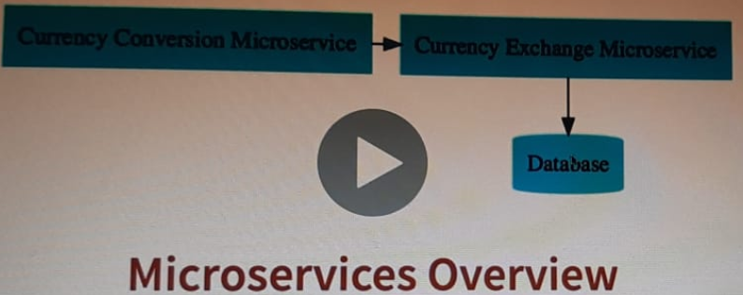

**So** finally we have completed the successful flow of taking Currency-Conversion-Service to Currency-Exchange-Service which in-turn talk to database. However there is still small problem what is the problem?

|  |
| --- |
| **@FeignClient(name ="currency-exchange", url = "localhost:8000")**  **public** **interface** CurrencyConversionProxy {  **@GetMapping(path="/currency-exchange/from/{from}/to/{to}")**  **public CurrencyConversion retriveExchangeRate(@PathVariable String from, @PathVariable String to);**  } |

So the problem is still we have hard coded the URL in the proxy class and let’s say if we have more the one instance of currency-exchange services running on different port(like 8001,8002 etc) or if we have modified the existing instance port number then in this case we have to modify the code every time.

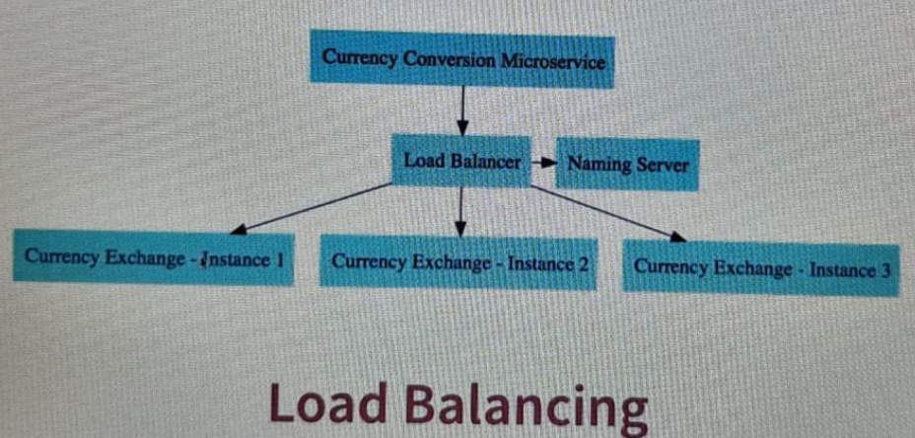

**As per the diagram we want to create dynamic instance and want to distribute its loads equally using load balancer. As here we have three instances 1, 2, 3. Let’s say these instances are running on 8001, 8002, 8003 ports respectively and as instances come up and goes down then we would want to discover them automatically and load balance automatically between them.**

**Even if Feign provide the URL in the list format like [url = "localhost:8000; localhost:8001; localhost:8002"] even this solution also will not work because then in this case we can create the instances which are mentioned here and if we want to add any new instances then again we need to add the newly created instance here in the list. So every time we have to change the code and its configuration.**

**To solve this problem we will go with Service-Registry or a Naming-Server.**

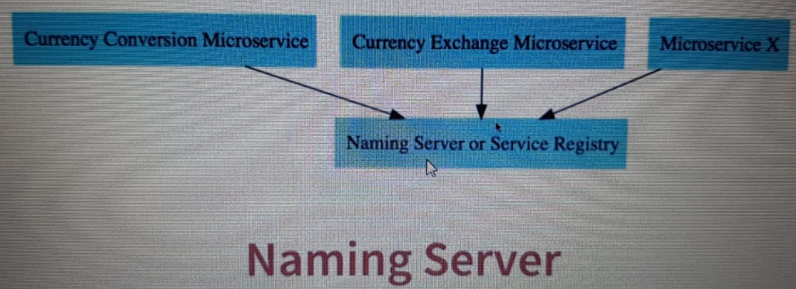

**So In a Microservice Architecture all the instances of all the Microservices would register with a Naming server or service Registry.**

**So as per the diagram Currency-Conversion-Services, Currency-Exchange-Service and others are registered with the Naming server and now let’s say if Currency-Conversion-Service want to communicate with Currency-Exchange-Service then it would ask Service Registry “Hey what are the addresses of currency-exchange-services” and Service-Registry would return back those to Currency-Conversion-Microservice and then further CCnS can send the request o CExS. So this is theoretical concept of Naming Server or Server Registry.**

**Now let’s create one Naming Server in Spring cloud one of the option Eureka.**

Go to start.spring.io

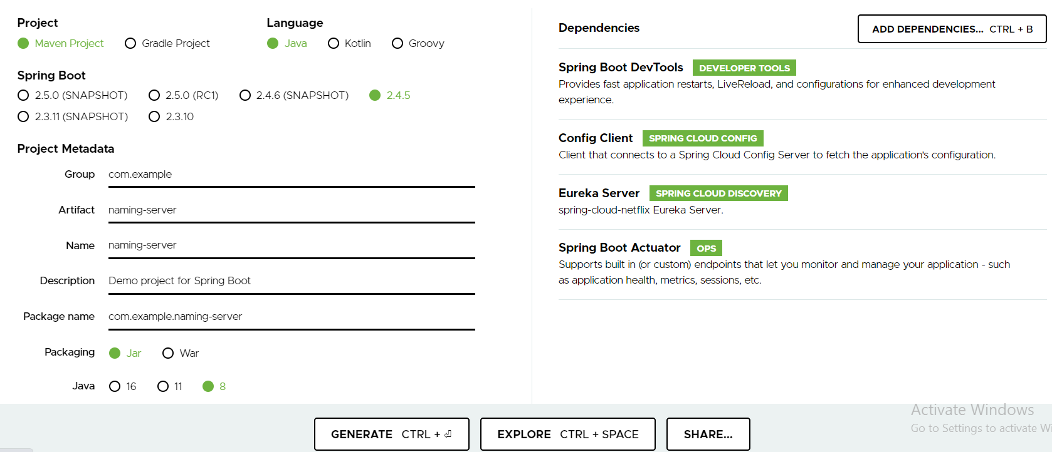

Dependencies:

* **Spring Boot DevTools:** Provides fast application restarts, LiveReload, and configurations for enhanced development experience.
* **Config Client:** Client that connects to a Spring Cloud Config Server to fetch the application's configuration.
* **Eureka Server: spring-cloud-Netflix Eureka Server.**
* **Spring Boot Actuator**Supports built in (or custom) endpoints that let you monitor and manage your application - such as application health, metrics, sessions, etc.

Step-1: Import the project

So here we have one more added new dependency to create naming server project.

|  |
| --- |
| <dependency>  <groupId>org.springframework.cloud</groupId>  <artifactId>spring-cloud-starter-netflix-eureka-server</artifactId>  </dependency> |

Step-2:

As for us to be able to use Eureka server there is one change that we have to make in Naming-Server spring launcher class as given below.

|  |
| --- |
| **package** com.in28minutes.microservices.namingserver;  **import** org.springframework.boot.SpringApplication;  **import** org.springframework.boot.autoconfigure.SpringBootApplication;  **import** org.springframework.cloud.netflix.eureka.server.EnableEurekaServer;  @EnableEurekaServer  @SpringBootApplication  **public** **class** NamingServerApplication {  **public** **static** **void** main(String[] args) {  SpringApplication.*run*(NamingServerApplication.**class**, args);  }  } |

Step-3: Now mention the application name and port number in the naming-server application.properties file.

|  |
| --- |
| spring.application.name = naming-server  spring.port = 8761 |

Note: Apart from these two properties we have others properties recommended by Eureka and that is here we are creating Eureka server and we don’t want it be resister with itself.

|  |
| --- |
| #Don’t register this Eureka with itself  eureka.client.register-with-eureka=false  eureka.client.fetch-registry=false |

Now let’s start the Naming-server application server:

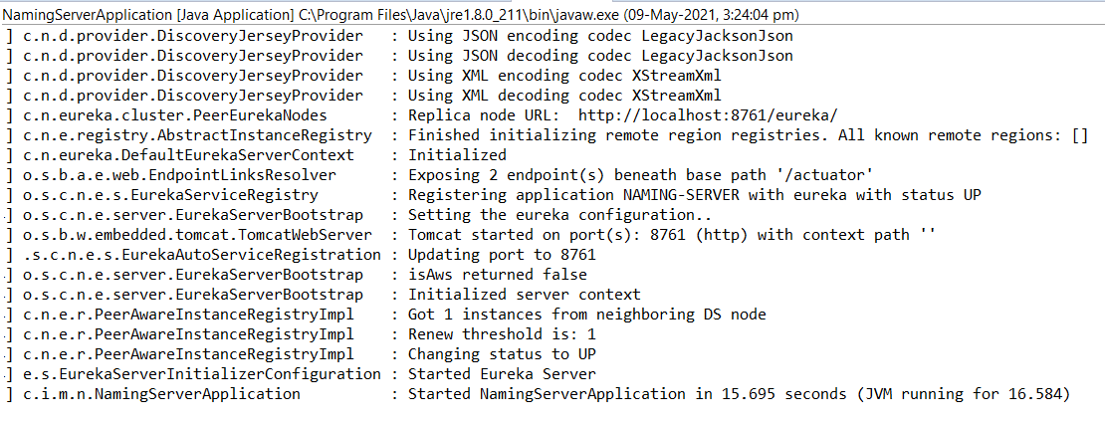

Now let’s lance the url: <http://localhost:8761/>

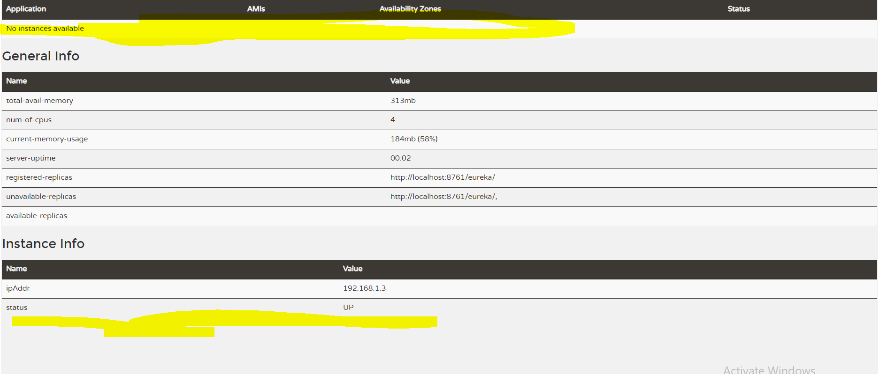

And ….Opps nothing registers in the Eureka. Let’s fix in the next step:

Debugging Problems with Eureka - V2

**Debugging** microservices problems can be **difficult** as there are multiple components involved.

**Step by Step instructions** is provided in the **troubleshooting guide** to help you troubleshoot frequently occurring problems.

Using the **Chrome Browser** is recommended.

**COMPLETE DEBUGGING GUIDE**

<https://github.com/in28minutes/spring-microservices-v2/blob/main/03.microservices/01-step-by-step-changes/microservices-v2-1.md#eureka---step-19-to-21>

**Top Recommendation From Debugging Guide:**

**Give these settings a try individually in application.properties of all microservices (currency-exchange, currency-conversion) to see if they help**

1. **eureka.instance.prefer-ip-address=true**

**OR**

1. **eureka.instance.hostname=localhost**

**154. Step 20 - Connect Currency Conversion & Currency Exchange Microservices - V2**

In the previous step we have created naming-server. Now in this step let’s register our services to the naming server.

In this step we will register CCnS and CExS with the naming server. And the way we do that is very simple.

1. Open the pom.xml of the CCnS and CExS or the service application which needs to be registered with naming-server
2. Add the just below dependency in each service application pom.xml file

|  |
| --- |
| <dependency>  <groupId>org.springframework.cloud</groupId>  <artifactId>spring-cloud-starter-netflix-eureka-client</artifactId>  </dependency> |

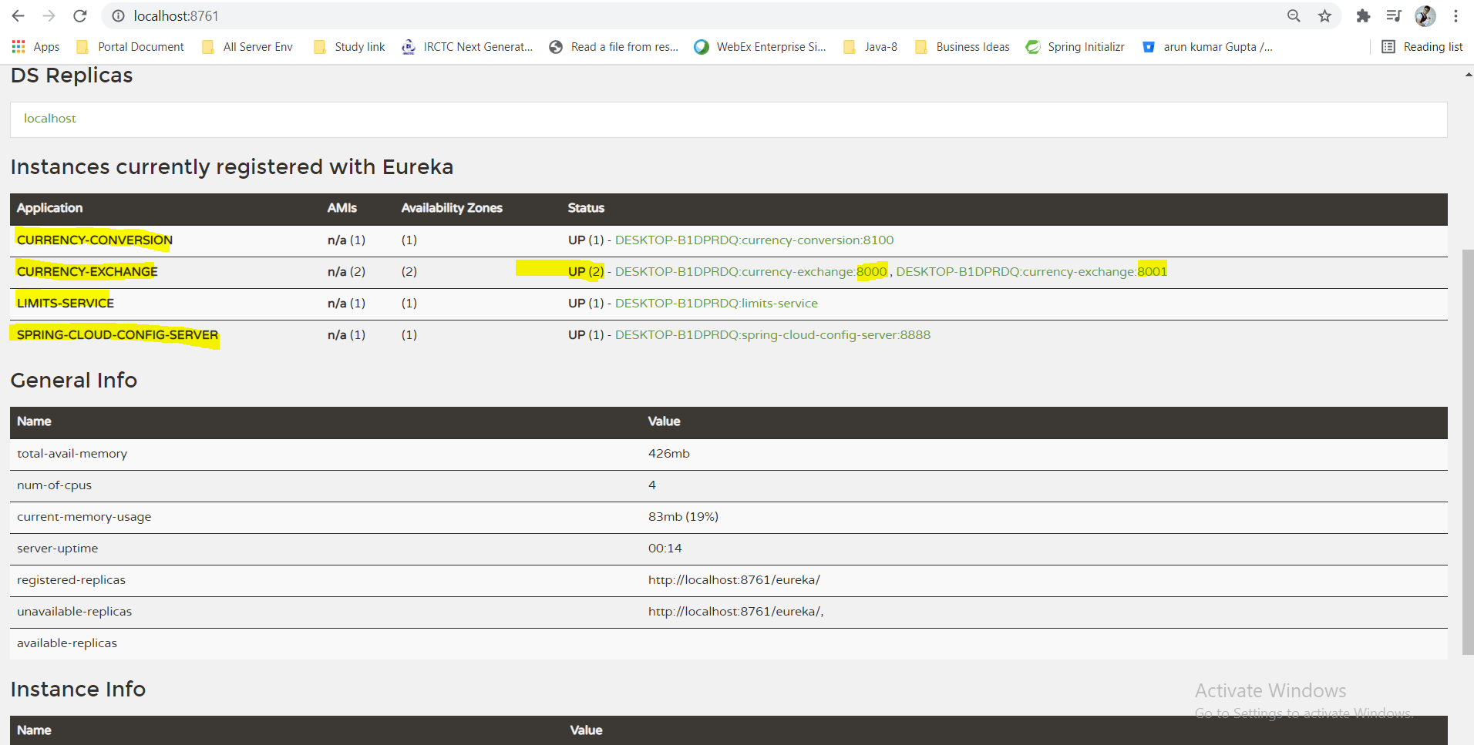

Once we added the above dependency in the pom.xml of all the project and restart the server and then check in Eureka then we have found that all the services now got registered with Eureka Naming server. Here we can see the status of all the services and their number instances up and running. Ex. Here we have two instances of Currency-Exchange service up and running at 8000 and 8001 port.

So in this way we can register all the services in the naming server.

**Note**: To be more sure we can do one more thing apart from adding this dependency, we can add the below property in all the microservices **application.properties** file as given below.

|  |
| --- |
| #Configure naming server property with URL  eureka.client.serviceUrl.defaultZone=http://localhost:8761/eureka |

After adding this property to all microservices application.properties file let’s test naming server once again.

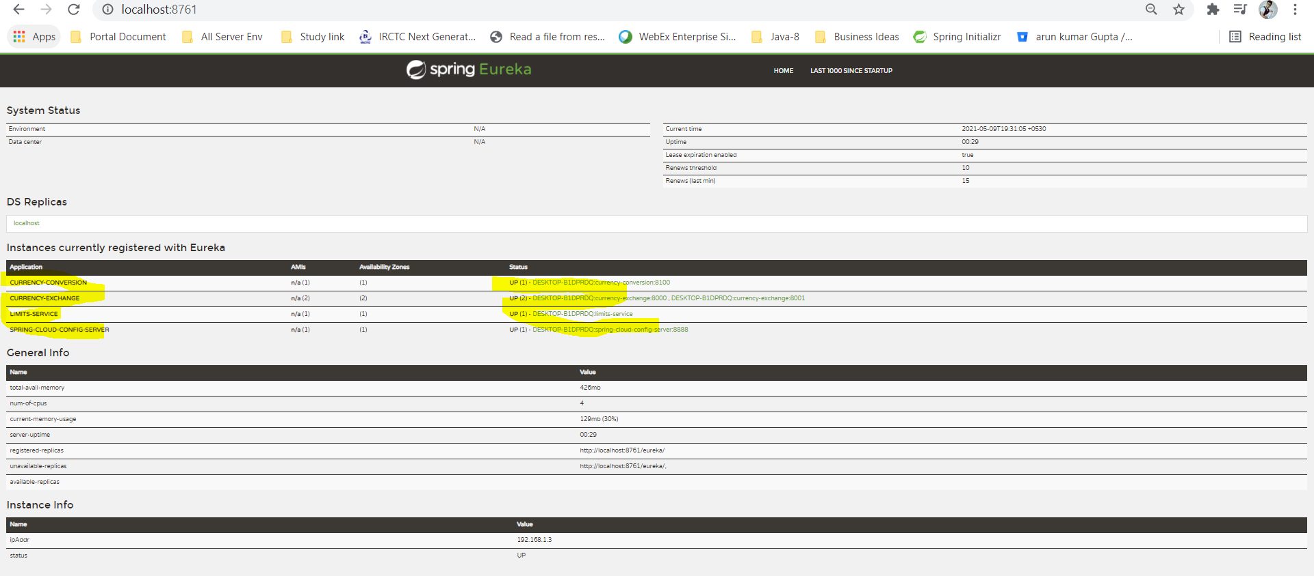

**Hence we can register all the microservices into naming server.**

**In the naming server log file also we can see the detail of up and down status of servers.**

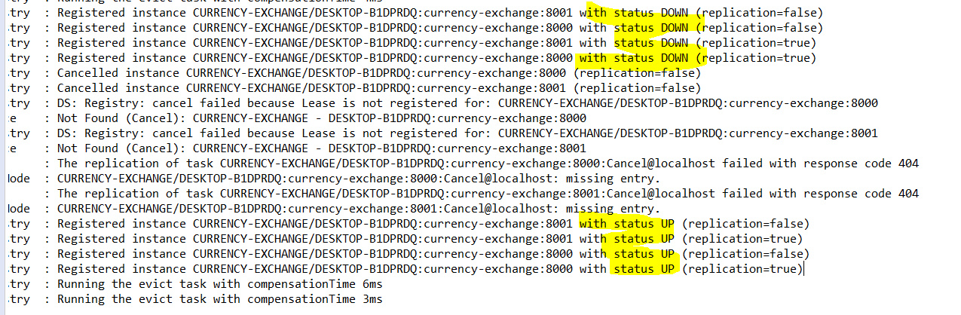

**So each time we start the server then first it would un-register and then it would register the services in the naming server.**

**In the next step we will talk about load balancing for all the instances registered with naming server.**

**156. Step 22 - Load Balancing with Eureka, Feign & Spring Cloud Load Balancer - V2**



Here we will focus on load balancing between multiple instances of CExS and CCnS. It seems very difficult, but it is very simple to implement.

Let’s go back to CCnS proxy class:

|  |
| --- |
| **package** com.in28minutes.microservices.currencyconversionservice.proxy;  **import** org.springframework.cloud.openfeign.FeignClient;  **import** org.springframework.web.bind.annotation.GetMapping;  **import** org.springframework.web.bind.annotation.PathVariable;  **import** com.in28minutes.microservices.currencyconversionservice.bean.CurrencyConversion;  @FeignClient(name ="currency-exchange", url = "localhost:8000")  **public** **interface** CurrencyConversionProxy {  @GetMapping(path="/currency-exchange/from/{from}/to/{to}")  **public** CurrencyConversion retriveExchangeRate(@PathVariable String from, @PathVariable String to);  } |

So this is the proxy which was talking to CExS based on Service Name and defined URL. But to use the load balancing we just need to remove URL part from the FeignClient. So the above code in case of load balancing would look like as given below.

|  |
| --- |
| @FeignClient(name ="currency-exchange")  **public** **interface** CurrencyConversionProxy {  @GetMapping(path="/currency-exchange/from/{from}/to/{to}")  **public** CurrencyConversion retriveExchangeRate(@PathVariable String from, @PathVariable String to);  } |

So now here the Feign client will talk to Eureka naming server and pick the instances of CExS and do load balancing between them. So this load balancing magic happens just by removing URL. So now we don’t have any specific instance configured in the CCnS, let’s save and run.

Now let’s hit the URL and check: <http://localhost:8100/currency-conversion-feign/from/USD/to/INR/quantity/10>

|  |  |
| --- | --- |
| {  "id": 1001,  "from": "USD",  "to": "INR",  "conversionMultiple": 65.00,  "quantity": 10,  "totalCalculatedAmount": 650.00,  "port": "8001-From FeignClient"  } | {  "id": 1001,  "from": "USD",  "to": "INR",  "conversionMultiple": 65.00,  "quantity": 10,  "totalCalculatedAmount": 650.00,  "port": "8000-From FeignClient"  } |

Note: Here the CExS is running with two instances at port number 8001 & 8000 respectively and now when we hit the above URL so some time CCnS talk to CExS instance with port 8000 and sometime with port 8001. So this way it balancing the load between multiple instances of CExS.

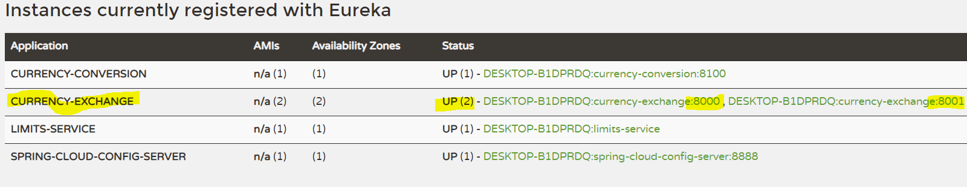



**So what is happening here?**

**Inside the CCnMS there is load balancer component which talking to the naming server, finding the instances and doing automatic load balancing between them and this is called client side load balancing and this happening through Feign.**

**How does Feign load balancing?**

**It goes inside POM of CCnMS and if we click on Dependency Hierarchy and type load in the filter text box then we would see there a load balancer (jar) with name [spring-cloud-loadbalancer] which brought into the classpath by [spring-cloud-starter-netflix-eureka-client] and this the loadbalancer framework which is used by feign to distribute the load among multiple instances which are returned by Eureka naming server.**

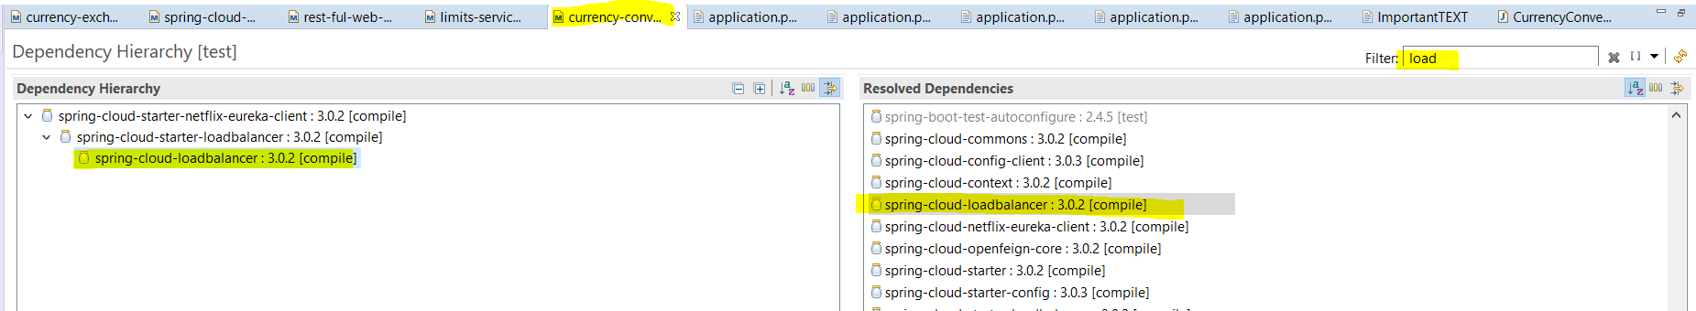

**Note: In the earlier version of cloud the load balancer which was used was Ribon and in the recent version spring cloud shifted to spring cloud load balancer as the load balancer.**

**The great thing if we are Using Eureka and Feign then load balancing comes for free. This is client load balancing and comes free.**

**Progress cannot be changed for this item**

**157. Step 22 - Setting up Spring Cloud API Gateway**

**So far we have developed several microservices, register them into naming server. These microservices have several common features like- Authentication, Authorization, Logging, Rate-Limiting which needs to be configured then how?**

**So the Answer is these several common features can be configured with the API Gateway.**

**In the older version of spring cloud the popular API Gateway used was ZUUL. Now this ZUUL is no longer supported by Netflix, so the spring has moved on and now the recommended option as an API Gateway is the Spring Cloud API Gateway.**

**Let’s gets started implementation with Spring Cloud API Gateway and look at the features it brings in.**

Dependencies:

* **Spring Boot DevTools :**Provides fast application restarts, LiveReload, and configurations for enhanced development experience.
* **Config Client :** Client that connects to a Spring Cloud Config Server to fetch the application's configuration.
* **Spring Boot Actuator:** Supports built in (or custom) endpoints that let you monitor and manage your application - such as application health, metrics, sessions, etc.
* **Eureka Discovery Client::**A REST based service for locating services for the purpose of load balancing and failover of middle-tier servers.
* **Gateway::**Provides a simple, yet effective way to route to APIs and provide cross cutting concerns to them such as security, monitoring/metrics, and resiliency.

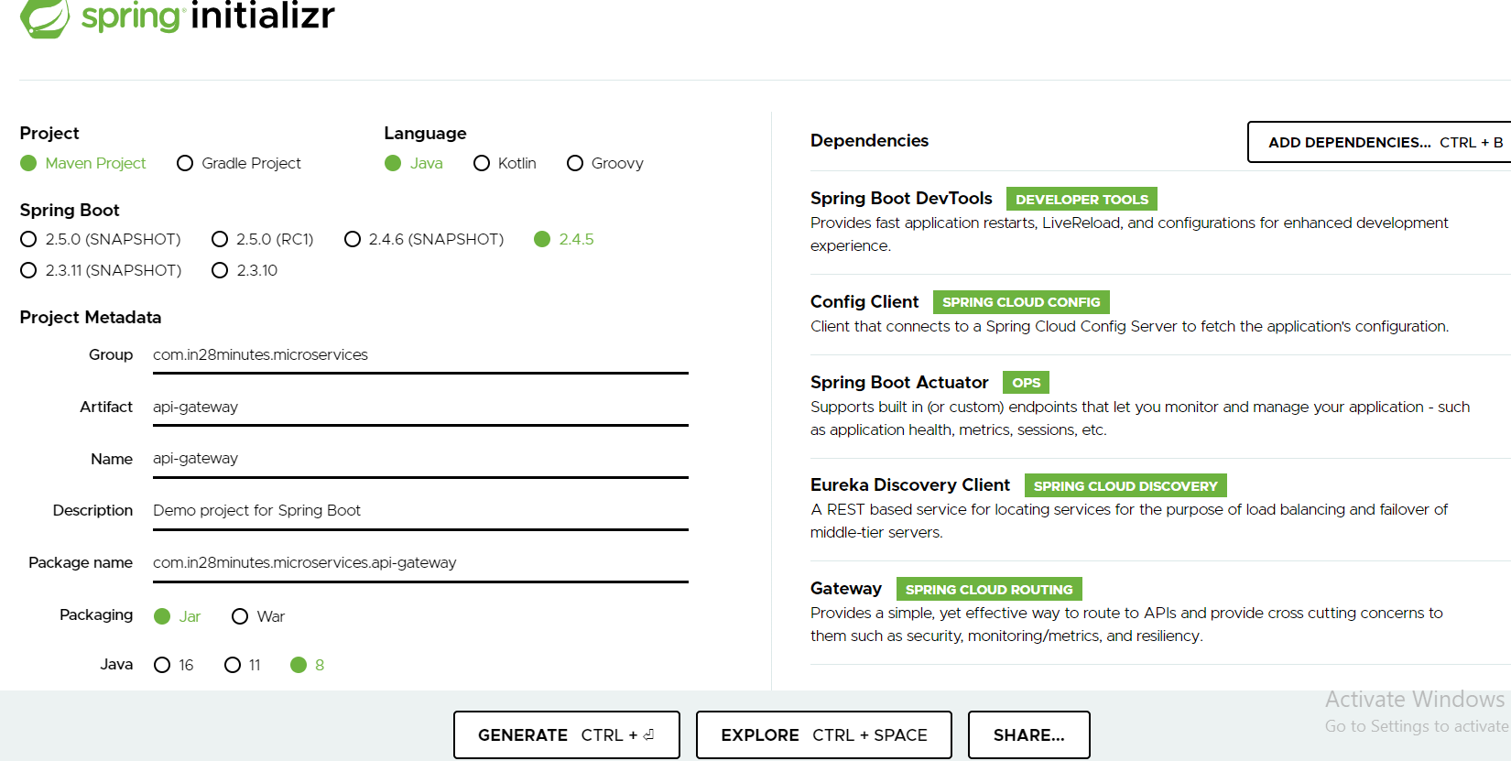

Get the project:

Extract and import into eclipse:

In the application.properties file mention the application name and server port.

|  |
| --- |
| spring.application.name=api-gateway  server.port=8765  #CENTRALZED CONFIG SERVER TO IMPORT CONFIGURATION FROM GIT  spring.config.import=optional:configserver:http://localhost:8888  #Configure naming server property with URL  eureka.client.serviceUrl.defaultZone=http://localhost:8761/eureka |

|  |
| --- |
| These two dependency we have added in the pom.xml  <dependency>  <groupId>org.springframework.cloud</groupId>  <artifactId>spring-cloud-starter-gateway</artifactId>  </dependency>  <dependency>  <groupId>org.springframework.cloud</groupId>  <artifactId>spring-cloud-starter-netflix-eureka-client</artifactId>  </dependency> |

Because of this dependency [spring-cloud-starter-netflix-eureka-client] api-gateway would automatically register with Eureka Naming server.

Now open the Eureka Naming server page and check whether this api-gate got registered or not.

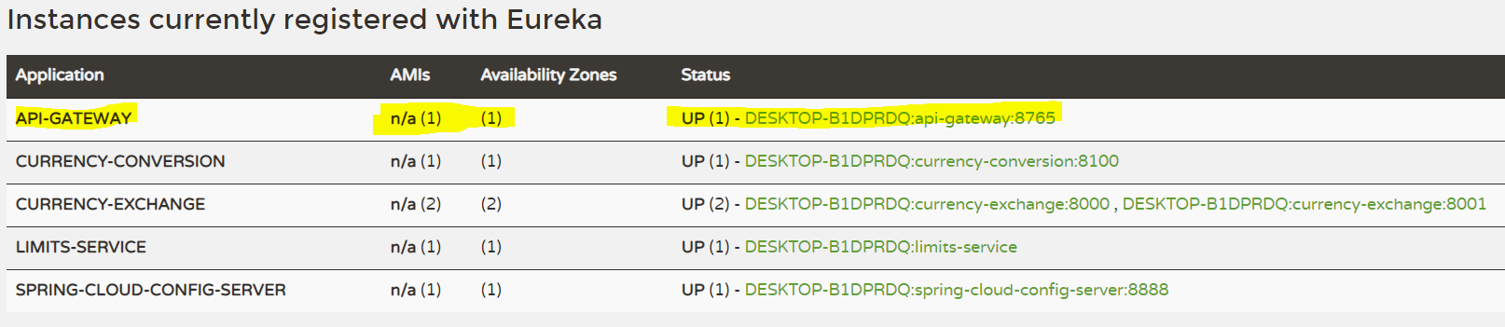

As now we can see that it got registered with naming server.

In this step we have launched up api-gateway and registered with naming server. In the next step let’s play with API-Gateway.

**URLs for next Lecture**

Some of these URLs may be complex to write by hand:

Refer back to here if you have problems in the next steps.

**Initial**

- http://localhost:8765/CURRENCY-EXCHANGE/currency-exchange/from/USD/to/INR

- http://localhost:8765/CURRENCY-CONVERSION/currency-conversion/from/USD/to/INR/quantity/10

- http://localhost:8765/CURRENCY-CONVERSION/currency-conversion-feign/from/USD/to/INR/quantity/10

**Lower Case**

- http://localhost:8765/currency-exchange/currency-exchange/from/USD/to/INR

- http://localhost:8765/currency-conversion/currency-conversion/from/USD/to/INR/quantity/10

- http://localhost:8765/currency-conversion/currency-conversion-feign/from/USD/to/INR/quantity/10

**Custom Routes**

- http://localhost:8765/currency-exchange/from/USD/to/INR

- http://localhost:8765/currency-conversion/from/USD/to/INR/quantity/10

- http://localhost:8765/currency-conversion-feign/from/USD/to/INR/quantity/10

- http://localhost:8765/currency-conversion-new/from/USD/to/INR/quantity/10

**159. Step 23 - Enabling Discovery Locator with Eureka for Spring Cloud Gateway**

So far we have used the below urls for spring microservices applications.

<http://localhost:8100/currency-conversion-feign/from/USD/to/INR/quantity/10>

<http://localhost:8000/currency-exchange/from/USD/to/INR>

Naming-Server

<http://localhost:8761/>

Limit-services through spring cloud config

<http://localhost:8888/limits-service/qa>

API-GATEWAY

<http://localhost:8765>

Now let’s try to call the Microservice through api-gateway and for that we have to check the service name which is registered in the Eureka Naming server and then append the remaining URL as given below.

- <http://localhost:8765/CURRENCY-EXCHANGE/currency-exchange/from/USD/to/INR>

- <http://localhost:8765/CURRENCY-CONVERSION/currency-conversion/from/USD/to/INR/quantity/10>

- <http://localhost:8765/CURRENCY-CONVERSION/currency-conversion-feign/from/USD/to/INR/quantity/10>

Here <http://localhost:8765> is the api-gateway + RegisterServiceNameInNamingServer (**CURRENCY-CONVERSION**)+ the remaining url method in the controller class method(**currency-conversion-feign/from/USD/to/INR/quantity/10**)

**This way we can configured the service resource URL with API-Gateway and naming server. Now let’s hit this URL and check.**

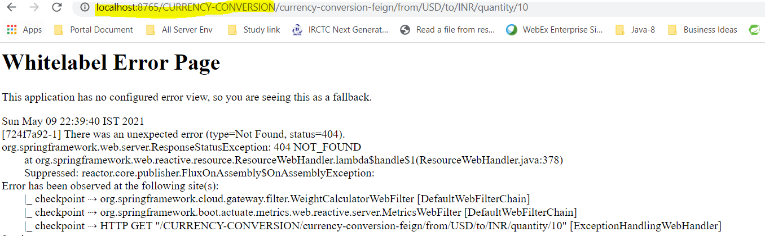

Oops, we have to the above error. Because still this URL is not enabled api-gateway. To enable this feature in spring cloud Api-Gateway we have to add a property in application.properties of api-gateway application.

|  |
| --- |
| #Enabling spring cloud gateway discovery client  spring.cloud.gateway.discovery.locator.enabled=true |

By default this feature is disabled, so to enable this we have to set the above property in the api-gateway application.properties file.

# In the latest version of spring boot 2.4.5 we are getting [Spring Boot API Gateway Unable to resolve name](https://stackoverflow.com/questions/66133925/spring-boot-api-gateway-unable-to-resolve-name)

**To solve this issue let’s set the below property in all microservices including api-gateway and start the server in the below sequence.**

**eureka.instance.hostname=localhost**

(1) Make sure you start the services in this order (a)netflix-eureka-naming-server (b)currency-exchange-service (c)currency-conversion-service

(2) Make sure all the components are registered with naming server.

(3) Give a minute of warm up time!

**For more information: go through the below link**

[**https://github.com/in28minutes/spring-microservices-v2/blob/main/03.microservices/01-step-by-step-changes/microservices-v2-1.md#eureka---step-19-to-21**](https://github.com/in28minutes/spring-microservices-v2/blob/main/03.microservices/01-step-by-step-changes/microservices-v2-1.md#eureka---step-19-to-21)

**Now try to hit the above url once again and check:**

[**http://localhost:8765/CURRENCY-CONVERSION/currency-conversion-feign/from/AUD/to/INR/quantity/100**](http://localhost:8765/CURRENCY-CONVERSION/currency-conversion-feign/from/AUD/to/INR/quantity/100)

|  |
| --- |
| **// 20210509230257**  **// http://localhost:8765/CURRENCY-CONVERSION/currency-conversion-feign/from/AUD/to/INR/quantity/100**  **{**  **"id": 1003,**  **"from": "AUD",**  **"to": "INR",**  **"conversionMultiple": 80.00,**  **"quantity": 100,**  **"totalCalculatedAmount": 8000.00,**  **"port": "8000-From FeignClient"**  **}** |

**And yes we have to the response from api-gateway:**

[**http://localhost:8765/CURRENCY-EXCHANGE/currency-exchange/from/USD/to/INR**](http://localhost:8765/CURRENCY-EXCHANGE/currency-exchange/from/USD/to/INR)

|  |
| --- |
| **// 20210509231836**  **// http://localhost:8765/CURRENCY-EXCHANGE/currency-exchange/from/USD/to/INR**  **{**  **"id": 1001,**  **"from": "USD",**  **"to": "INR",**  **"conversionRate": 65.00,**  **"port": "8000"**  **}** |

**So now we can any microservices which is registered with Eureka Naming Server through the api-gateway:**

**If we want to implement authentication and we want allows only the authenticated user then all this authenticated logic can be implemented in the api-gateway**

**One of the problem we can see that this URL is not looking really good.**

**Note:** When we hit the above URL matching exactly with the registered service name in the Eureka naming server through the api-gateway then it is working fine, but if we change the lower case of registered name in Eureka Naming Server then it does not work:

[**http://localhost:8765/currency-exchange/currency-exchange/from/USD/to/INR**](http://localhost:8765/currency-exchange/currency-exchange/from/USD/to/INR)

[**http://localhost:8765/currency-conversion/currency-conversion-feign/from/USD/to/INR/quantity/10**](http://localhost:8765/currency-conversion/currency-conversion-feign/from/USD/to/INR/quantity/10)

**We are getting below error:**

# Whitelabel Error Page

This application has no configured error view, so you are seeing this as a fallback.

Sun May 09 23:19:30 IST 2021

[da96db0c-2] There was an unexpected error (type=Not Found, status=404).

org.springframework.web.server.ResponseStatusException: 404 NOT_FOUND

And apart from that here we have used application name two times in the URL which is also not fine.

Ans: So we can fix this lower case issue by setting one property in the api-gateway application.properties file as given below.

|  |  |
| --- | --- |
| #lowercase issue property  spring.cloud.gateway.discovery.locator.lowerCaseServiceId=true | |
| <http://localhost:8765/currency-exchange/currency-exchange/from/USD/to/INR>  {  "id": 1001,  "from": "USD",  "to": "INR",  "conversionRate": 65.00,  "port": "8000"  } | <http://localhost:8765/currency-conversion/currency-conversion-feign/from/USD/to/INR/quantity/10>  {  "id": 1001,  "from": "USD",  "to": "INR",  "conversionMultiple": 65.00,  "quantity": 10,  "totalCalculatedAmount": 650.00,  "port": "8000-From FeignClient"  } |

So now we are getting the response with lower case but it would not work with capital case. So this is not the complete solution. To get the complete solution we have to customize the URL and need to remove the extra name coming in the URL. How to fix?

**In this step we have learnt how we can call the microservices through the proxy api-gateway**

Debugging Problems with Spring Cloud Gateway - V2

**Debugging** microservices problems can be **difficult** as there are multiple components involved.

**Step by Step instructions** is provided in the **troubleshooting guide** to help you troubleshoot frequently occurring problems.

Using the **Chrome Browser** is recommended.

**COMPLETE DEBUGGING GUIDE**

[**https://github.com/in28minutes/spring-microservices-v2/blob/main/03.microservices/01-step-by-step-changes/microservices-v2-1.md#spring-cloud-api-gateway---step-22-to-step-25**](https://github.com/in28minutes/spring-microservices-v2/blob/main/03.microservices/01-step-by-step-changes/microservices-v2-1.md#spring-cloud-api-gateway---step-22-to-step-25)

**TOP Recommendation from Debugging Guide:**

(6) Some student reported success when using lower-case-service-id instead of spring.cloud.gateway.discovery.locator.lowerCaseServiceId. See if it helps!

spring.cloud.gateway.discovery.locator.enabled=true

spring.cloud.gateway.discovery.locator.lower-case-service-id=true

**161. Step 24 - Exploring Routes with Spring Cloud Gateway**